UNITED STATES
SECURITIES AND EXCHANGE COMMISSION
Washington, D.C. 20549
________________________
FORM 8-K
________________________________________________________________________________________________
CURRENT REPORT
Pursuant to Section 13 or 15(d)
of the Securities Exchange Act of 1934
Date of Report (Date of earliest event reported): August 6, 2026
________________________________________________________________________________________________
Foghorn Therapeutics Inc.
(Exact name of registrant as specified in its charter)
________________________________________________________________________________________________
Delaware |  |  |  |  |  | 001-39634 |  |  |  |  |  | 47-5271393
(State or other jurisdiction of incorporation) |  |  |  |  |  | (Commission  File Number) |  |  |  |  |  | (IRS Employer Identification No.)
 |  |  | 99 Coolidge Avenue, Suite 500
 |  |  | Watertown, |  |  |  |  |  | Massachusetts |  |  |  |  |  |  |  |  | 02472
 |  |  | (Address of principal executive offices) |  |  |  |  |  |  |  |  |  |  |  |  |  |  | (Zip Code)
(Registrant’s telephone number, including area code): (617) 586-3100
Not Applicable
(Former name or former address, if changed since last report)
________________________
Check the appropriate box below if the Form 8-K filing is intended to simultaneously satisfy the filing obligation of the registrant under any of the following provisions:
☐ |  |  | Written communications pursuant to Rule 425 under the Securities Act (17 CFR 230.425)
☐ |  |  | Soliciting material pursuant to Rule 14a-12 under the Exchange Act (17 CFR 240.14a-12)
☐ |  |  | Pre-commencement communications pursuant to Rule 14d-2(b) under the Exchange Act (17 CFR 240.14d-2(b))
☐ |  |  | Pre-commencement communications pursuant to Rule 13e-4(c) under the Exchange Act (17 CFR 240.13e-4(c))
Securities registered pursuant to Section 12(b) of the Act:
Title of each class |  |  |  |  |  | Trading  Symbol(s) |  |  |  |  |  | Name of each exchange  on which registered
Common Stock, $0.0001 par value per share |  |  |  |  |  | FHTX |  |  |  |  |  | The Nasdaq Global Market
Indicate by check mark whether the registrant is an emerging growth company as defined in Rule 405 of the Securities Act of 1933 (§230.405 of this chapter) or Rule 12b-2 of the Securities Exchange Act of 1934 (§240.12b-2 of this chapter).
Emerging growth company ☐
If an emerging growth company, indicate by check mark if the registrant has elected not to use the extended transition period for complying with any new or revised financial accounting standards provided pursuant to Section 13(a) of the Exchange Act. ☐

Item 2.02 Results of Operations and Financial Condition.
On August 6, 2026, Foghorn Therapeutics Inc. (the “Company”) issued a press release announcing certain of the Company’s financial results for the quarter ended June 30, 2026. A copy of the press release is furnished as Exhibit 99.1 to this Current Report on Form 8-K.
The information in this Item 2.02 (including Exhibit 99.1 attached hereto) is being furnished and shall not be deemed “filed” for purposes of Section 18 of the Securities Exchange Act of 1934, as amended (the “Exchange Act”), or otherwise subject to the liabilities of that section, nor shall it be deemed incorporated by reference into any filing by the Company under the Securities Act of 1933, as amended (the “Securities Act”), or the Exchange Act, except as expressly set forth by specific reference in such filing.

Item 7.01 Regulation FD Disclosure.
The Company is furnishing as Exhibit 99.2 to this Current Report on Form 8-K a presentation, dated August 2026, which the Company intends to use in meetings with or presentations to investors.
The information in this Item 7.01 (including Exhibit 99.2 attached hereto) is being furnished and shall not be deemed “filed” for purposes of Section 18 of the Exchange Act, or otherwise subject to the liabilities of that section, nor shall it be deemed incorporated by reference into any filing by the Company under the Securities Act or the Exchange Act, except as expressly set forth by specific reference in such filing.

Item 9.01 Financial Statements and Exhibits.
(d) Exhibits

Exhibit No. |  |  | Description
99.1 |  |  | Press Release issued on August 6, 2026
99.2 |  |  | Investor Presentation dated August 2026

SIGNATURES
Pursuant to the requirements of the Securities Exchange Act of 1934, the registrant has duly caused this report to be signed on its behalf by the undersigned hereunto duly authorized.

 |  |  | FOGHORN THERAPEUTICS INC.
 |  |  | By: |  |  |  |  |  | /s/ Ryan Maynard
 |  |  |  |  |  |  |  |  | Ryan Maynard
 |  |  |  |  |  |  |  |  | Chief Financial Officer
Date: August 6, 2026

Exhibit 99.1

Foghorn Therapeutics Provides Second Quarter 2026 Financial and Corporate Update
- FHD-909 (LY4050784) Phase 1 dose-escalation trial advancing as planned with non-small cell lung cancer (NSCLC) as the primary target population

- Selective EP300 degraders with potential to treat multiple myeloma and other hematological malignancies advancing; IND targeted in 2027

- Accelerating a novel oral small molecule in immunology and inflammation toward IND in 2027

- Strong balance sheet with cash, cash equivalents, and marketable securities of approximately
$168 million; cash runway into the first half of 2028

WATERTOWN, Mass. -- (GLOBE NEWSWIRE) – August 6, 2026 -- Foghorn® Therapeutics Inc. (Nasdaq: FHTX), a clinical-stage biotechnology company pioneering a new class of medicines that treat serious diseases by correcting abnormal gene expression, today provided a financial and corporate update in conjunction with the Company’s 10-Q filing for the second quarter ended June 30, 2026. With an initial focus in oncology, Foghorn’s Gene Traffic Control® Platform and resulting broad pipeline have the potential to transform the lives of people suffering from a wide spectrum of diseases.
“Our FHD-909 trial in collaboration with Lilly continues to advance through dose escalation, with an initial focus on SMARCA4-mutant NSCLC, a setting where effective treatment options remain limited and outcomes poor,” said Adrian Gottschalk, President and Chief Executive Officer of Foghorn Therapeutics.
Mr. Gottschalk continued, “We are excited to advance our wholly-owned pipeline toward the clinic. Beyond oncology, we are now extending the reach of our platform with an undisclosed program in immunology and inflammation. We are targeting an IND in 2027 for this asset, underscoring the breadth of our platform and demonstrating its potential across multiple therapeutic areas. In oncology, our Selective EP300 degrader program in multiple myeloma has shown improved safety and efficacy versus clinical benchmarks, while our Selective CBP degrader, FHT-171, has demonstrated strong anti-tumor activity and tolerability in heavily pretreated ER+ breast cancer models. Together, these programs reflect the significant opportunity we see to expand our pipeline and create value across multiple therapeutic areas.”
Program Overview and Upcoming Milestones
FHD-909 (LY4050784). FHD-909 is a first-in-class oral SMARCA2 selective inhibitor that has demonstrated in preclinical studies to have high selectivity over its closely-related paralog SMARCA4, two proteins that are the catalytic engines across all forms of the BAF complex. Selectively blocking SMARCA2 activity is a promising synthetic lethal strategy intended to induce tumor death while sparing healthy cells. SMARCA4 is mutated in up to 10% of NSCLC and implicated in a significant number of solid tumors. Across lines of therapy, significant unmet needs remain for patients with SMARCA4 (BRG1)-mutant cancers with both poor response rates and short progression-free survival.
•Phase 1 trial on track. Enrollment in the first-in-human Phase 1 multi-center trial of FHD-909 is progressing well. The trial in patients with NSCLC as the primary target population is on track, following the dosing of the first patient in October 2024.

•Robust and durable preclinical data for FHD-909 plus anti-PD-1 antibody. Preclinical data have demonstrated complete tumor regression in syngeneic efficacy models of FHD-909 in combination with an anti-PD-1 antibody, with no tumor regrowth observed after dosing was halted. An immune memory effect was further supported by tumor rejection upon rechallenge in treated animals.
•Pending successful Phase 1 dose escalation results, Foghorn and Lilly anticipate evaluating FHD-909 in combination studies in NSCLC with pembrolizumab.
Ongoing strategic collaboration with Lilly. Foghorn is collaborating with Lilly to develop novel oncology medicines, including a 50/50 U.S. co-development and co-commercialization agreement for its selective SMARCA2 oncology program that includes both a selective inhibitor and a selective degrader, as well as an additional undisclosed oncology target. The collaboration, the research term of which will expire in December 2026, also includes three discovery programs from Foghorn’s proprietary Gene Traffic Control® platform.

I&I Novel Oral Small Molecule. Foghorn is advancing a novel oral small molecule in immunology and inflammation (I&I).
•IND targeted in 2027.

Selective EP300 degrader program. These degraders are being developed for the treatment of hematological malignancies and prostate cancer. Attempts to selectively drug EP300 have been challenging due to the high level of similarity between EP300 and CBP, while dual inhibition of CBP/EP300 has been associated with dose limiting toxicities. EP300 lineage dependencies are established in multiple myeloma (MM) and diffuse large b-cell lymphoma (DLBCL).
•EP300 degrader program outperforms clinical benchmark. Preclinical data highlight the therapeutic potential in multiple myeloma, including superior anti-tumor activity with complete responses, compared to clinical benchmark dual CBP/EP300 inhibitor inobrodib, superior safety by body weight loss and platelet counts over dual degradation, and tumor regression in a multiple myeloma xenograft model of acquired pomalidomide resistance.
•IND targeted in 2027, with a focus in MM and DLBCL.

Selective CBP degrader program. These degraders selectively target CBP, an acetyltransferase closely related to EP300. CBP lineage dependencies are established in several cancers, including breast cancer, and there is also a synthetic relationship in EP300-mutated cancers, which include endometrial, cervical, ovarian, bladder, and colorectal cancer. Attempts to selectively drug CBP have been challenging due to the high level of similarity between the two proteins, while dual inhibition of CBP/EP300 has been associated with dose-limiting toxicities.
•CBPd-171 shows strong therapeutic potential in ER+ breast cancer. Preclinical data for our lead Selective CBP degrader, CBPd-171, highlighted strong anti-tumor activity as a monotherapy in PDX models of heavily pretreated ER+ breast cancer, favorable preclinical in vivo tolerability profile, and high selectivity and potent CBP degradation with clear on-target transcriptional effects. We have developed a long-acting injectable (LAI) formulation for weekly subcutaneous administration to support convenient and patient-friendly dosing.
•The CBPd-171 timeline has been delayed due to an unexpected operational issue at a third-party contract research organization supporting the in vivo animal models. The Company will provide updated guidance once available.

Selective ARID1B degrader program. These degraders selectively target and degrade ARID1B and are being positioned as synthetic lethal opportunities for ARID1A-mutated cancers. ARID1A is the most mutated subunit in the BAF complex and amongst the most mutated proteins in cancer. These mutations lead to a dependency on ARID1B in several types of cancer, including endometrial, gastric, bladder and NSCLC. Attempts to selectively drug ARID1B have been challenging because of the high degree of similarity between ARID1A and ARID1B and the fact that ARID1B has no enzymatic activity to target. ARID1B is a major synthetic lethal target implicated in up to 5% of all solid tumors.
•First-in-class Selective ARID1B degrader program. Robust degradation with potential for oral bioavailability demonstrated preclinically across our cereblon-based Selective ARID1B degraders. Foghorn is developing cereblon-based bifunctional degraders achieving selective degradation of ARID1B and modulation of downstream target genes consistent with ARID1B pathway disruption.

Platform. Foghorn continues to advance its chromatin biology and degrader platform with investments in molecular glues, RIPTACs and induced proximity.
Second Quarter 2026 Financial Highlights
•Collaboration Revenue. Collaboration revenue was $16.1 million for the three months ended June 30, 2026, compared to $7.6 million for the three months ended June 30, 2025. The $8.5 million increase was driven by a $14.2 million cumulative catch-up adjustment to reflect updated future costs primarily due to the scheduled expiration of the research term in December 2026 partially offset by the timing of work performed under the Lilly Collaboration Agreement.

•Research and Development Expenses. Research and development expenses were $18.5 million for the three months ended June 30, 2026, compared to $21.8 million for the three months ended June 30, 2025. The $3.3 million decrease is attributed to a decrease in Lilly-partnered program costs, decreases in facilities and IT-related expenses, a decrease in FHD-286 costs, and decreases in personnel-related costs partially offset by an increase in early development and other external costs.

•General and Administrative Expenses. General and administrative expenses were $6.4 million for the three months ended June 30, 2026, compared to $6.9 million for the three months ended June 30, 2025. This $0.5 million decrease was primarily due to lower facilities and IT-related expenses.

•Net Loss. Net loss was $7.2 million for the three months ended June 30, 2026, compared to a net loss of $17.9 million for the three months ended June 30, 2025.

•Cash, Cash Equivalents, and Marketable Securities. As of June 30, 2026, the Company had $167.6 million in cash, cash equivalents, and marketable securities, providing cash runway into the first half of 2028.

About FHD-909
FHD-909 (LY4050784) is a potent, first-in-class, allosteric, and orally available small molecule that selectively inhibits the ATPase activity of SMARCA2 (BRM) over its closely related paralog SMARCA4 (BRG1), two proteins that are the catalytic engines across all forms of the BAF complex, one of the key

regulators of the chromatin regulatory system. In preclinical studies, tumors with mutations in SMARCA4 rely on SMARCA2 for their survival. FHD-909 has shown significant anti-tumor activity across multiple SMARCA4-mutant lung tumor models.

About Foghorn Therapeutics
Foghorn® Therapeutics is discovering and developing a novel class of medicines targeting genetically determined dependencies within the chromatin regulatory system. Through its proprietary scalable Gene Traffic Control® platform, Foghorn is systematically studying, identifying, and validating potential drug targets within the chromatin regulatory system. The Company is developing product candidates in oncology and in immunology & inflammation. Visit our website at www.foghorntx.com for more information on the Company, and follow us on X and LinkedIn.
Forward-Looking Statements
This press release contains “forward-looking statements.” Forward-looking statements include statements regarding the Company’s clinical and preclinical programs, including the ongoing Phase 1 trial evaluating FHD-909 in SMARCA4-mutated cancers, selective CBP and selective EP300 degrader programs, selective ARID1B degrader program, the novel oral small molecule in immunology and inflammation, and other preclinical product candidates, expected timing of clinical data, expected cash runway, expected timing of regulatory filings, and research efforts and other statements identified by words such as “could,” “may,” “might,” “will,” “likely,” “anticipates,” “intends,” “plans,” “seeks,” “believes,” “estimates,” “expects,” “continues,” “projects” and similar references to future periods. Forward-looking statements are based on our current expectations and assumptions regarding capital market conditions, our business, the economy and other future conditions. Because forward-looking statements relate to the future, by their nature, they are subject to inherent uncertainties, risks and changes in circumstances that are difficult to predict. As a result, actual results may differ materially from those contemplated by the forward-looking statements. Important factors that could cause actual results to differ materially from those in the forward-looking statements include regional, national or global political, economic, business, competitive, market and regulatory conditions, including risks relating to our clinical trials and other factors set forth under the heading “Risk Factors” in the Company’s Annual Report on Form 10-K for the year ended December 31, 2025, as filed with the Securities and Exchange Commission. Any forward-looking statement made in this press release speaks only as of the date on which it is made.

Condensed Consolidated Balance Sheets
(In thousands)

 |  |  | June 30, 2026 |  |  |  |  |  | December 31, 2025
Cash, cash equivalents and marketable securities |  |  | $ | 167,582 |  |  |  |  | $ | 158,894
All other assets |  |  | 35,811 |  |  |  |  |  | 39,209
Total assets |  |  | $ | 203,393 |  |  |  |  | $ | 198,103
Deferred revenue, total |  |  | $ | 229,815 |  |  |  |  | $ | 249,154
All other liabilities |  |  | 54,619 |  |  |  |  |  | 57,449
Total liabilities |  |  | $ | 284,434 |  |  |  |  | $ | 306,603
Total stockholders’ deficit |  |  | $ | (81,041) |  |  |  |  | $ | (108,500)
Total liabilities and stockholders’ deficit |  |  | $ | 203,393 |  |  |  |  | $ | 198,103

Condensed Consolidated Statements of Operations
(In thousands, except share and per share amounts)

 |  |  | Three Months Ended June 30,
 |  |  | 2026 |  |  |  |  |  | 2025
Collaboration revenue |  |  | $ | 16,072 |  |  |  |  | $ | 7,557
Operating expenses:
Research and development |  |  | 18,523 |  |  |  |  |  | 21,792
General and administrative |  |  | 6,354 |  |  |  |  |  | 6,862
Total operating expenses |  |  | $ | 24,877 |  |  |  |  | $ | 28,654
Loss from operations |  |  | $ | (8,805) |  |  |  |  | $ | (21,097)
Total other income, net |  |  | $ | 1,614 |  |  |  |  | $ | 3,161
Net loss |  |  | $ | (7,191) |  |  |  |  | $ | (17,936)
Net loss per share attributable to common stockholders—basic and diluted |  |  | (0.10) |  |  |  |  |  | (0.28)
Weighted average common shares outstanding—basic and diluted |  |  | 70,629,419 |  |  |  |  |  | 62,978,219

Contact:
Karin Hellsvik, Foghorn Therapeutics Inc.
khellsvik@foghorntx.com



Unique biology Precision therapeutics Broad impact NASDAQ LISTED FHTX August 2026 Exhibit 99.2

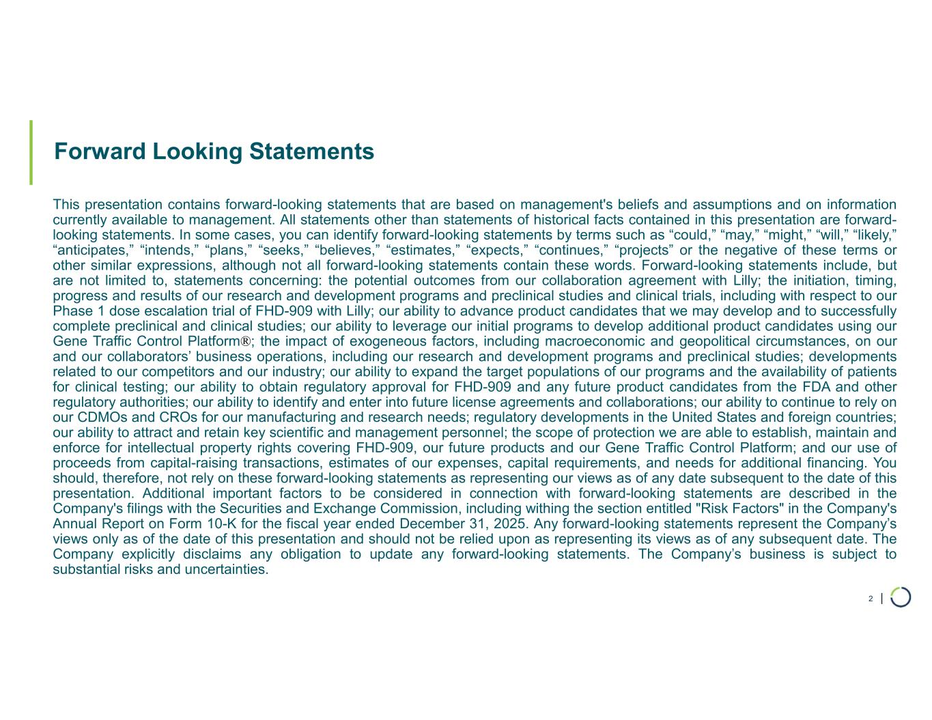
| Forward Looking Statements 2 This presentation contains forward-looking statements that are based on management's beliefs and assumptions and on information currently available to management. All statements other than statements of historical facts contained in this presentation are forward- looking statements. In some cases, you can identify forward-looking statements by terms such as “could,” “may,” “might,” “will,” “likely,” “anticipates,” “intends,” “plans,” “seeks,” “believes,” “estimates,” “expects,” “continues,” “projects” or the negative of these terms or other similar expressions, although not all forward-looking statements contain these words. Forward-looking statements include, but are not limited to, statements concerning: the potential outcomes from our collaboration agreement with Lilly; the initiation, timing, progress and results of our research and development programs and preclinical studies and clinical trials, including with respect to our Phase 1 dose escalation trial of FHD-909 with Lilly; our ability to advance product candidates that we may develop and to successfully complete preclinical and clinical studies; our ability to leverage our initial programs to develop additional product candidates using our Gene Traffic Control Platform®; the impact of exogeneous factors, including macroeconomic and geopolitical circumstances, on our and our collaborators’ business operations, including our research and development programs and preclinical studies; developments related to our competitors and our industry; our ability to expand the target populations of our programs and the availability of patients for clinical testing; our ability to obtain regulatory approval for FHD-909 and any future product candidates from the FDA and other regulatory authorities; our ability to identify and enter into future license agreements and collaborations; our ability to continue to rely on our CDMOs and CROs for our manufacturing and research needs; regulatory developments in the United States and foreign countries; our ability to attract and retain key scientific and management personnel; the scope of protection we are able to establish, maintain and enforce for intellectual property rights covering FHD-909, our future products and our Gene Traffic Control Platform; and our use of proceeds from capital-raising transactions, estimates of our expenses, capital requirements, and needs for additional financing. You should, therefore, not rely on these forward-looking statements as representing our views as of any date subsequent to the date of this presentation. Additional important factors to be considered in connection with forward-looking statements are described in the Company's filings with the Securities and Exchange Commission, including withing the section entitled "Risk Factors" in the Company's Annual Report on Form 10-K for the fiscal year ended December 31, 2025. Any forward-looking statements represent the Company’s views only as of the date of this presentation and should not be relied upon as representing its views as of any subsequent date. The Company explicitly disclaims any obligation to update any forward-looking statements. The Company’s business is subject to substantial risks and uncertainties.

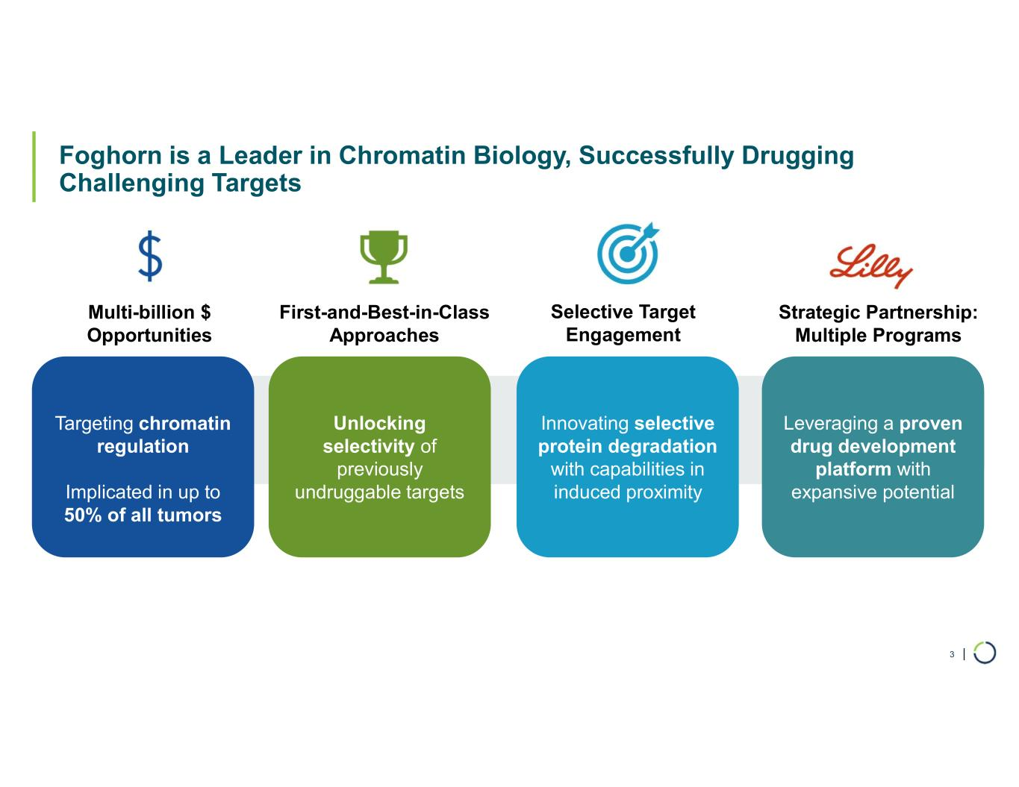
| Foghorn is a Leader in Chromatin Biology, Successfully Drugging Challenging Targets 3 Targeting chromatin regulation Implicated in up to 50% of all tumors Multi-billion $ Opportunities Unlocking selectivity of previously undruggable targets First-and-Best-in-Class Approaches Innovating selective protein degradation with capabilities in induced proximity Selective Target Engagement Leveraging a proven drug development platform with expansive potential Strategic Partnership: Multiple Programs

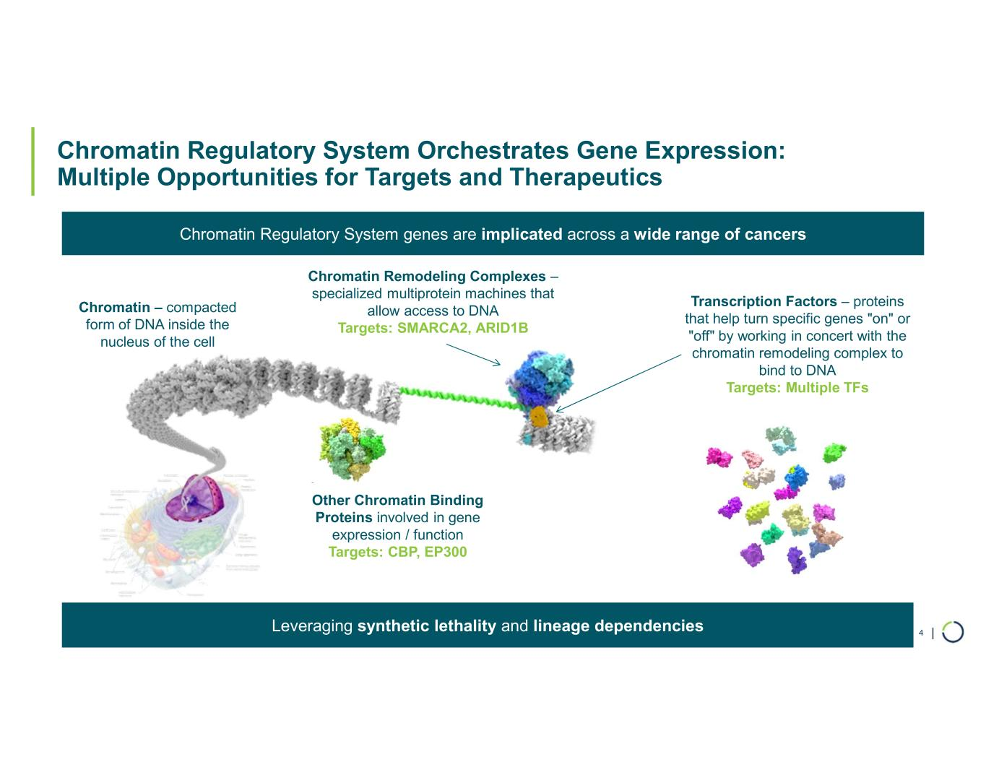
| Chromatin Regulatory System Orchestrates Gene Expression: Multiple Opportunities for Targets and Therapeutics 4 Chromatin – compacted form of DNA inside the nucleus of the cell Chromatin Remodeling Complexes – specialized multiprotein machines that allow access to DNA Targets: SMARCA2, ARID1B Transcription Factors – proteins that help turn specific genes "on" or "off" by working in concert with the chromatin remodeling complex to bind to DNA Targets: Multiple TFs Other Chromatin Binding Proteins involved in gene expression / function Targets: CBP, EP300 Chromatin Regulatory System genes are implicated across a wide range of cancers Leveraging synthetic lethality and lineage dependencies

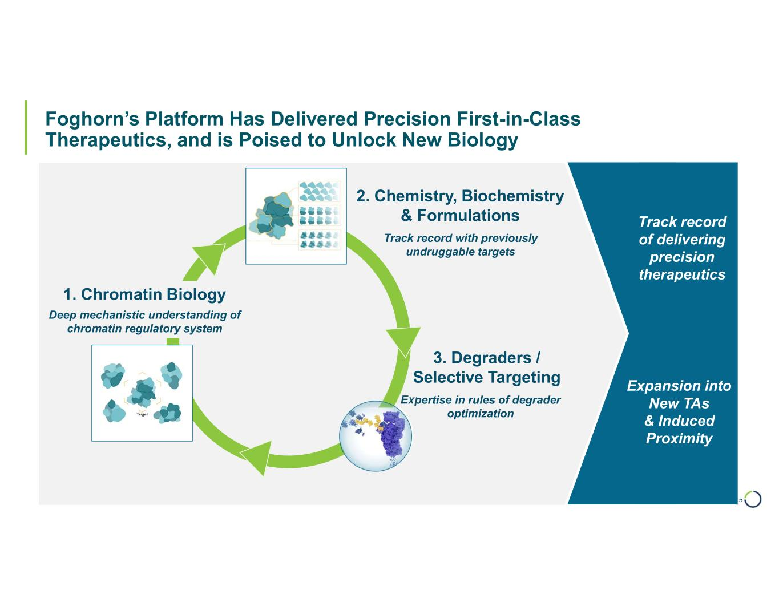
| Foghorn’s Platform Has Delivered Precision First-in-Class Therapeutics, and is Poised to Unlock New Biology 5 1. Chromatin Biology 2. Chemistry, Biochemistry & Formulations 3. Degraders / Selective Targeting Deep mechanistic understanding of chromatin regulatory system Expertise in rules of degrader optimization Track record with previously undruggable targets Expansion into New TAs & Induced Proximity Track record of delivering precision therapeutics

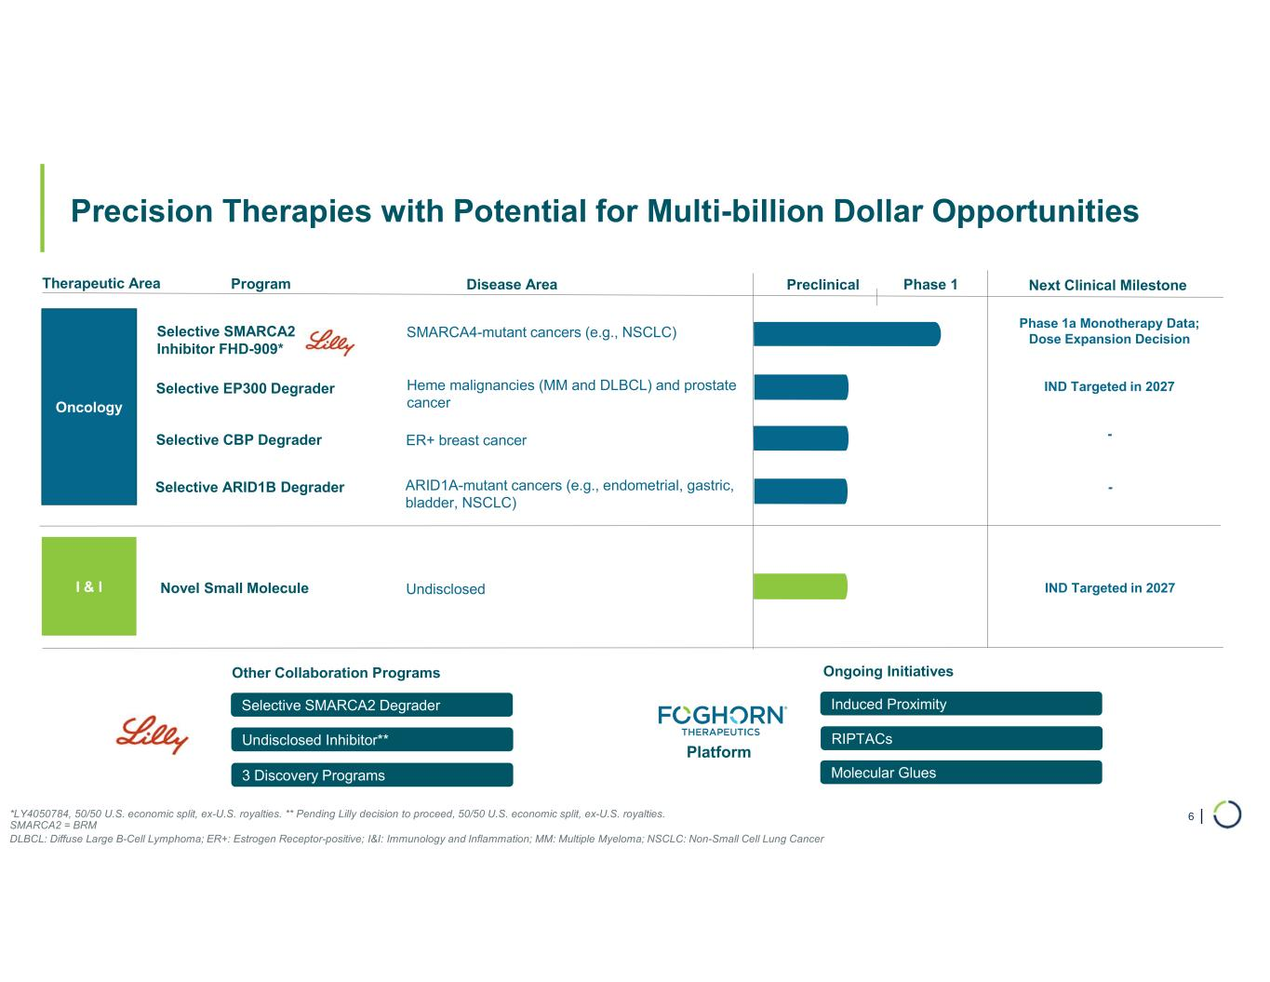
| 3 Discovery Programs Undisclosed Inhibitor** Selective SMARCA2 Degrader Precision Therapies with Potential for Multi-billion Dollar Opportunities 6 Therapeutic Area Program Phase 1 Oncology Selective SMARCA2 Inhibitor FHD-909* Disease Area SMARCA4-mutant cancers (e.g., NSCLC) Other Collaboration Programs Selective ARID1B Degrader ARID1A-mutant cancers (e.g., endometrial, gastric, bladder, NSCLC) Selective CBP Degrader ER+ breast cancer Selective EP300 Degrader Heme malignancies (MM and DLBCL) and prostate cancer Preclinical Next Clinical Milestone *LY4050784, 50/50 U.S. economic split, ex-U.S. royalties. ** Pending Lilly decision to proceed, 50/50 U.S. economic split, ex-U.S. royalties. SMARCA2 = BRM DLBCL: Diffuse Large B-Cell Lymphoma; ER+: Estrogen Receptor-positive; I&I: Immunology and Inflammation; MM: Multiple Myeloma; NSCLC: Non-Small Cell Lung Cancer Phase 1a Monotherapy Data; Dose Expansion Decision IND Targeted in 2027 - I & I Novel Small Molecule Undisclosed IND Targeted in 2027 - RIPTACs Induced Proximity Ongoing Initiatives Platform Molecular Glues

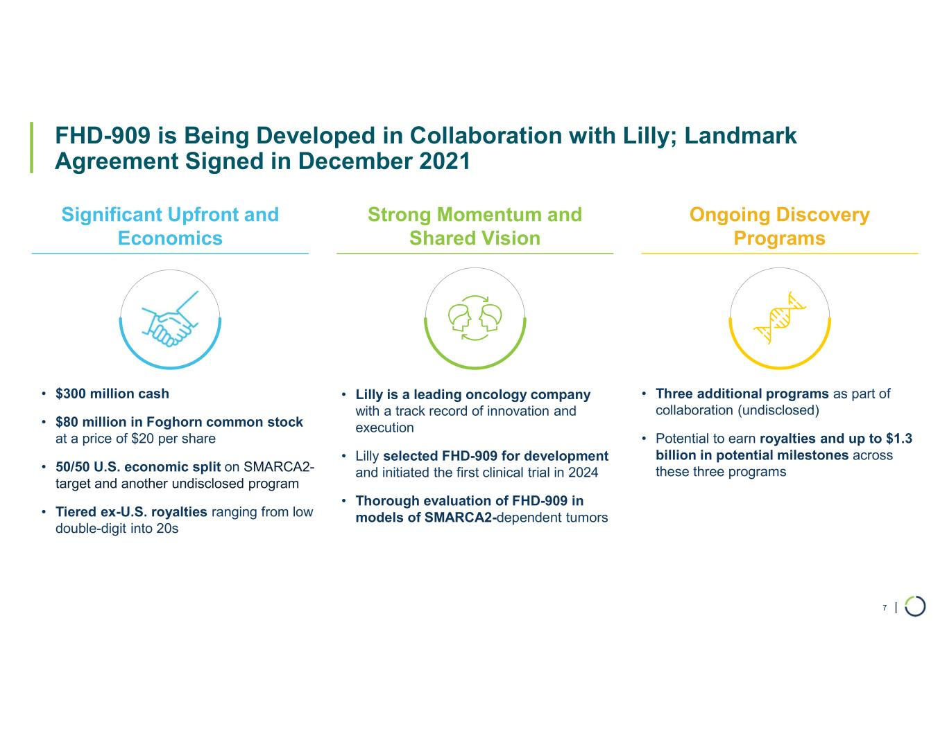
| FHD-909 is Being Developed in Collaboration with Lilly; Landmark Agreement Signed in December 2021 Significant Upfront and Economics Strong Momentum and Shared Vision Ongoing Discovery Programs • $300 million cash • $80 million in Foghorn common stock at a price of $20 per share • 50/50 U.S. economic split on SMARCA2- target and another undisclosed program • Tiered ex-U.S. royalties ranging from low double-digit into 20s • Lilly is a leading oncology company with a track record of innovation and execution • Lilly selected FHD-909 for development and initiated the first clinical trial in 2024 • Thorough evaluation of FHD-909 in models of SMARCA2-dependent tumors • Three additional programs as part of collaboration (undisclosed) • Potential to earn royalties and up to $1.3 billion in potential milestones across these three programs 7

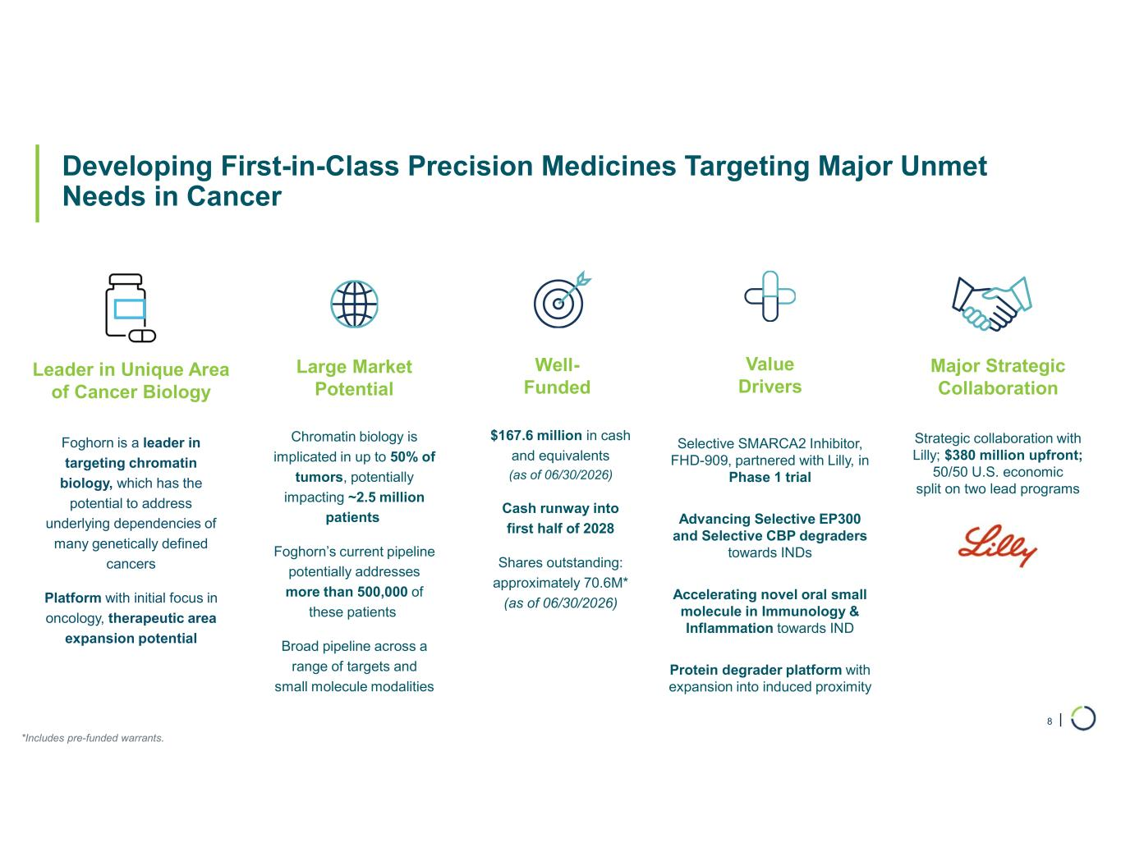
| Developing First-in-Class Precision Medicines Targeting Major Unmet Needs in Cancer 8 Large Market Potential Chromatin biology is implicated in up to 50% of tumors, potentially impacting ~2.5 million patients Foghorn’s current pipeline potentially addresses more than 500,000 of these patients Broad pipeline across a range of targets and small molecule modalities Major Strategic Collaboration Strategic collaboration with Lilly; $380 million upfront; 50/50 U.S. economic split on two lead programs Well- Funded $167.6 million in cash and equivalents (as of 06/30/2026) Cash runway into first half of 2028 Shares outstanding: approximately 70.6M* (as of 06/30/2026) Value Drivers Selective SMARCA2 Inhibitor, FHD-909, partnered with Lilly, in Phase 1 trial Advancing Selective EP300 and Selective CBP degraders towards INDs Accelerating novel oral small molecule in Immunology & Inflammation towards IND Protein degrader platform with expansion into induced proximity Leader in Unique Area of Cancer Biology Foghorn is a leader in targeting chromatin biology, which has the potential to address underlying dependencies of many genetically defined cancers Platform with initial focus in oncology, therapeutic area expansion potential *Includes pre-funded warrants.

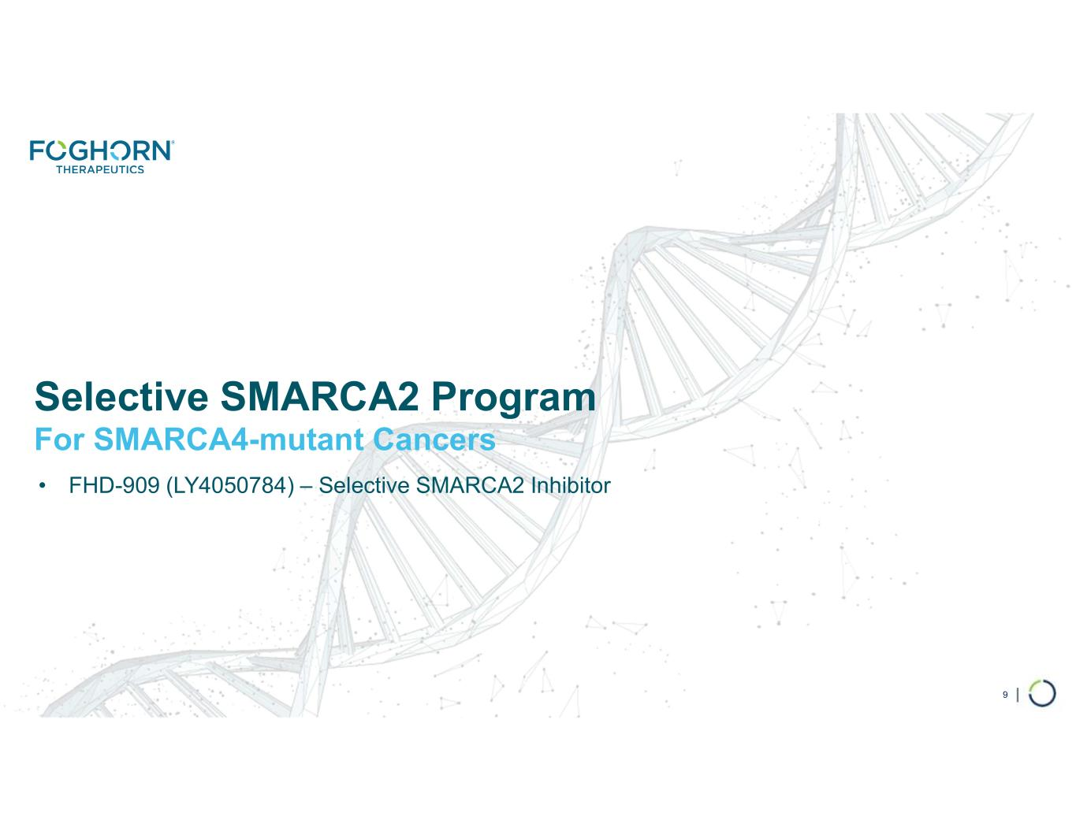
Selective SMARCA2 Program For SMARCA4-mutant Cancers • FHD-909 (LY4050784) – Selective SMARCA2 Inhibitor 9

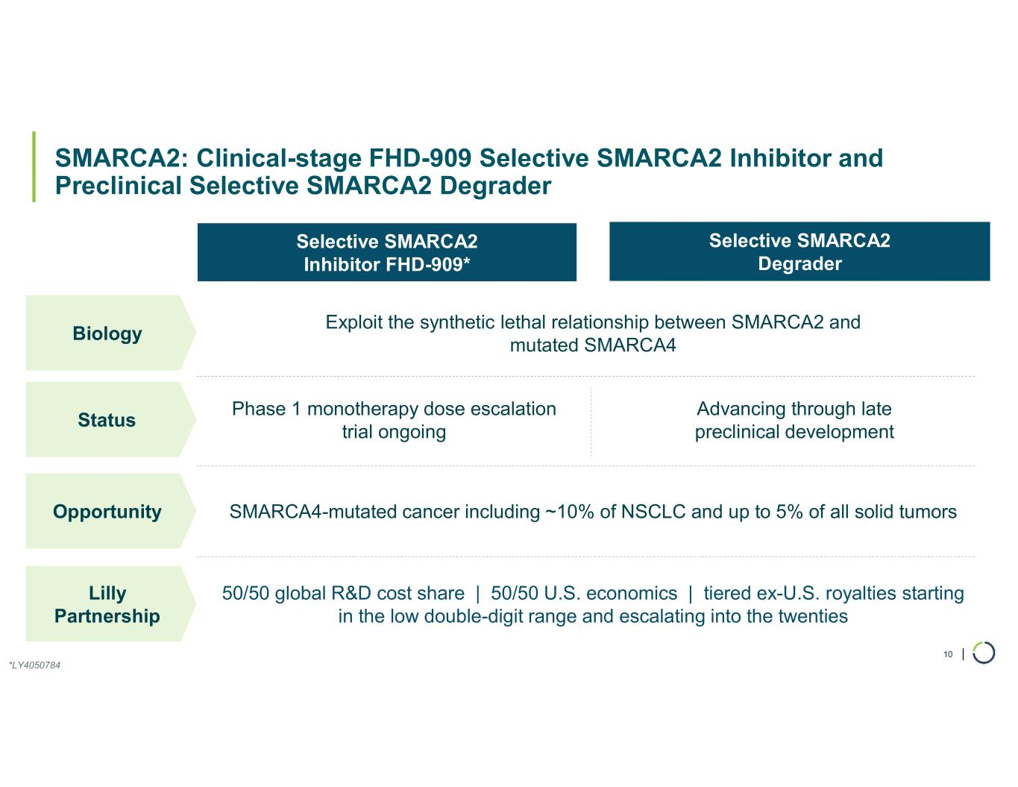
| SMARCA2: Clinical-stage FHD-909 Selective SMARCA2 Inhibitor and Preclinical Selective SMARCA2 Degrader 10 Selective SMARCA2 Inhibitor FHD-909* Selective SMARCA2 Degrader Biology Exploit the synthetic lethal relationship between SMARCA2 and mutated SMARCA4 Status Phase 1 monotherapy dose escalation trial ongoing Advancing through late preclinical development Opportunity SMARCA4-mutated cancer including ~10% of NSCLC and up to 5% of all solid tumors Lilly Partnership 50/50 global R&D cost share | 50/50 U.S. economics | tiered ex-U.S. royalties starting in the low double-digit range and escalating into the twenties *LY4050784

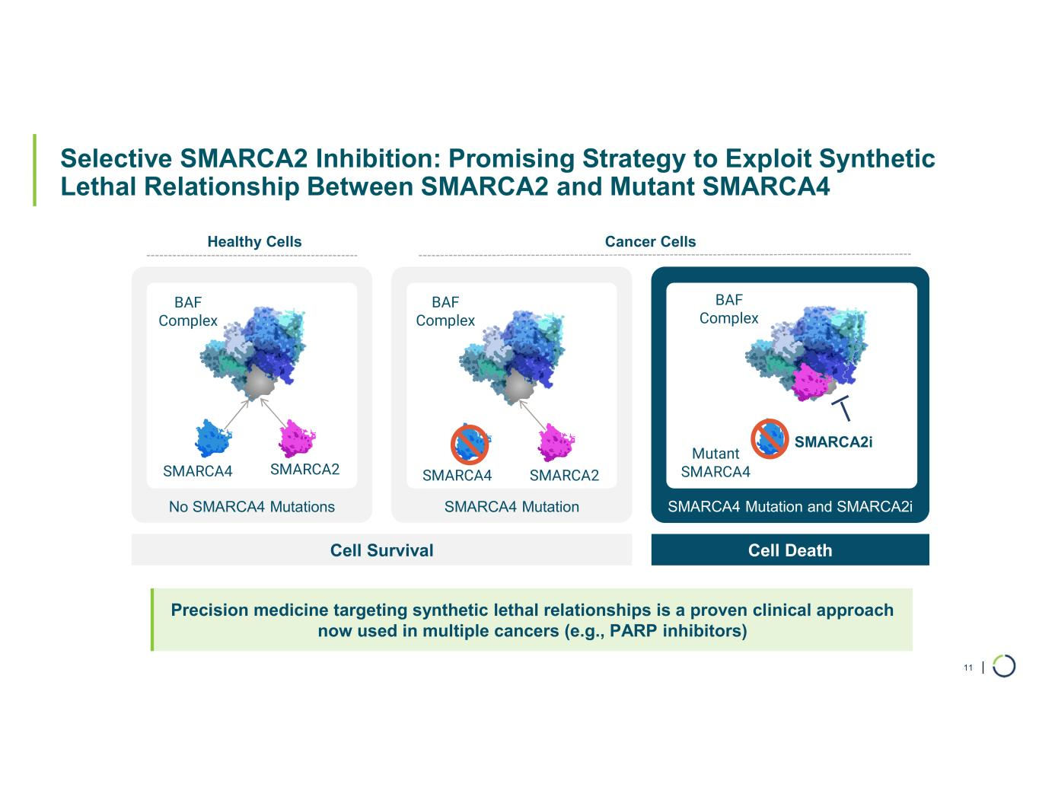
| Selective SMARCA2 Inhibition: Promising Strategy to Exploit Synthetic Lethal Relationship Between SMARCA2 and Mutant SMARCA4 11 No SMARCA4 Mutations SMARCA4 Mutation SMARCA4 Mutation and SMARCA2i Cell Survival Cell Death Healthy Cells Cancer Cells SMARCA4 SMARCA2 BAF Complex BAF Complex Mutant SMARCA4 BAF Complex SMARCA2i Precision medicine targeting synthetic lethal relationships is a proven clinical approach now used in multiple cancers (e.g., PARP inhibitors) SMARCA4 SMARCA2

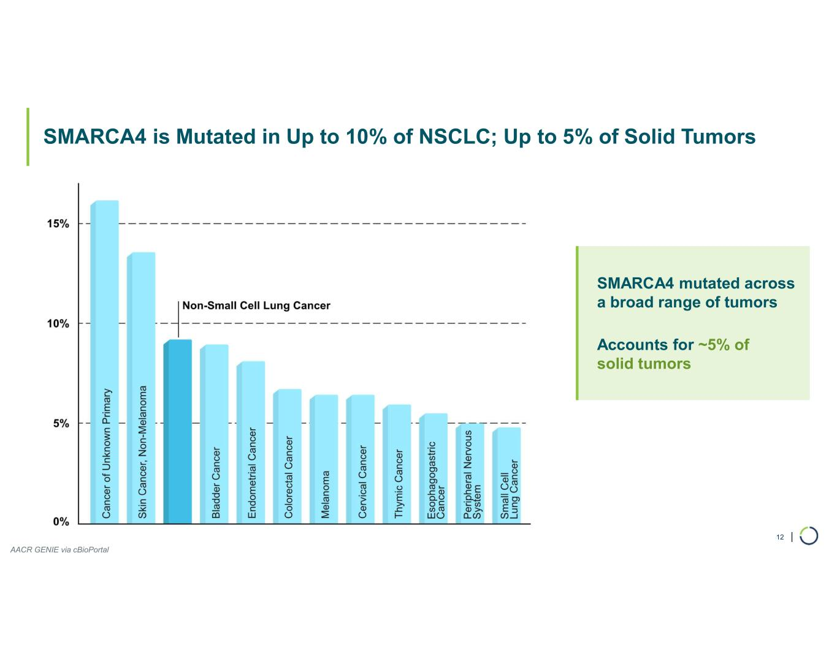
| SMARCA4 is Mutated in Up to 10% of NSCLC; Up to 5% of Solid Tumors 12 SMARCA4 mutated across a broad range of tumors Accounts for ~5% of solid tumors AACR GENIE via cBioPortal

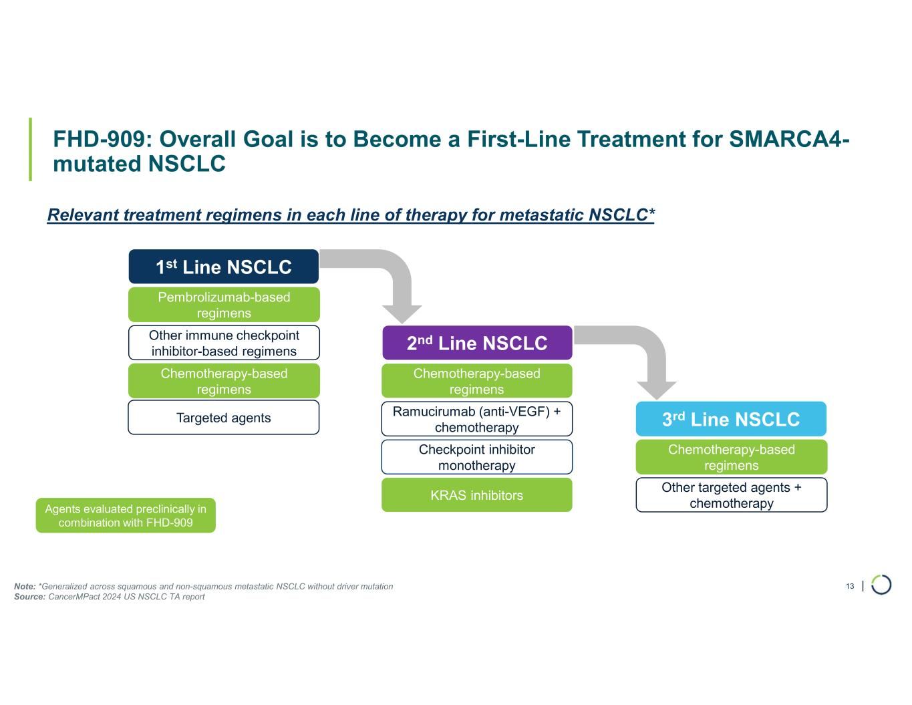
| FHD-909: Overall Goal is to Become a First-Line Treatment for SMARCA4- mutated NSCLC 13 1st Line NSCLC Pembrolizumab-based regimens Other immune checkpoint inhibitor-based regimens Chemotherapy-based regimens 2nd Line NSCLC Chemotherapy-based regimens Ramucirumab (anti-VEGF) + chemotherapy Checkpoint inhibitor monotherapy 3rd Line NSCLC Chemotherapy-based regimens Other targeted agents + chemotherapy Relevant treatment regimens in each line of therapy for metastatic NSCLC* Agents evaluated preclinically in combination with FHD-909 KRAS inhibitors Targeted agents Note: *Generalized across squamous and non-squamous metastatic NSCLC without driver mutation Source: CancerMPact 2024 US NSCLC TA report

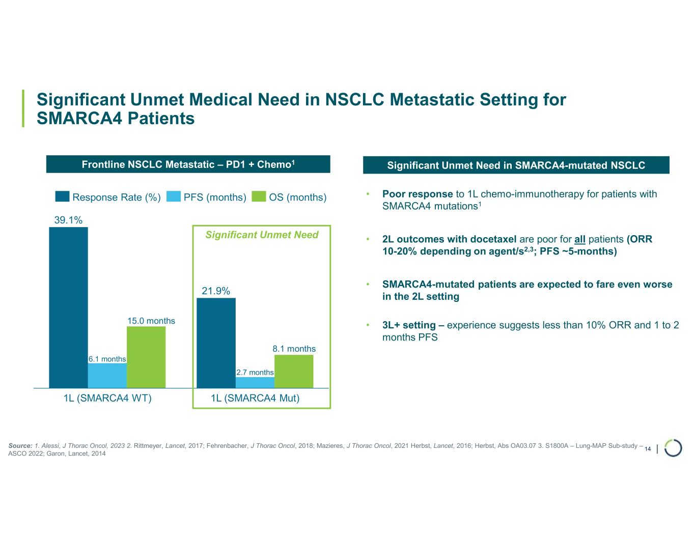
| 14 Significant Unmet Medical Need in NSCLC Metastatic Setting for SMARCA4 Patients ~15 months ~8 months 1L (SMARCA4 WT) 1L (SMARCA4 Mut) 39.1% 21.9% 2.7 months Response Rate (%) PFS (months) OS (months) Significant Unmet Need Frontline NSCLC Metastatic – PD1 + Chemo1 Source: 1. Alessi, J Thorac Oncol, 2023 2. Rittmeyer, Lancet, 2017; Fehrenbacher, J Thorac Oncol, 2018; Mazieres, J Thorac Oncol, 2021 Herbst, Lancet, 2016; Herbst, Abs OA03.07 3. S1800A – Lung-MAP Sub-study – ASCO 2022; Garon, Lancet, 2014 • Poor response to 1L chemo-immunotherapy for patients with SMARCA4 mutations1 • 2L outcomes with docetaxel are poor for all patients (ORR 10-20% depending on agent/s2,3; PFS ~5-months) • SMARCA4-mutated patients are expected to fare even worse in the 2L setting • 3L+ setting – experience suggests less than 10% ORR and 1 to 2 months PFS Significant Unmet Need in SMARCA4-mutated NSCLC 8.1 t 6.1 months 15.0 t s

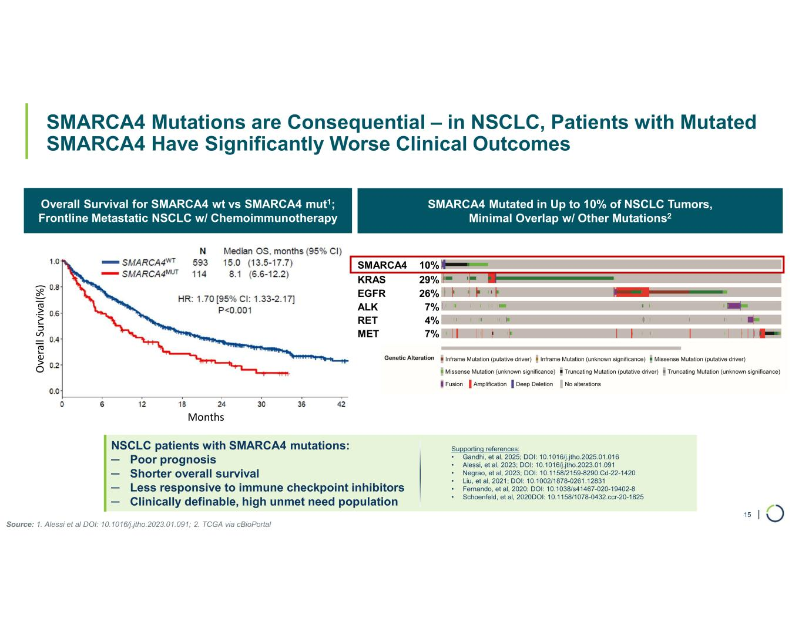
| NSCLC patients with SMARCA4 mutations: ─ Poor prognosis ─ Shorter overall survival ─ Less responsive to immune checkpoint inhibitors ─ Clinically definable, high unmet need population SMARCA4 Mutated in Up to 10% of NSCLC Tumors, Minimal Overlap w/ Other Mutations2 Overall Survival for SMARCA4 wt vs SMARCA4 mut1; Frontline Metastatic NSCLC w/ Chemoimmunotherapy SMARCA4 Mutations are Consequential – in NSCLC, Patients with Mutated SMARCA4 Have Significantly Worse Clinical Outcomes 15 SMARCA4 10% KRAS 29% EGFR 26% ALK 7% RET 4% MET 7% Source: 1. Alessi et al DOI: 10.1016/j.jtho.2023.01.091; 2. TCGA via cBioPortal O ve ra ll Su rv iv al (% ) Months Supporting references: • Gandhi, et al, 2025; DOI: 10.1016/j.jtho.2025.01.016 • Alessi, et al, 2023; DOI: 10.1016/j.jtho.2023.01.091 • Negrao, et al, 2023; DOI: 10.1158/2159-8290.Cd-22-1420 • Liu, et al, 2021; DOI: 10.1002/1878-0261.12831 • Fernando, et al, 2020; DOI: 10.1038/s41467-020-19402-8 • Schoenfeld, et al, 2020DOI: 10.1158/1078-0432.ccr-20-1825

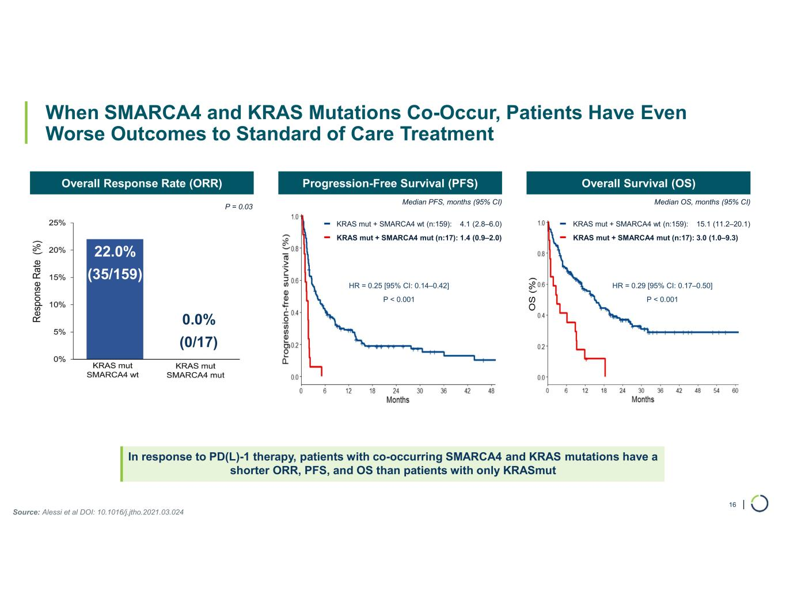
| When SMARCA4 and KRAS Mutations Co-Occur, Patients Have Even Worse Outcomes to Standard of Care Treatment In response to PD(L)-1 therapy, patients with co-occurring SMARCA4 and KRAS mutations have a shorter ORR, PFS, and OS than patients with only KRASmut 16 Overall Response Rate (ORR) Source: Alessi et al DOI: 10.1016/j.jtho.2021.03.024 Progression-Free Survival (PFS) Overall Survival (OS) Median PFS, months (95% CI) Median OS, months (95% CI) KRAS mut + SMARCA4 wt (n:159): 15.1 (11.2–20.1) KRAS mut + SMARCA4 mut (n:17): 3.0 (1.0–9.3) HR = 0.25 [95% CI: 0.14–0.42] P < 0.001 HR = 0.29 [95% CI: 0.17–0.50] P < 0.001 0.0% (0/17) KRAS mut + SMARCA4 wt (n:159): 4.1 (2.8–6.0) KRAS mut + SMARCA4 mut (n:17): 1.4 (0.9–2.0) P = 0.03 22.0% (35/159)

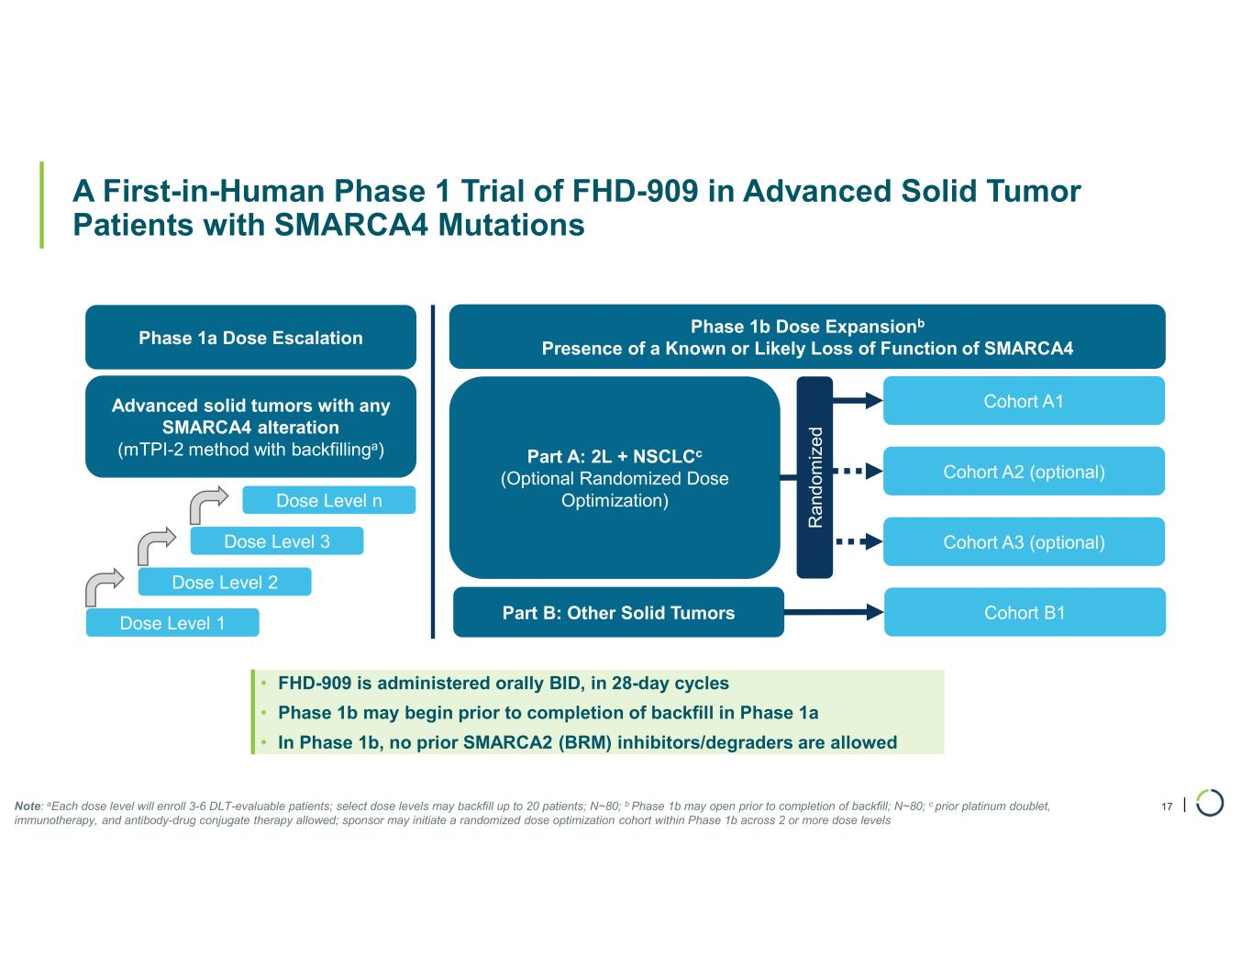
| A First-in-Human Phase 1 Trial of FHD-909 in Advanced Solid Tumor Patients with SMARCA4 Mutations Phase 1a Dose Escalation Advanced solid tumors with any SMARCA4 alteration (mTPI-2 method with backfillinga) Dose Level 1 Dose Level 2 Dose Level 3 Dose Level n Phase 1b Dose Expansionb Presence of a Known or Likely Loss of Function of SMARCA4 Part A: 2L + NSCLCc (Optional Randomized Dose Optimization) Part B: Other Solid Tumors Cohort A1 Cohort A2 (optional) Cohort A3 (optional) R an d om iz ed Cohort B1 • FHD-909 is administered orally BID, in 28-day cycles • Phase 1b may begin prior to completion of backfill in Phase 1a • In Phase 1b, no prior SMARCA2 (BRM) inhibitors/degraders are allowed Note: aEach dose level will enroll 3-6 DLT-evaluable patients; select dose levels may backfill up to 20 patients; N~80; b Phase 1b may open prior to completion of backfill; N~80; c prior platinum doublet, immunotherapy, and antibody-drug conjugate therapy allowed; sponsor may initiate a randomized dose optimization cohort within Phase 1b across 2 or more dose levels 17

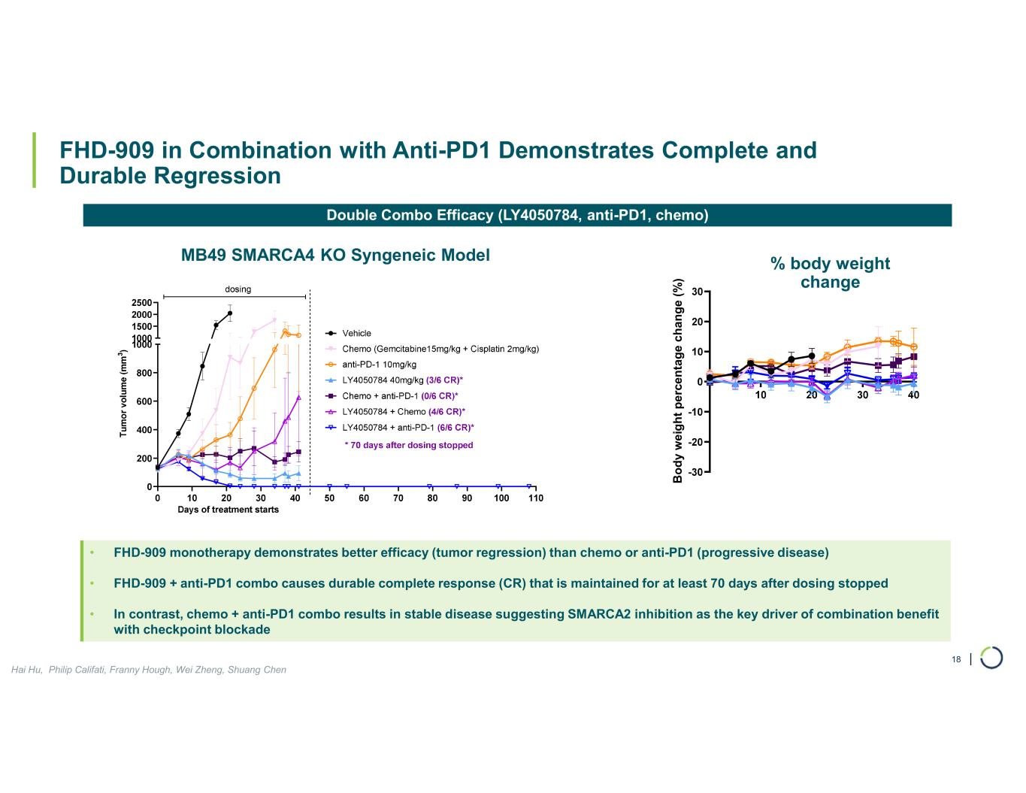
| FHD-909 in Combination with Anti-PD1 Demonstrates Complete and Durable Regression 18 Double Combo Efficacy (LY4050784, anti-PD1, chemo) B o d y w e ig h t p e rc en ta g e c h a n g e (% ) • FHD-909 monotherapy demonstrates better efficacy (tumor regression) than chemo or anti-PD1 (progressive disease) • FHD-909 + anti-PD1 combo causes durable complete response (CR) that is maintained for at least 70 days after dosing stopped • In contrast, chemo + anti-PD1 combo results in stable disease suggesting SMARCA2 inhibition as the key driver of combination benefit with checkpoint blockade % body weight change Hai Hu, Philip Califati, Franny Hough, Wei Zheng, Shuang Chen MB49 SMARCA4 KO Syngeneic Model

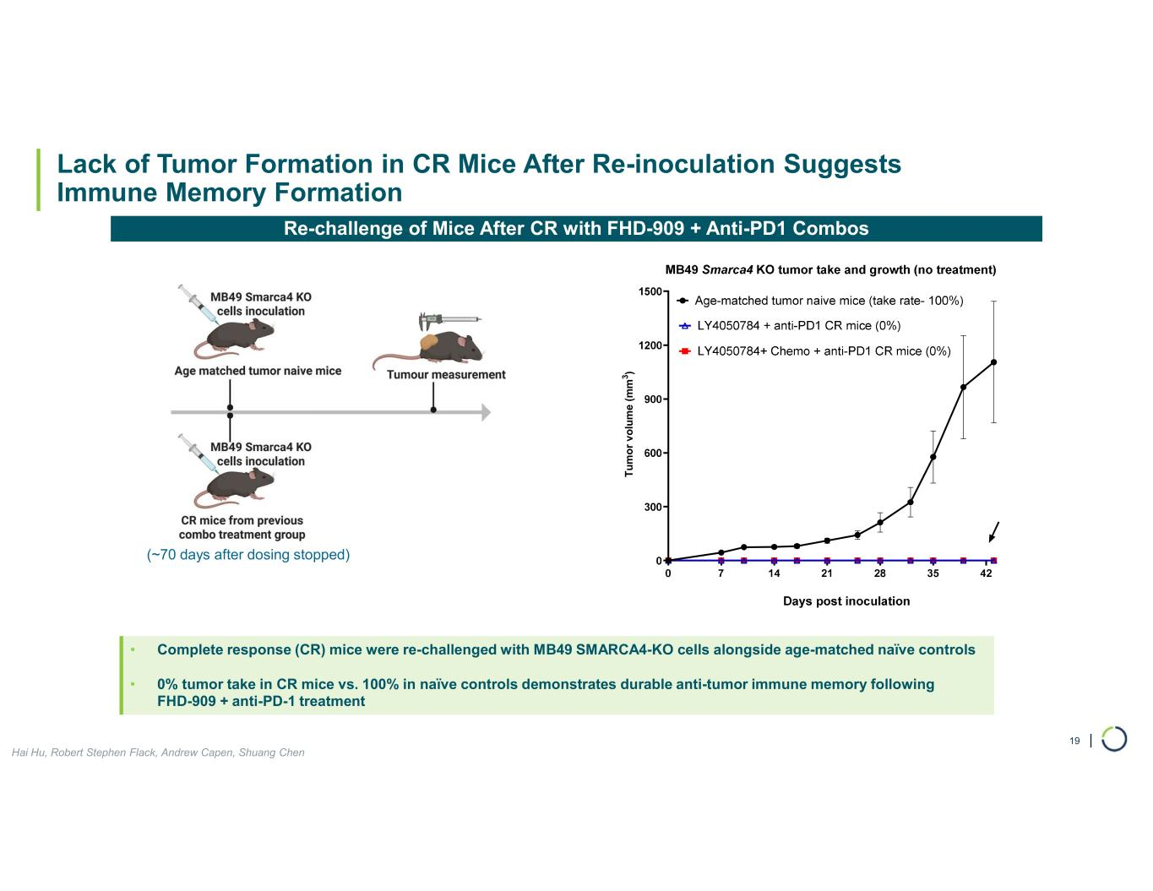
| Lack of Tumor Formation in CR Mice After Re-inoculation Suggests Immune Memory Formation 19 Re-challenge of Mice After CR with FHD-909 + Anti-PD1 Combos • Complete response (CR) mice were re-challenged with MB49 SMARCA4-KO cells alongside age-matched naïve controls • 0% tumor take in CR mice vs. 100% in naïve controls demonstrates durable anti-tumor immune memory following FHD-909 + anti-PD-1 treatment T u m o r v o lu m e ( m m 3 ) Hai Hu, Robert Stephen Flack, Andrew Capen, Shuang Chen (~70 days after dosing stopped)

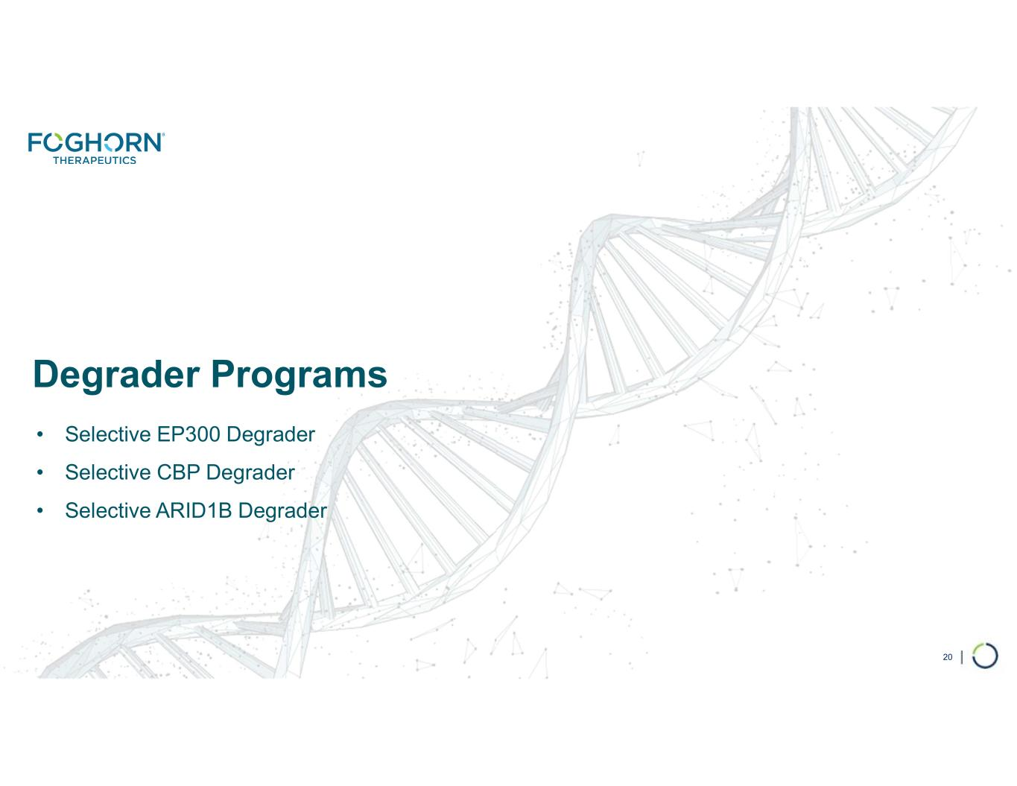
Degrader Programs • Selective EP300 Degrader • Selective CBP Degrader • Selective ARID1B Degrader 20

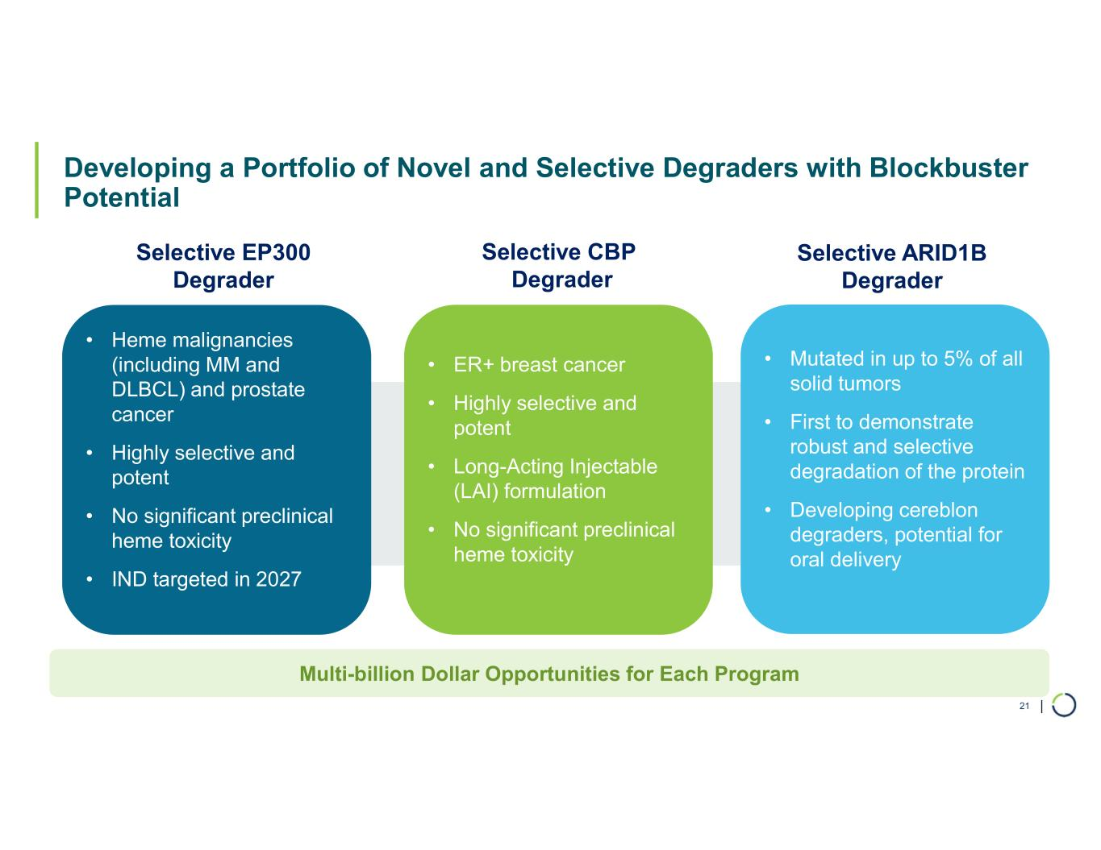
| Multi-billion Dollar Opportunities for Each Program Developing a Portfolio of Novel and Selective Degraders with Blockbuster Potential 21 Selective ARID1B Degrader Selective CBP Degrader • Mutated in up to 5% of all solid tumors • First to demonstrate robust and selective degradation of the protein • Developing cereblon degraders, potential for oral delivery • ER+ breast cancer • Highly selective and potent • Long-Acting Injectable (LAI) formulation • No significant preclinical heme toxicity • Heme malignancies (including MM and DLBCL) and prostate cancer • Highly selective and potent • No significant preclinical heme toxicity • IND targeted in 2027 Selective EP300 Degrader

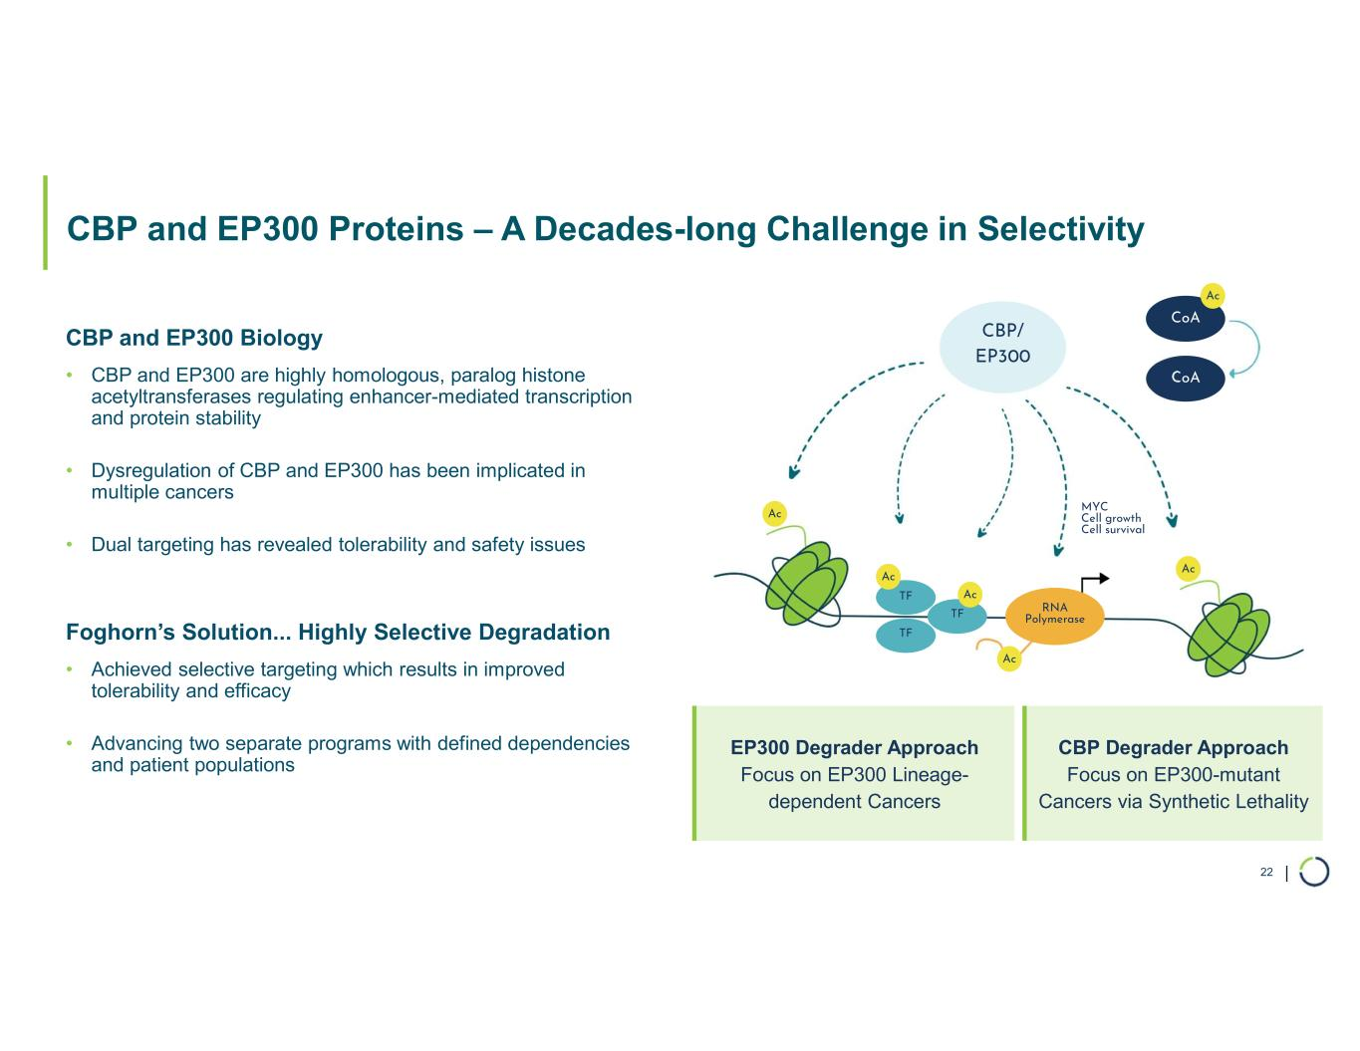
| CBP and EP300 Proteins – A Decades-long Challenge in Selectivity 22 CBP and EP300 Biology • CBP and EP300 are highly homologous, paralog histone acetyltransferases regulating enhancer-mediated transcription and protein stability • Dysregulation of CBP and EP300 has been implicated in multiple cancers • Dual targeting has revealed tolerability and safety issues Foghorn’s Solution... Highly Selective Degradation • Achieved selective targeting which results in improved tolerability and efficacy • Advancing two separate programs with defined dependencies and patient populations CoA TF TF TF RNA Polymerase Ac Ac CoA Ac Ac Ac CBP/ EP300 MYC Cell growth Cell survival Ac EP300 Degrader Approach Focus on EP300 Lineage- dependent Cancers CBP Degrader Approach Focus on EP300-mutant Cancers via Synthetic Lethality

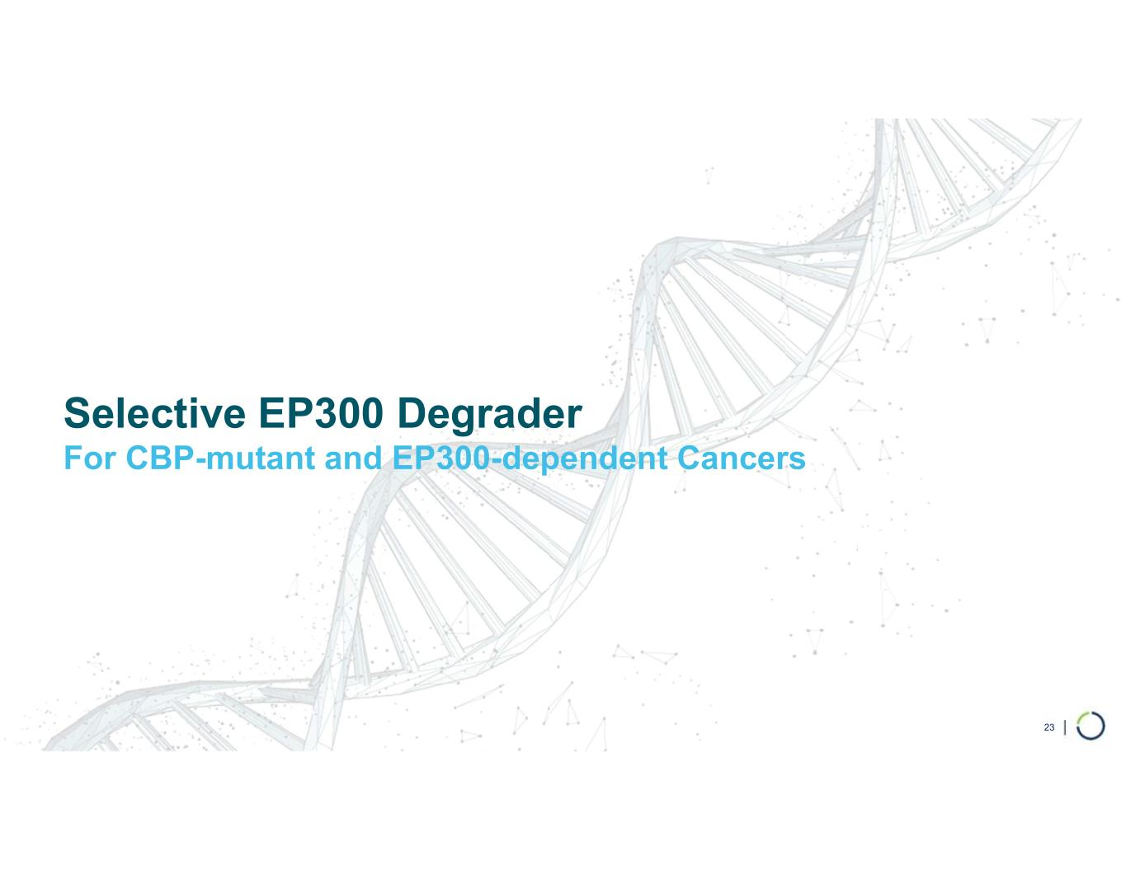
Selective EP300 Degrader For CBP-mutant and EP300-dependent Cancers 23

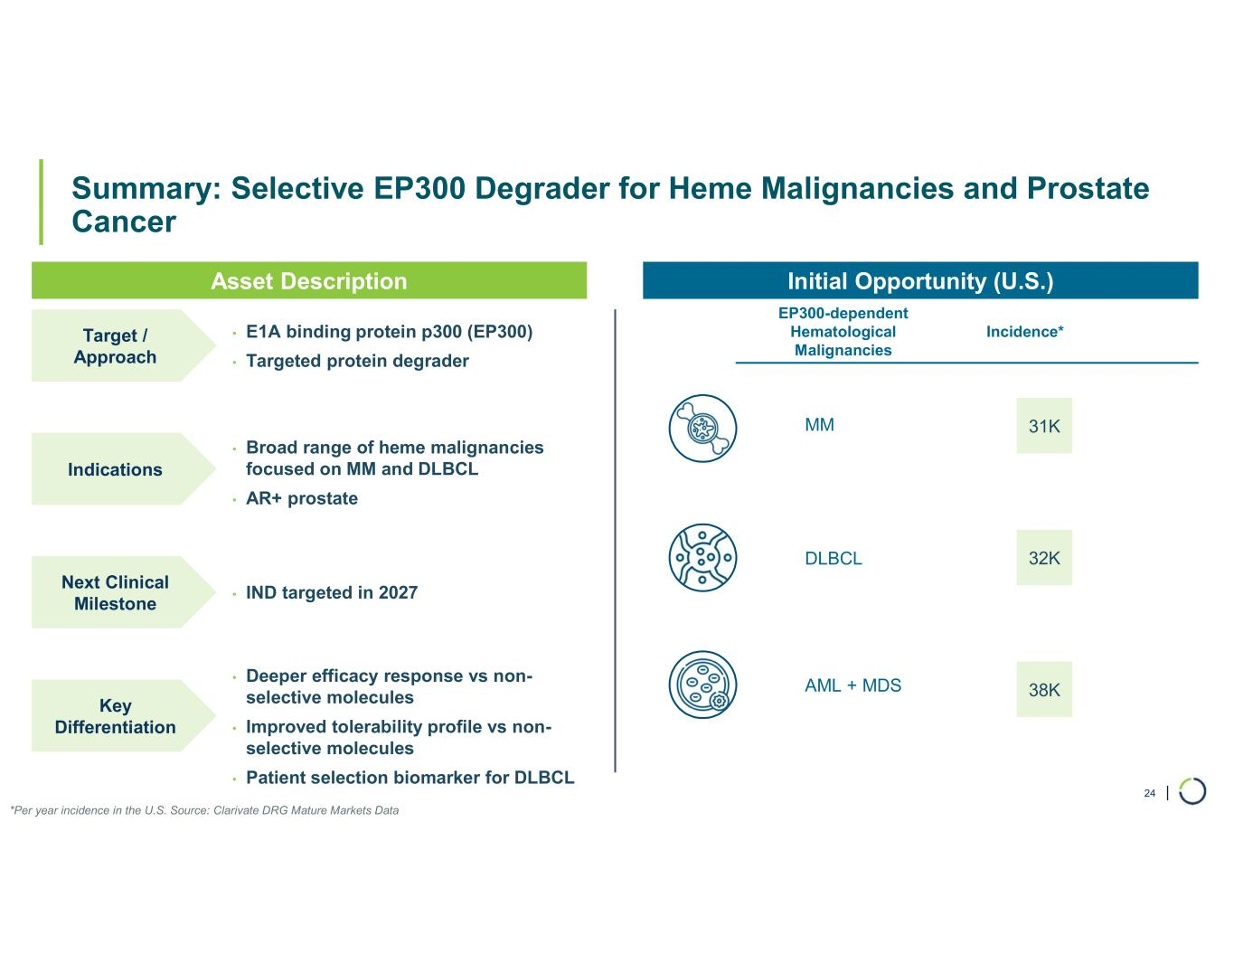
| Summary: Selective EP300 Degrader for Heme Malignancies and Prostate Cancer 24 • E1A binding protein p300 (EP300) • Targeted protein degrader MM AML + MDS DLBCL Target / Approach • IND targeted in 2027 Next Clinical Milestone • Deeper efficacy response vs non- selective molecules • Improved tolerability profile vs non- selective molecules • Patient selection biomarker for DLBCL Asset Description Initial Opportunity (U.S.) Incidence* 31K 32K 38K *Per year incidence in the U.S. Source: Clarivate DRG Mature Markets Data EP300-dependent Hematological Malignancies Key Differentiation • Broad range of heme malignancies focused on MM and DLBCL • AR+ prostate Indications

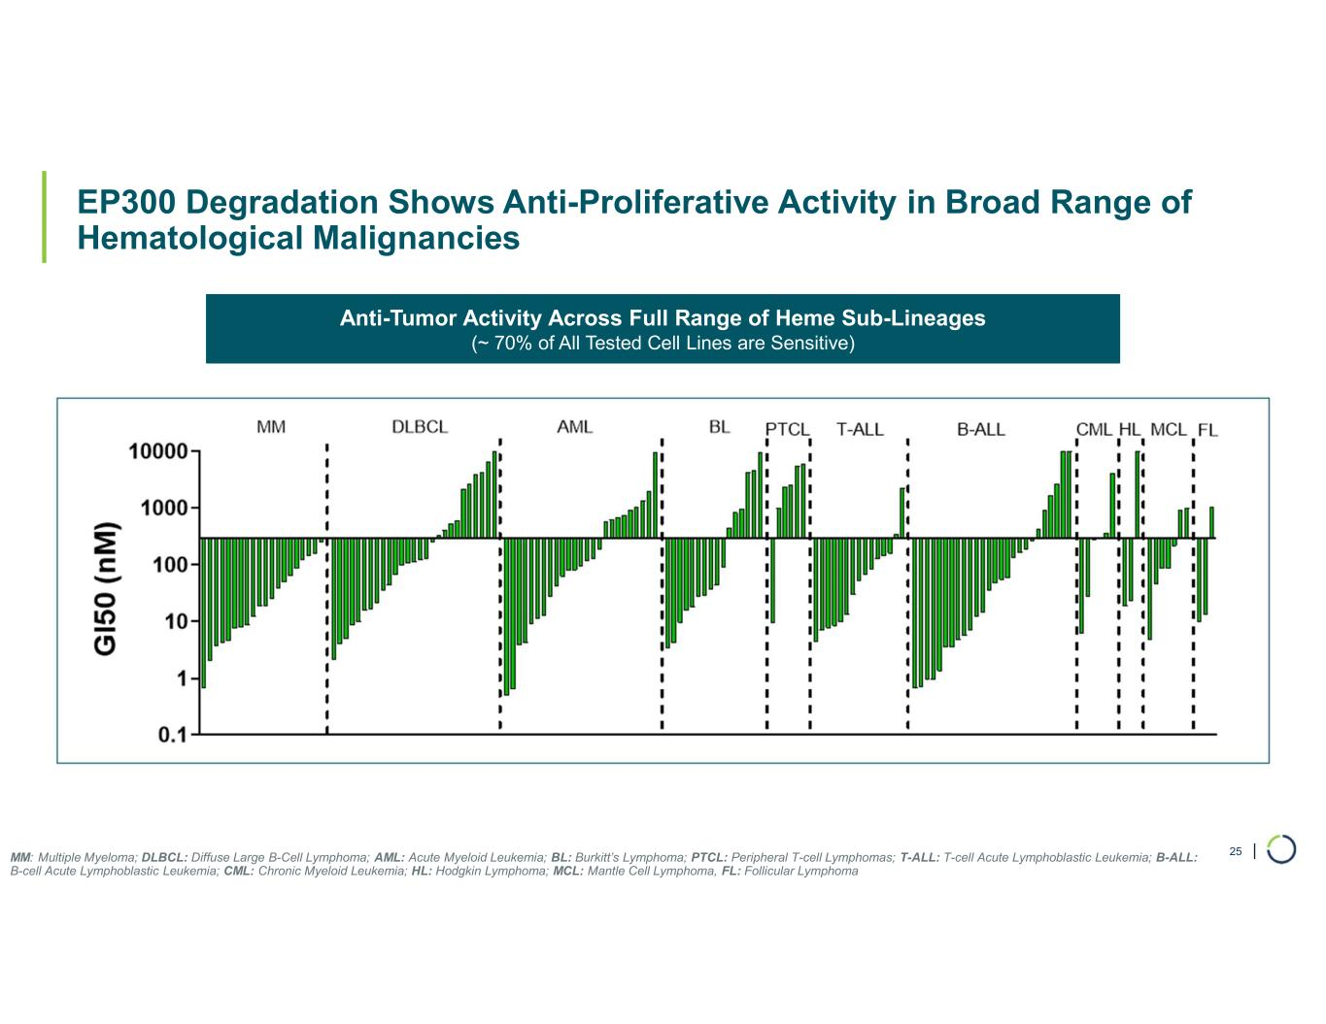
| EP300 Degradation Shows Anti-Proliferative Activity in Broad Range of Hematological Malignancies 25MM: Multiple Myeloma; DLBCL: Diffuse Large B-Cell Lymphoma; AML: Acute Myeloid Leukemia; BL: Burkitt’s Lymphoma; PTCL: Peripheral T-cell Lymphomas; T-ALL: T-cell Acute Lymphoblastic Leukemia; B-ALL: B-cell Acute Lymphoblastic Leukemia; CML: Chronic Myeloid Leukemia; HL: Hodgkin Lymphoma; MCL: Mantle Cell Lymphoma, FL: Follicular Lymphoma Anti-Tumor Activity Across Full Range of Heme Sub-Lineages (~ 70% of All Tested Cell Lines are Sensitive)

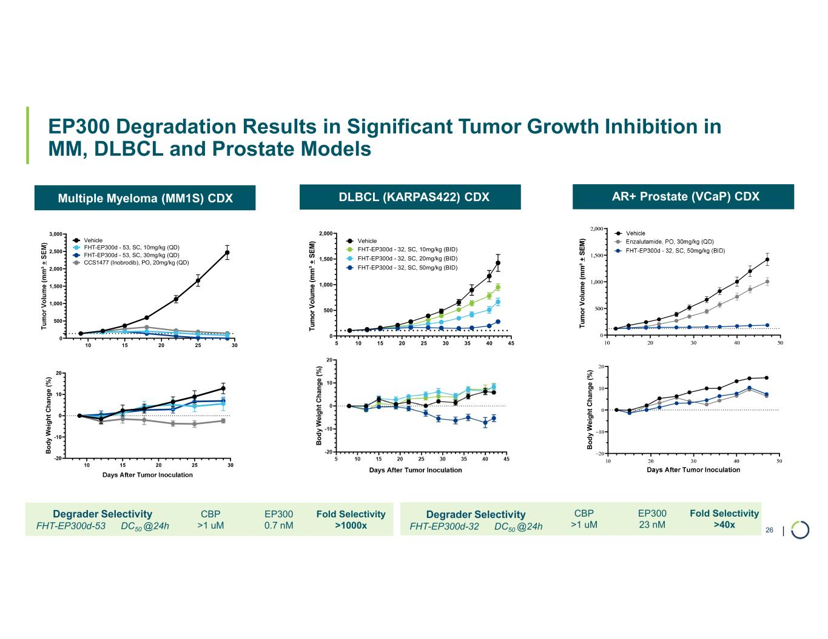
| Multiple Myeloma (MM1S) CDX DLBCL (KARPAS422) CDX AR+ Prostate (VCaP) CDX EP300 Degradation Results in Significant Tumor Growth Inhibition in MM, DLBCL and Prostate Models 26 B o d y W ei g h t C h an g e ( % ) 5 10 15 20 25 30 35 40 45 0 500 1,000 1,500 2,000 Vehicle FHT-EP300d - 32, SC, 50mg/kg (BID) Days After Tumor Inoculation FHT-EP300d - 32, SC, 20mg/kg (BID) FHT-EP300d - 32, SC, 10mg/kg (BID) B o d y W e ig h t C h an g e ( % ) 10 15 20 25 30 0 500 1,000 1,500 2,000 2,500 3,000 Days After Tumor Inoculation Vehicle FHT-EP300d - 53, SC, 30mg/kg (QD) FHT-EP300d - 53, SC, 10mg/kg (QD) CCS1477 (Inobrodib), PO, 20mg/kg (QD) Fold Selectivity >1000x EP300 0.7 nM CBP >1 uM Degrader Selectivity FHT-EP300d-53 DC50 @24h Fold Selectivity >40x EP300 23 nM CBP >1 uM Degrader Selectivity FHT-EP300d-32 DC50 @24h

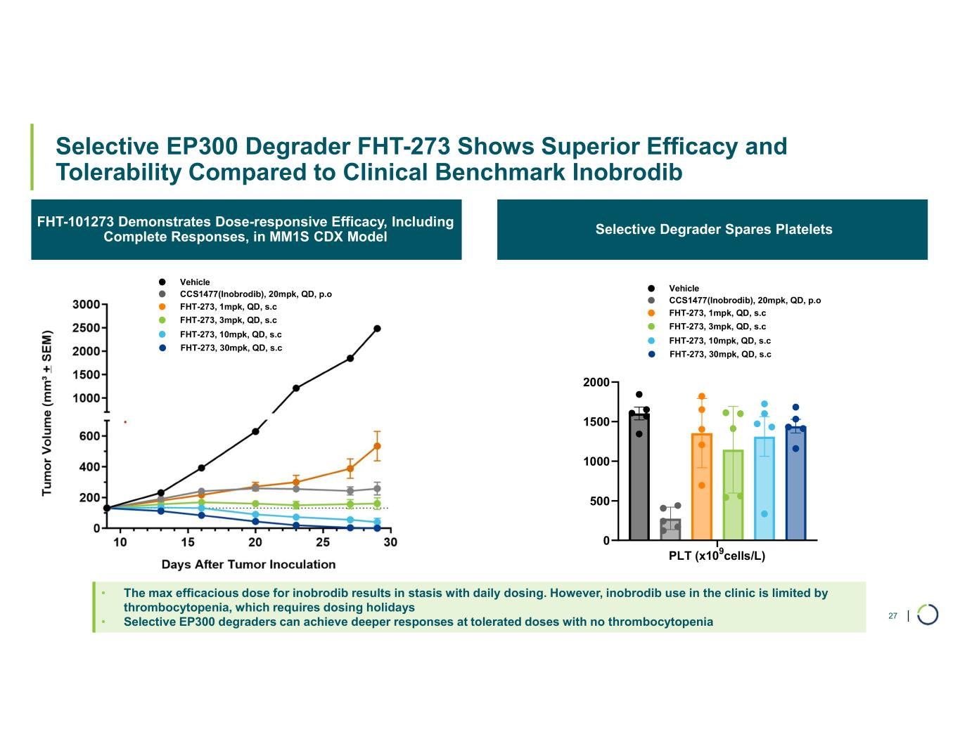
| • The max efficacious dose for inobrodib results in stasis with daily dosing. However, inobrodib use in the clinic is limited by thrombocytopenia, which requires dosing holidays • Selective EP300 degraders can achieve deeper responses at tolerated doses with no thrombocytopenia Selective EP300 Degrader FHT-273 Shows Superior Efficacy and Tolerability Compared to Clinical Benchmark Inobrodib 27 FHT-101273 Demonstrates Dose-responsive Efficacy, Including Complete Responses, in MM1S CDX Model Selective Degrader Spares Platelets PLT (x109cells/L) 0 500 1000 1500 2000 Vehicle FHT-273, 30mpk, QD, s.c FHT-273, 10mpk, QD, s.c FHT-273, 3mpk, QD, s.c FHT-273, 1mpk, QD, s.c CCS1477(Inobrodib), 20mpk, QD, p.o Vehicle FHT-273, 30mpk, QD, s.c FHT-273, 10mpk, QD, s.c FHT-273, 3mpk, QD, s.c FHT-273, 1mpk, QD, s.c CCS1477(Inobrodib), 20mpk, QD, p.o

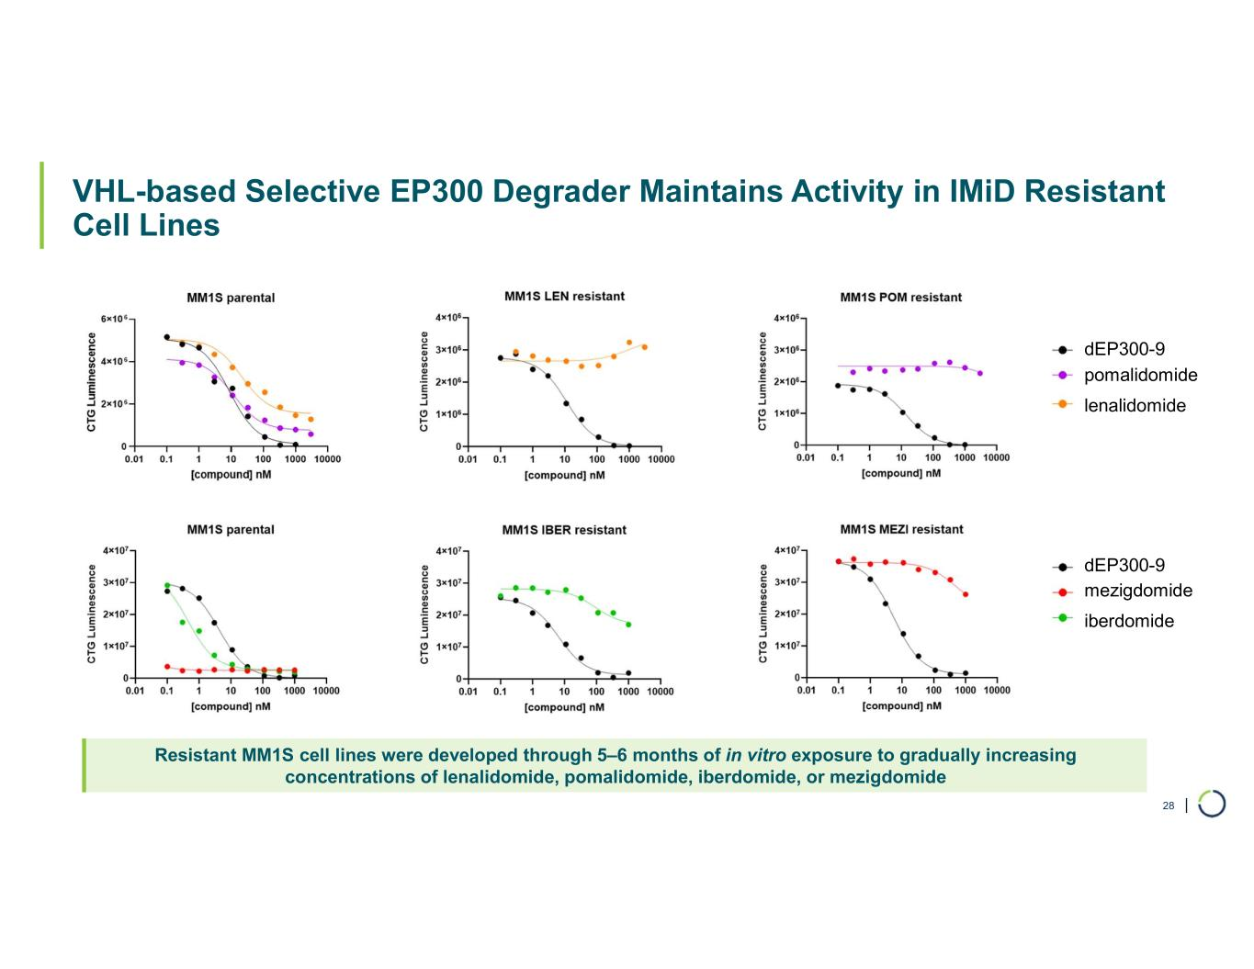
| VHL-based Selective EP300 Degrader Maintains Activity in IMiD Resistant Cell Lines 28 Resistant MM1S cell lines were developed through 5–6 months of in vitro exposure to gradually increasing concentrations of lenalidomide, pomalidomide, iberdomide, or mezigdomide dEP300-9 dEP300-9 pomalidomide lenalidomide mezigdomide iberdomide

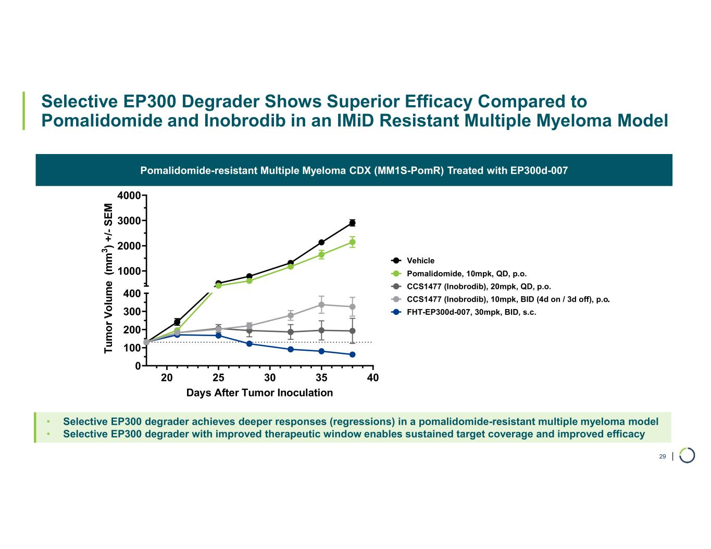
| 20 25 30 35 40 0 100 200 300 400 1000 2000 3000 4000 Days After Tumor Inoculation Vehicle FHT-EP300d-007, 30mpk, BID, s.c. CCS1477 (Inobrodib), 10mpk, BID (4d on / 3d off), p.o CCS1477 (Inobrodib), 20mpk, QD, p.o. Pomalidomide, 10mpk, QD, p.o. Selective EP300 Degrader Shows Superior Efficacy Compared to Pomalidomide and Inobrodib in an IMiD Resistant Multiple Myeloma Model Pomalidomide-resistant Multiple Myeloma CDX (MM1S-PomR) Treated with EP300d-007 29 • Selective EP300 degrader achieves deeper responses (regressions) in a pomalidomide-resistant multiple myeloma model • Selective EP300 degrader with improved therapeutic window enables sustained target coverage and improved efficacy .

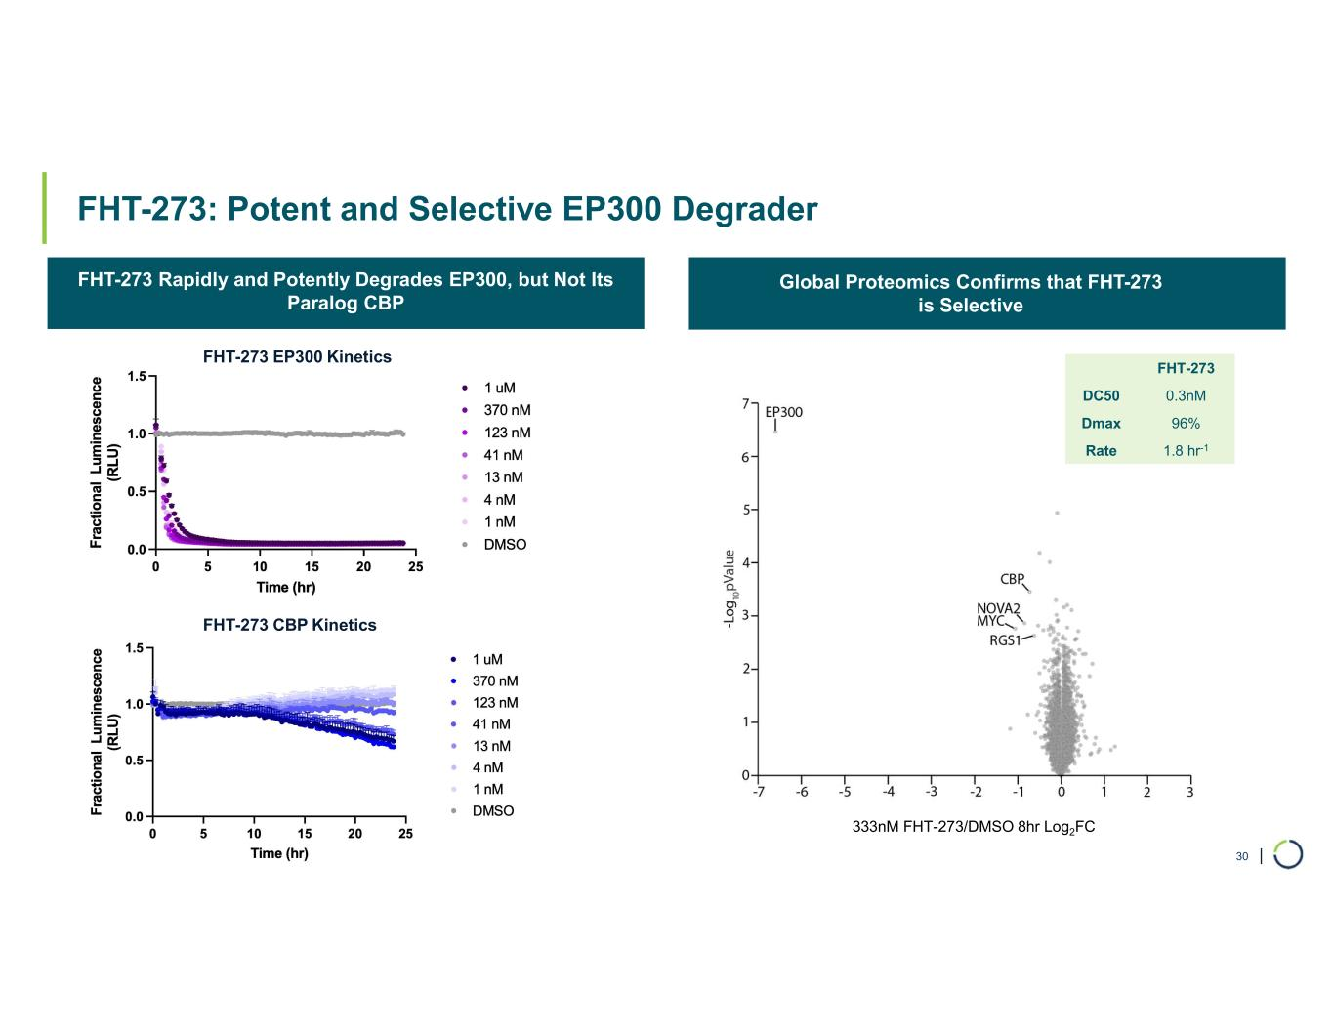
| FHT-273: Potent and Selective EP300 Degrader FHT-273 Rapidly and Potently Degrades EP300, but Not Its Paralog CBP Global Proteomics Confirms that FHT-273 is Selective 30 333nM FHT-273/DMSO 8hr Log2FC FHT-273 0.3nMDC50 96%Dmax 1.8 hr-1Rate FHT-273 EP300 Kinetics FHT-273 CBP Kinetics

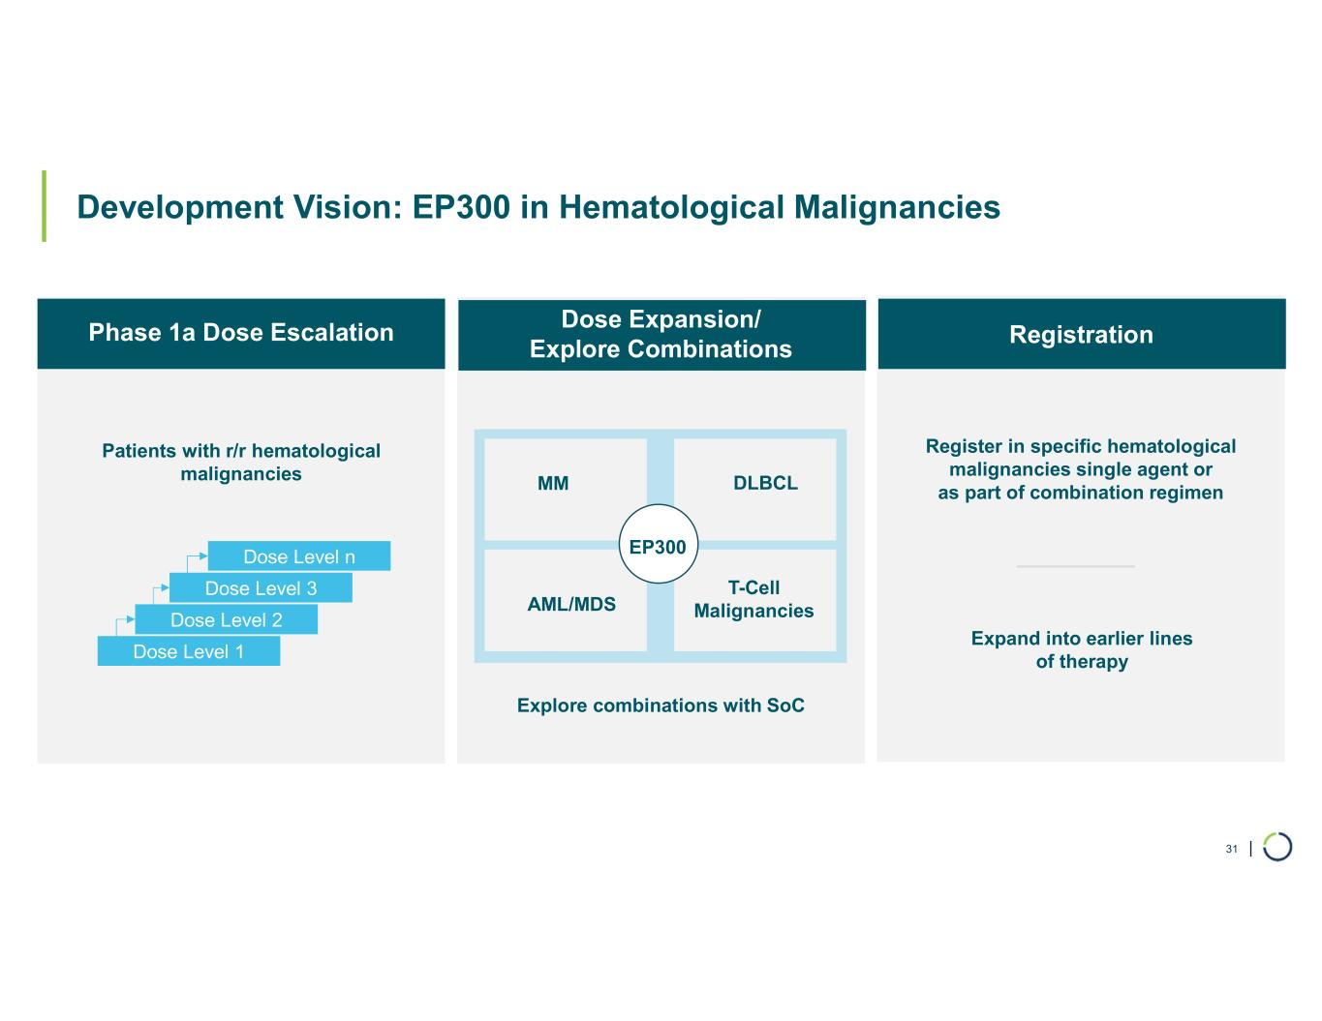
| 31 Development Vision: EP300 in Hematological Malignancies e Patients with r/r hematological malignancies Dose Level 1 Dose Level 2 Dose Level 3 Dose Level n Register in specific hematological malignancies single agent or as part of combination regimen AML/MDS T-Cell Malignancies Expand into earlier lines of therapy MM DLBCL EP300 Explore combinations with SoC Phase 1a Dose Escalation Dose Expansion/ Explore Combinations Registration

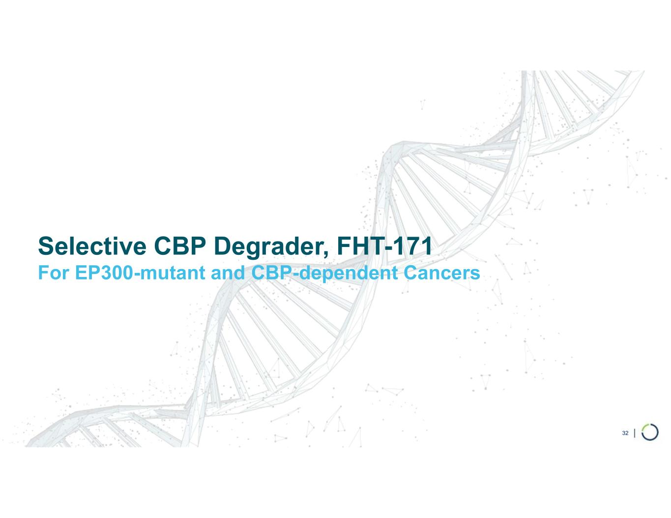
Selective CBP Degrader, FHT-171 For EP300-mutant and CBP-dependent Cancers 32

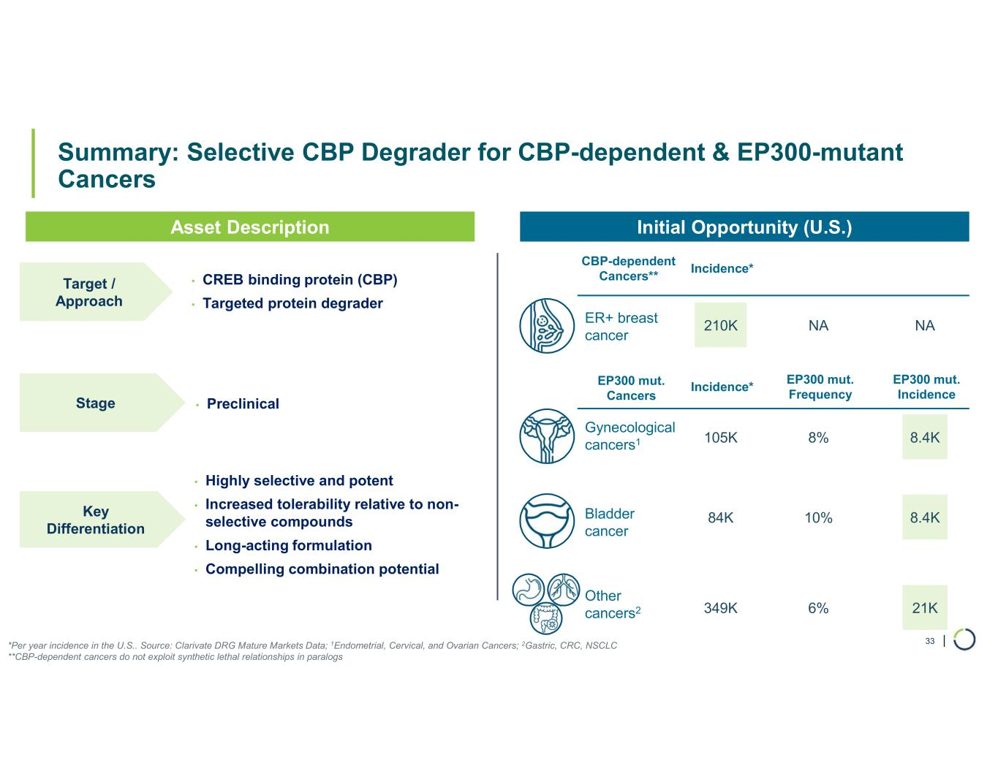
| Summary: Selective CBP Degrader for CBP-dependent & EP300-mutant Cancers 33 • CREB binding protein (CBP) • Targeted protein degrader Gynecological cancers1 Other cancers2 Bladder cancer ER+ breast cancer Target / Approach • Preclinical Stage • Highly selective and potent • Increased tolerability relative to non- selective compounds • Long-acting formulation • Compelling combination potential Asset Description Initial Opportunity (U.S.) Incidence* EP300 mut. Frequency EP300 mut. Incidence 105K 8% 8.4K 84K 10% 8.4K 349K 6% 21K 210K NA NA *Per year incidence in the U.S.. Source: Clarivate DRG Mature Markets Data; 1Endometrial, Cervical, and Ovarian Cancers; 2Gastric, CRC, NSCLC **CBP-dependent cancers do not exploit synthetic lethal relationships in paralogs EP300 mut. Cancers CBP-dependent Cancers** Incidence* Key Differentiation

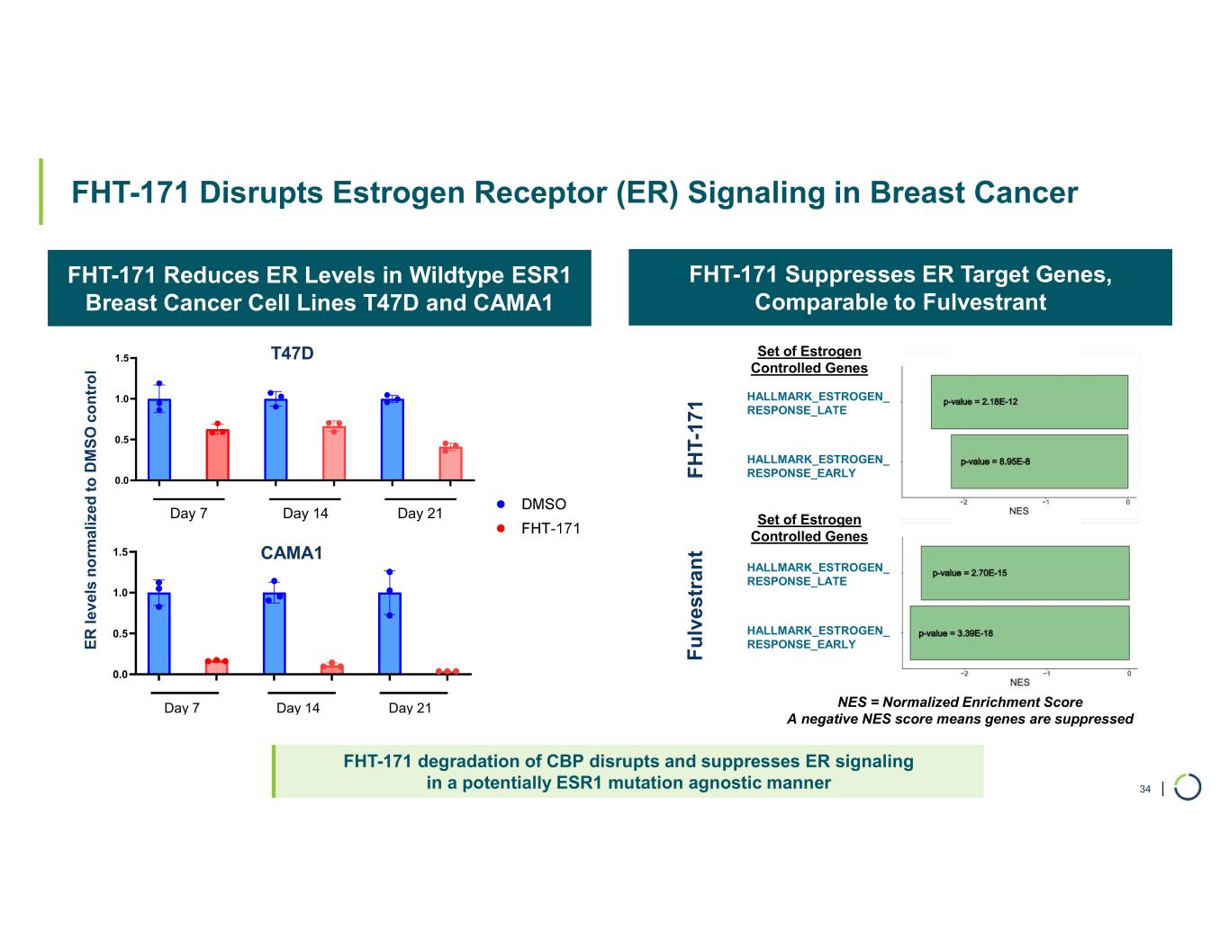
| FHT-171 Reduces ER Levels in Wildtype ESR1 Breast Cancer Cell Lines T47D and CAMA1 FHT-171 degradation of CBP disrupts and suppresses ER signaling in a potentially ESR1 mutation agnostic manner FHT-171 Disrupts Estrogen Receptor (ER) Signaling in Breast Cancer 34 0.0 0.5 1.0 1.5 Day 7 Day 14 Day 21 0.0 0.5 1.0 1.5 Day 7 Day 14 Day 21 E R le v el s n o rm a liz ed t o D M S O c o n tr o l HALLMARK_ESTROGEN_ RESPONSE_LATE HALLMARK_ESTROGEN_ RESPONSE_EARLY HALLMARK_ESTROGEN_ RESPONSE_LATE HALLMARK_ESTROGEN_ RESPONSE_EARLY F H T- 17 1 F u lv es tr a n t FHT-171 Suppresses ER Target Genes, Comparable to Fulvestrant NES = Normalized Enrichment Score A negative NES score means genes are suppressed Set of Estrogen Controlled Genes Set of Estrogen Controlled Genes T47D CAMA1

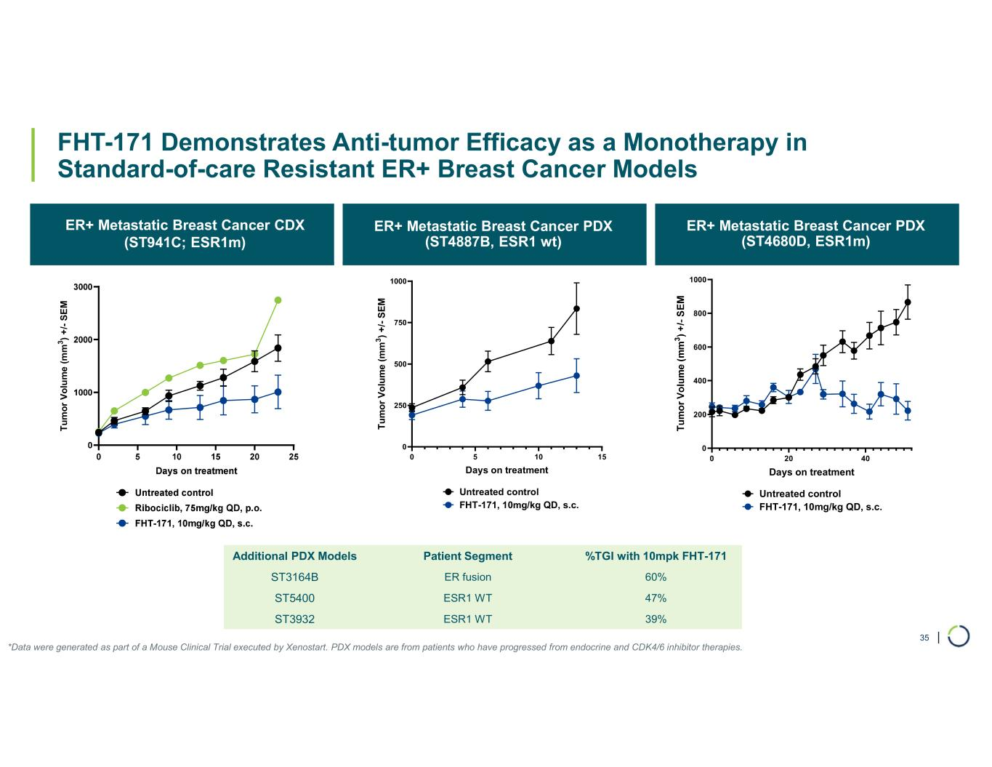
| FHT-171 Demonstrates Anti-tumor Efficacy as a Monotherapy in Standard-of-care Resistant ER+ Breast Cancer Models ER+ Metastatic Breast Cancer CDX (ST941C; ESR1m) ER+ Metastatic Breast Cancer PDX (ST4887B, ESR1 wt) ER+ Metastatic Breast Cancer PDX (ST4680D, ESR1m) 35 T u m o r V o lu m e ( m m 3 ) + /- S E M *Data were generated as part of a Mouse Clinical Trial executed by Xenostart. PDX models are from patients who have progressed from endocrine and CDK4/6 inhibitor therapies. 0 20 40 0 200 400 600 800 1000 Days on treatment Untreated control FHT-171, 10mg/kg QD, s.c. 0 5 10 15 0 250 500 750 1000 Days on treatment T u m o r V o lu m e ( m m 3 ) + /- S E M Untreated control FHT-171, 10mg/kg QD, s.c. %TGI with 10mpk FHT-171Patient SegmentAdditional PDX Models 60%ER fusionST3164B 47%ESR1 WTST5400 39%ESR1 WTST3932

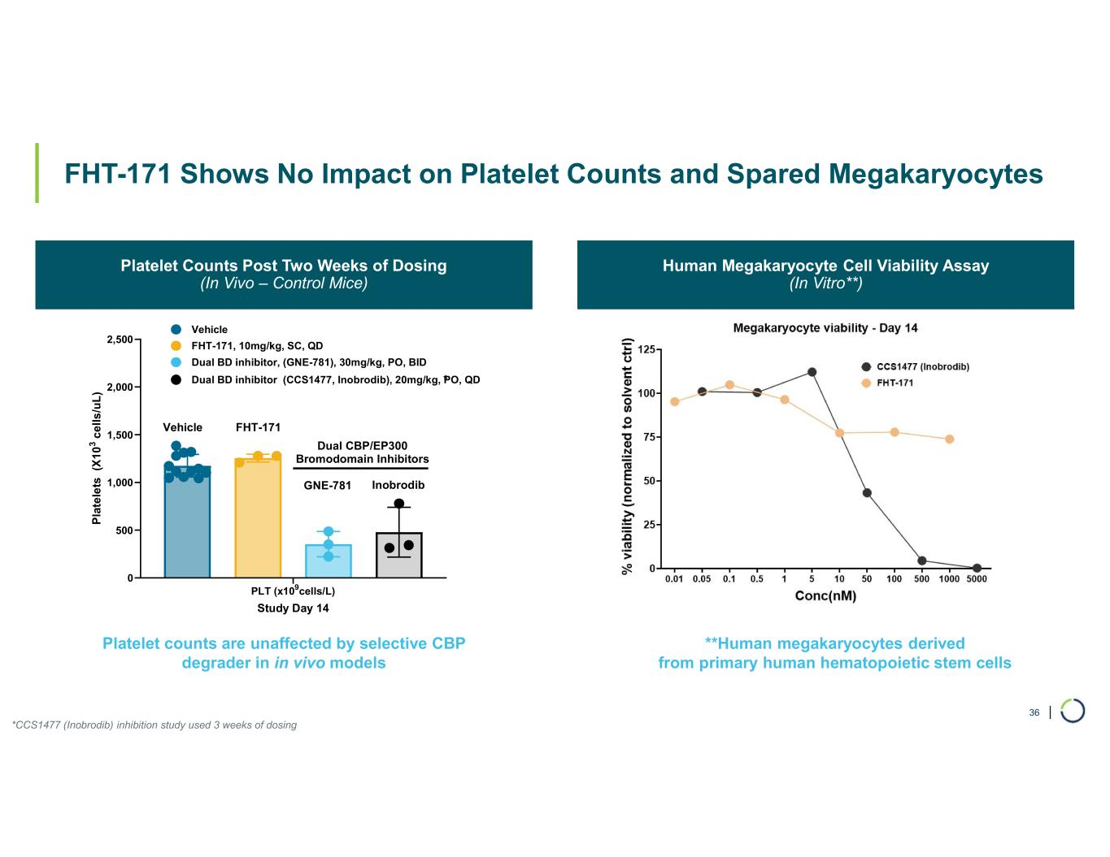
| FHT-171 Shows No Impact on Platelet Counts and Spared Megakaryocytes • C B P Platelet Counts Post Two Weeks of Dosing (In Vivo – Control Mice) Human Megakaryocyte Cell Viability Assay (In Vitro**) *CCS1477 (Inobrodib) inhibition study used 3 weeks of dosing Platelet counts are unaffected by selective CBP degrader in in vivo models **Human megakaryocytes derived from primary human hematopoietic stem cells 36 PLT (x109cells/L) 0 500 1,000 1,500 2,000 2,500 Study Day 14 P la te le ts (X 1 0 3 c e ll s /u L ) Vehicle FHT-171, 10mg/kg, SC, QD Dual BD inhibitor, (GNE-781), 30mg/kg, PO, BID FHT-171 Dual CBP/EP300 Bromodomain Inhibitors Vehicle Dual BD inhibitor (CCS1477, Inobrodib), 20mg/kg, PO, QD GNE-781 Inobrodib *

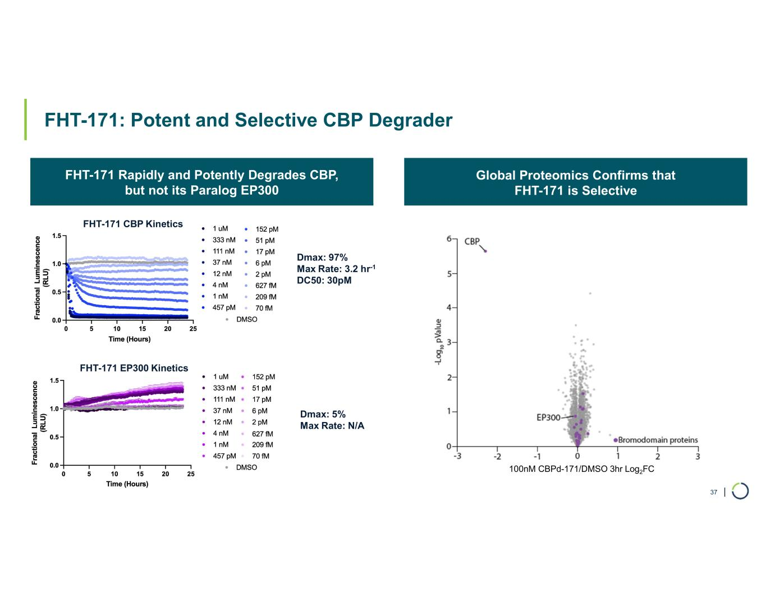
| FHT-171: Potent and Selective CBP Degrader • C B P Global Proteomics Confirms that FHT-171 is Selective 37 FHT-171 Rapidly and Potently Degrades CBP, but not its Paralog EP300 Dmax: 97% Max Rate: 3.2 hr-1 DC50: 30pM Dmax: 5% Max Rate: N/A 100nM CBPd-171/DMSO 3hr Log2FC FHT-171 CBP Kinetics FHT-171 EP300 Kinetics

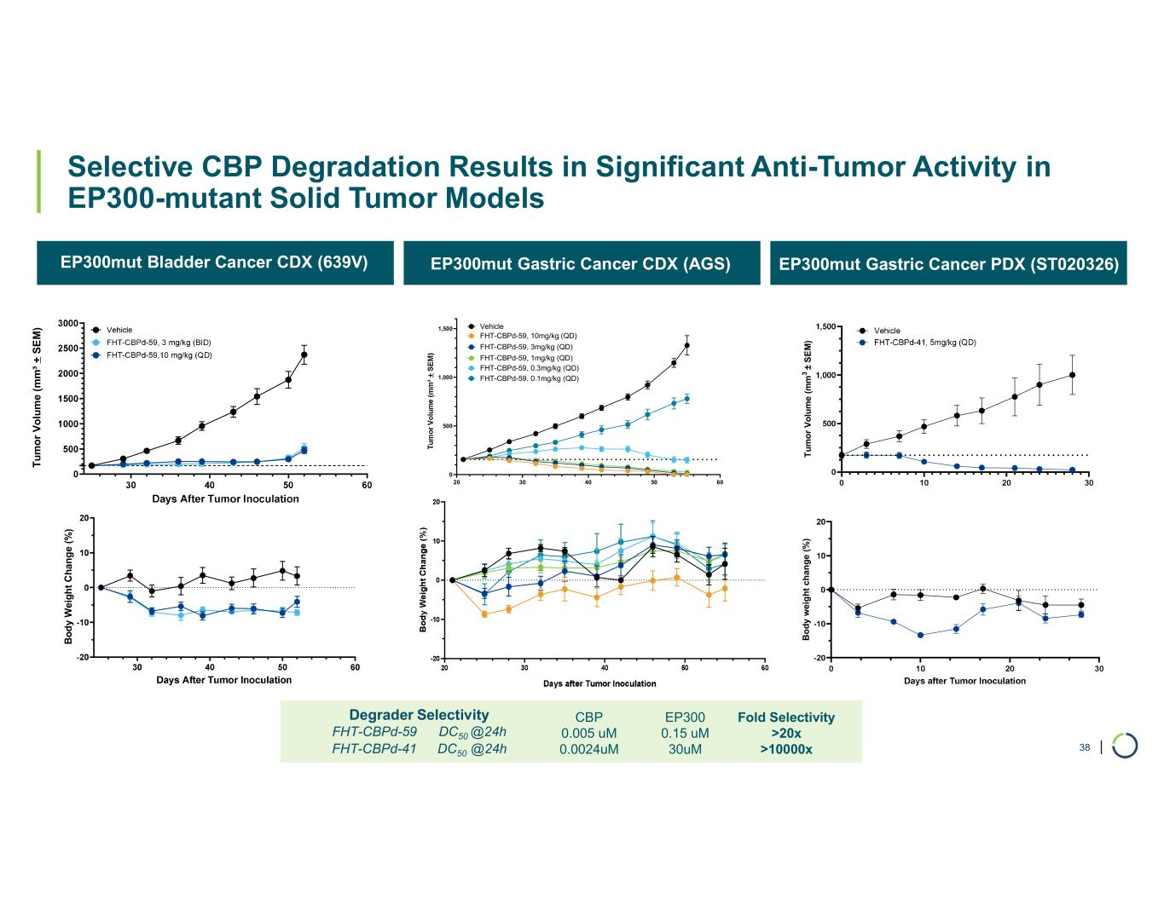
| Selective CBP Degradation Results in Significant Anti-Tumor Activity in EP300-mutant Solid Tumor Models EP300mut Bladder Cancer CDX (639V) EP300mut Gastric Cancer CDX (AGS) EP300mut Gastric Cancer PDX (ST020326) T u m o r V o lu m e (m m ³ + S E M ) B o d y W ei g h t C h an g e (% ) 20 30 40 50 60 0 500 1,000 1,500 Vehicle FHT-CBPd-59, 10mg/kg (QD) FHT-CBPd-59, 3mg/kg (QD) FHT-CBPd-59, 1mg/kg (QD) FHT-CBPd-59, 0.3mg/kg (QD) FHT-CBPd-59, 0.1mg/kg (QD) T u m o r V o lu m e ( m m 3 ± S E M ) B o d y w e ig h t c h a n g e ( % ) Fold Selectivity >20x >10000x EP300 0.15 uM 30uM CBP 0.005 uM 0.0024uM Degrader Selectivity FHT-CBPd-59 DC50 @24h FHT-CBPd-41 DC50 @24h 38

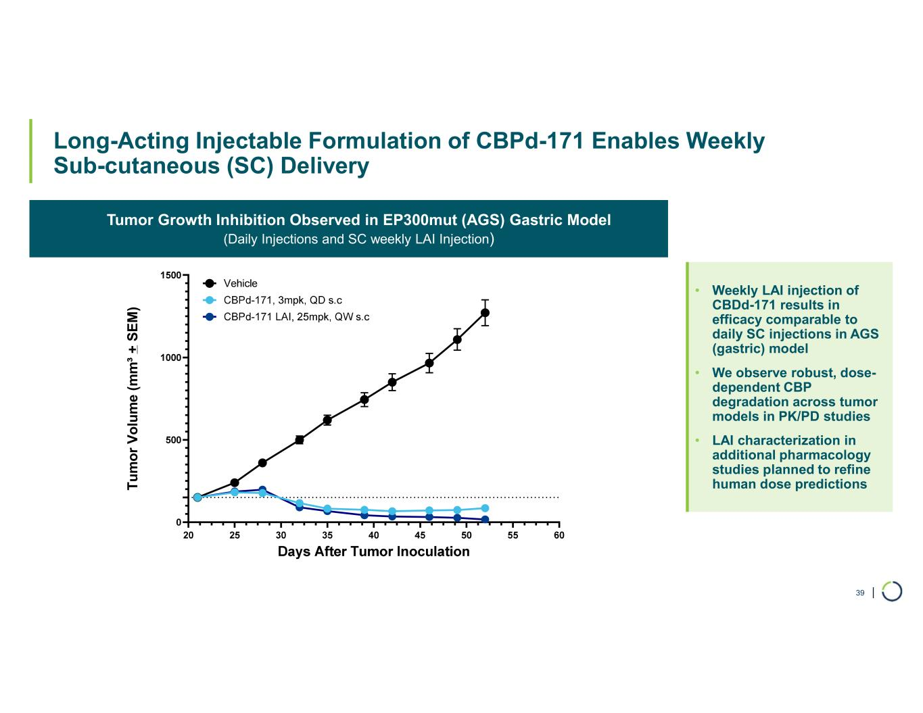
| Long-Acting Injectable Formulation of CBPd-171 Enables Weekly Sub-cutaneous (SC) Delivery 39 Tumor Growth Inhibition Observed in EP300mut (AGS) Gastric Model (Daily Injections and SC weekly LAI Injection) • Weekly LAI injection of CBDd-171 results in efficacy comparable to daily SC injections in AGS (gastric) model • We observe robust, dose- dependent CBP degradation across tumor models in PK/PD studies • LAI characterization in additional pharmacology studies planned to refine human dose predictionsT u m o r V o lu m e (m m ³ + S E M )

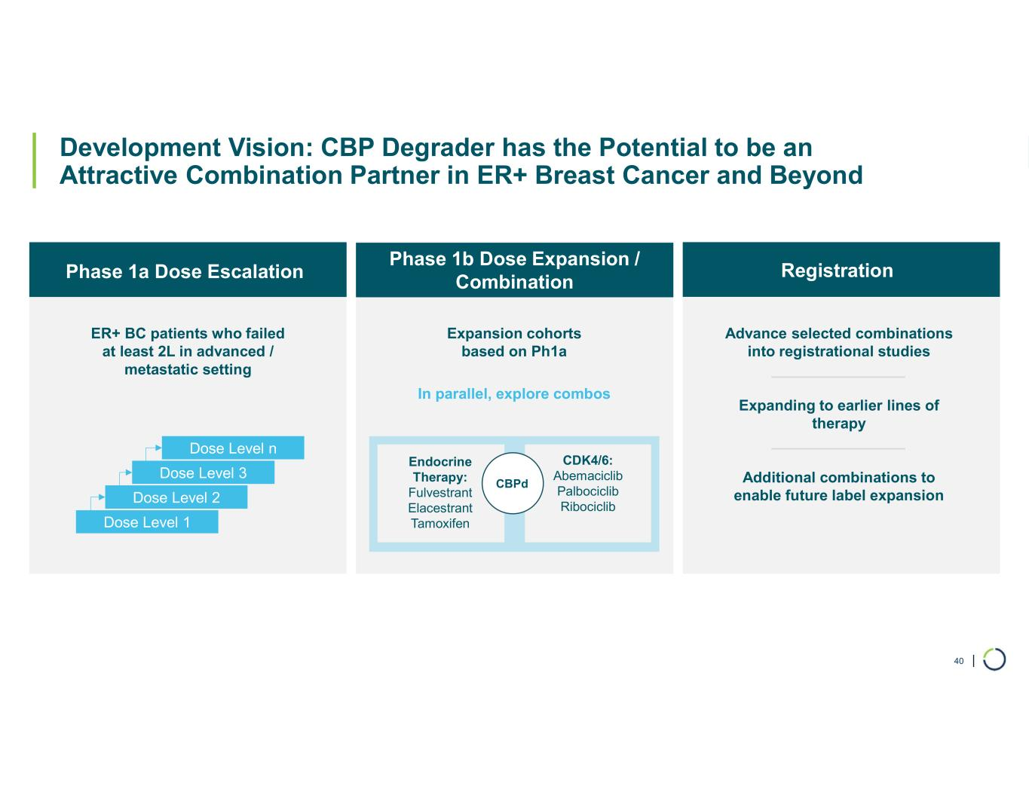
| 40 Development Vision: CBP Degrader has the Potential to be an Attractive Combination Partner in ER+ Breast Cancer and Beyond Phase 1b Dose Expansion / Combination ER+ BC patients who failed at least 2L in advanced / metastatic setting In parallel, explore combos Dose Level 1 Dose Level 2 Dose Level 3 Dose Level n Expansion cohorts based on Ph1a Advance selected combinations into registrational studies Expanding to earlier lines of therapy Additional combinations to enable future label expansion Endocrine Therapy: Fulvestrant Elacestrant Tamoxifen CDK4/6: Abemaciclib Palbociclib Ribociclib CBPd Phase 1a Dose Escalation Registration

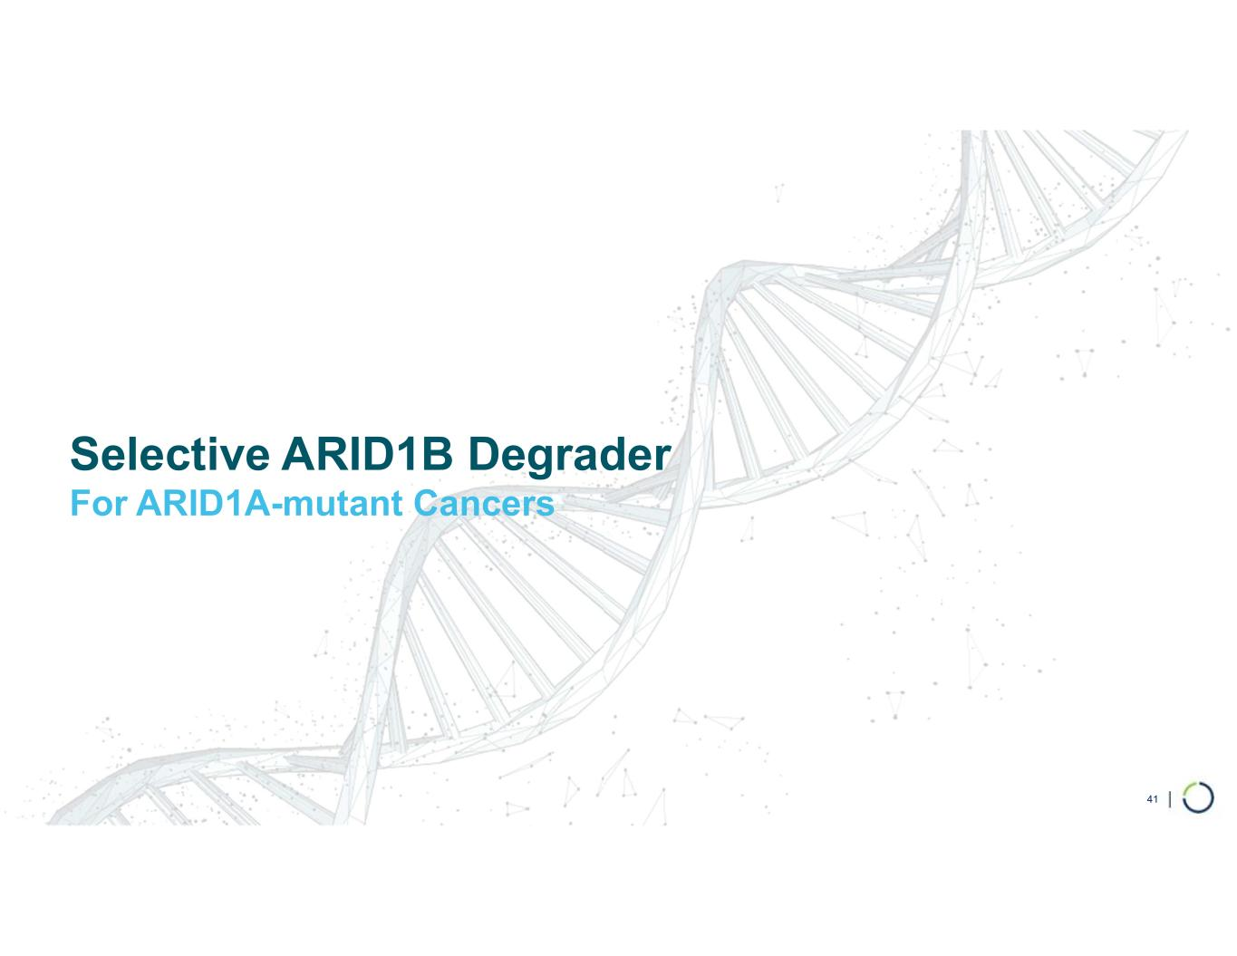
Selective ARID1B Degrader For ARID1A-mutant Cancers 41

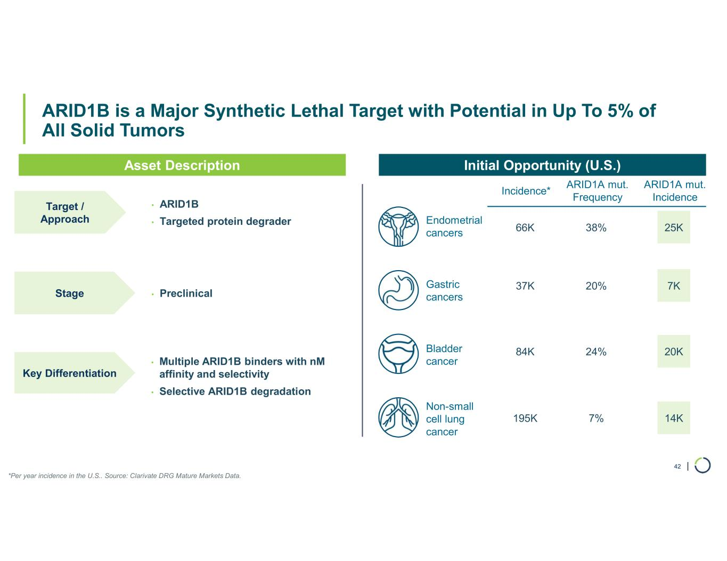
| ARID1B is a Major Synthetic Lethal Target with Potential in Up To 5% of All Solid Tumors 42 • ARID1B • Targeted protein degrader Endometrial cancers Gastric cancers Bladder cancer Non-small cell lung cancer • Preclinical • Multiple ARID1B binders with nM affinity and selectivity • Selective ARID1B degradation Asset Description Initial Opportunity (U.S.) Incidence* ARID1A mut. Frequency ARID1A mut. Incidence 66K 38% 25K 37K 20% 7K 84K 24% 20K 195K 7% 14K *Per year incidence in the U.S.. Source: Clarivate DRG Mature Markets Data. Target / Approach Stage Key Differentiation

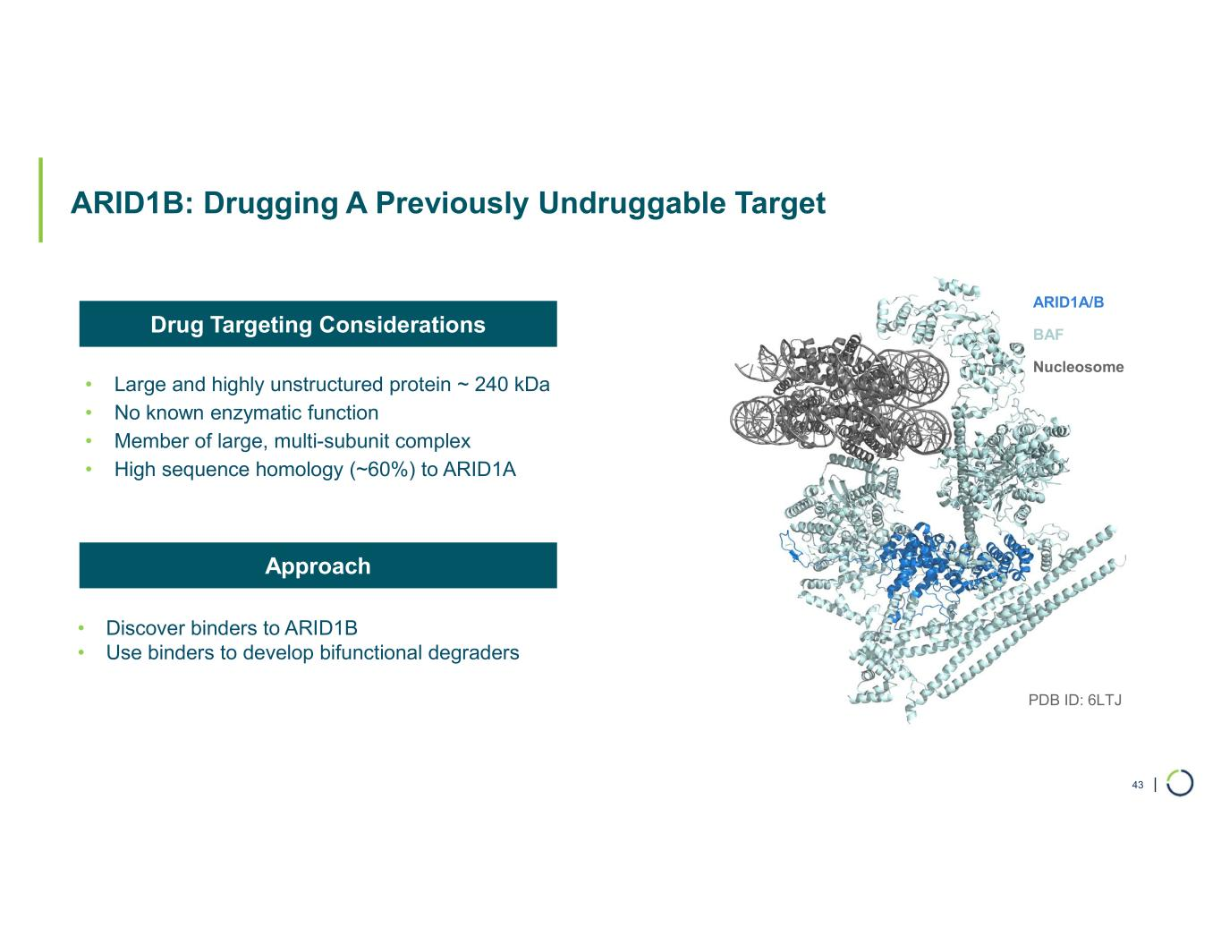
| ARID1B: Drugging A Previously Undruggable Target • Large and highly unstructured protein ~ 240 kDa • No known enzymatic function • Member of large, multi-subunit complex • High sequence homology (~60%) to ARID1A 43 ARID1A/B BAF Nucleosome PDB ID: 6LTJ • Discover binders to ARID1B • Use binders to develop bifunctional degraders Drug Targeting Considerations Approach

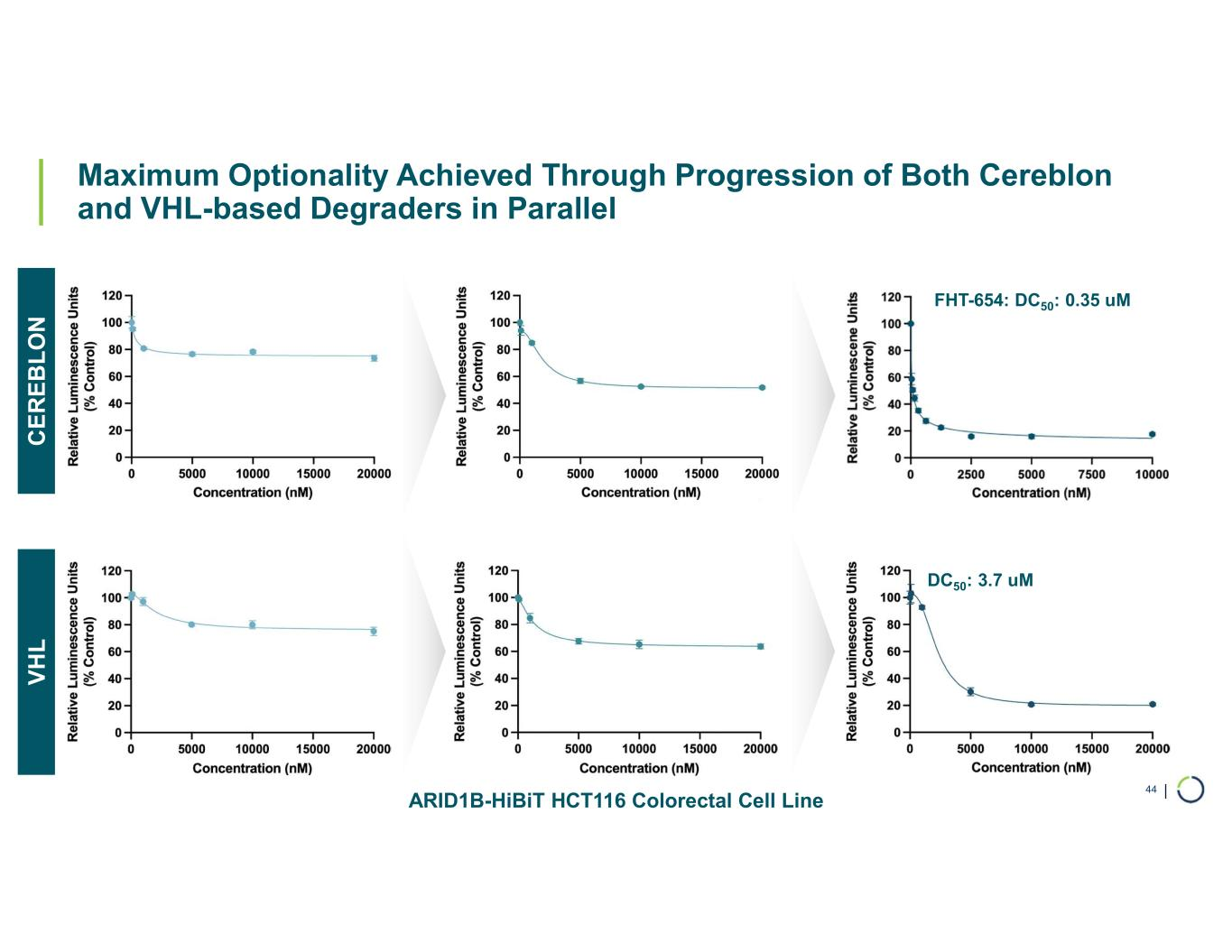
| Maximum Optionality Achieved Through Progression of Both Cereblon and VHL-based Degraders in Parallel 44 C E R E B L O N V H L FHT-654: DC50: 0.35 uM DC50: 3.7 uM ARID1B-HiBiT HCT116 Colorectal Cell Line

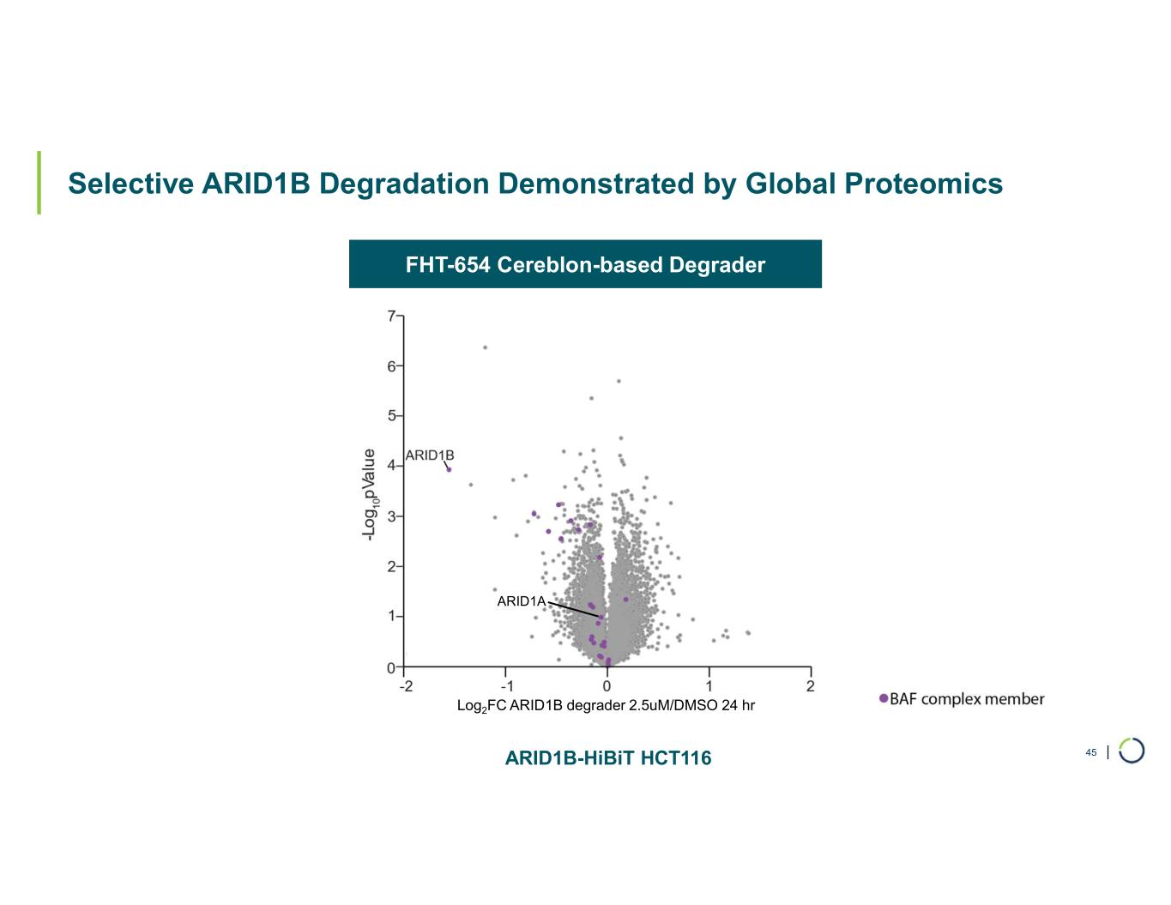
| Selective ARID1B Degradation Demonstrated by Global Proteomics 45 FHT-654 Cereblon-based Degrader ARID1A Log2FC ARID1B degrader 2.5uM/DMSO 24 hr ARID1B-HiBiT HCT116

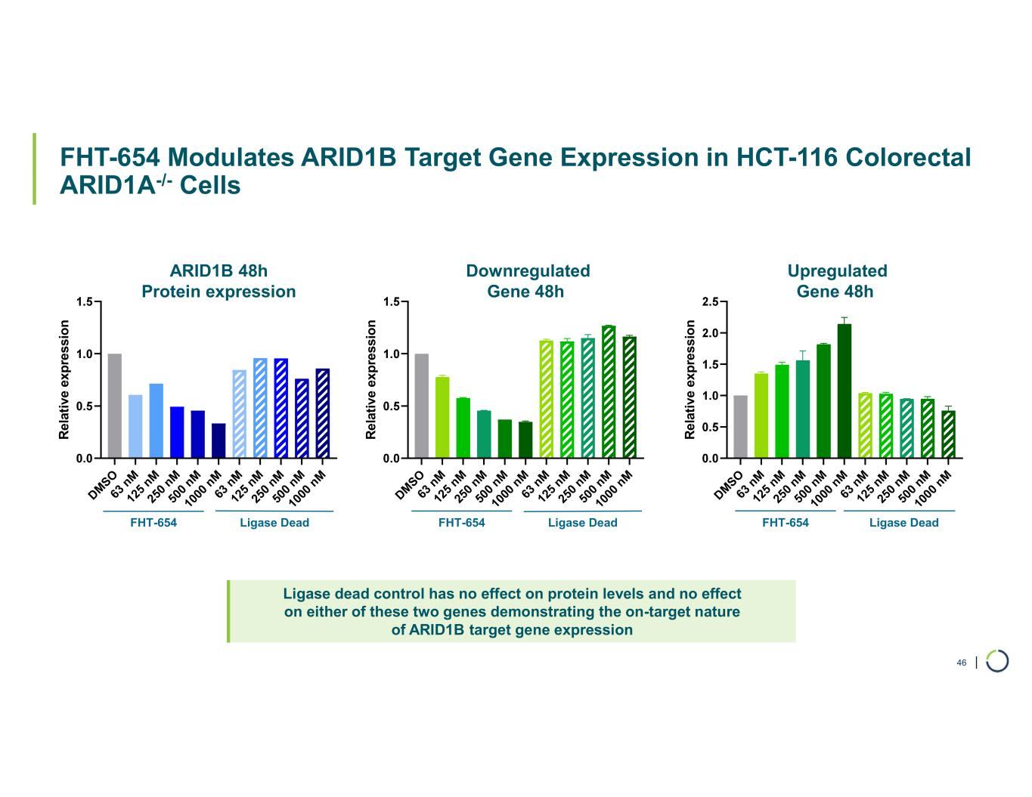
| FHT-654 Modulates ARID1B Target Gene Expression in HCT-116 Colorectal ARID1A-/- Cells DM SO 63 n M 12 5 nM 25 0 nM 50 0 nM 10 00 n M 63 n M 12 5 nM 25 0 nM 50 0 nM 10 00 n M R el at iv e ex p re ss io n DM SO 63 n M 12 5 nM 25 0 nM 50 0 nM 10 00 n M 63 n M 12 5 nM 25 0 nM 50 0 nM 10 00 n M R el at iv e ex p re ss io n DM SO 63 n M 12 5 nM 25 0 nM 50 0 nM 10 00 n M 63 n M 12 5 nM 25 0 nM 50 0 nM 10 00 n M R el at iv e ex p re ss io n ARID1B 48h Protein expression Downregulated Gene 48h Upregulated Gene 48h FHT-654 Ligase Dead FHT-654 Ligase Dead FHT-654 Ligase Dead Ligase dead control has no effect on protein levels and no effect on either of these two genes demonstrating the on-target nature of ARID1B target gene expression 46

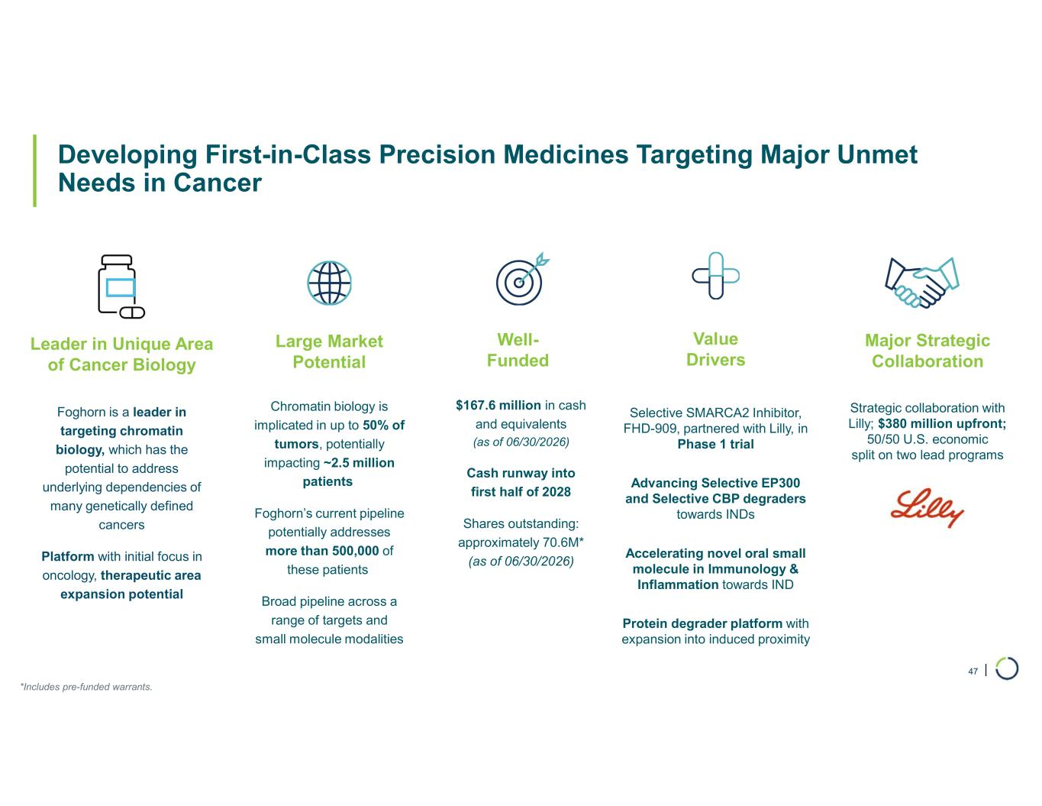
| Developing First-in-Class Precision Medicines Targeting Major Unmet Needs in Cancer 47 Large Market Potential Chromatin biology is implicated in up to 50% of tumors, potentially impacting ~2.5 million patients Foghorn’s current pipeline potentially addresses more than 500,000 of these patients Broad pipeline across a range of targets and small molecule modalities Major Strategic Collaboration Strategic collaboration with Lilly; $380 million upfront; 50/50 U.S. economic split on two lead programs Well- Funded $167.6 million in cash and equivalents (as of 06/30/2026) Cash runway into first half of 2028 Shares outstanding: approximately 70.6M* (as of 06/30/2026) Value Drivers Selective SMARCA2 Inhibitor, FHD-909, partnered with Lilly, in Phase 1 trial Advancing Selective EP300 and Selective CBP degraders towards INDs Accelerating novel oral small molecule in Immunology & Inflammation towards IND Protein degrader platform with expansion into induced proximity Leader in Unique Area of Cancer Biology Foghorn is a leader in targeting chromatin biology, which has the potential to address underlying dependencies of many genetically defined cancers Platform with initial focus in oncology, therapeutic area expansion potential *Includes pre-funded warrants.


Unique biology Precision therapeutics Broad impact 48 August 2026

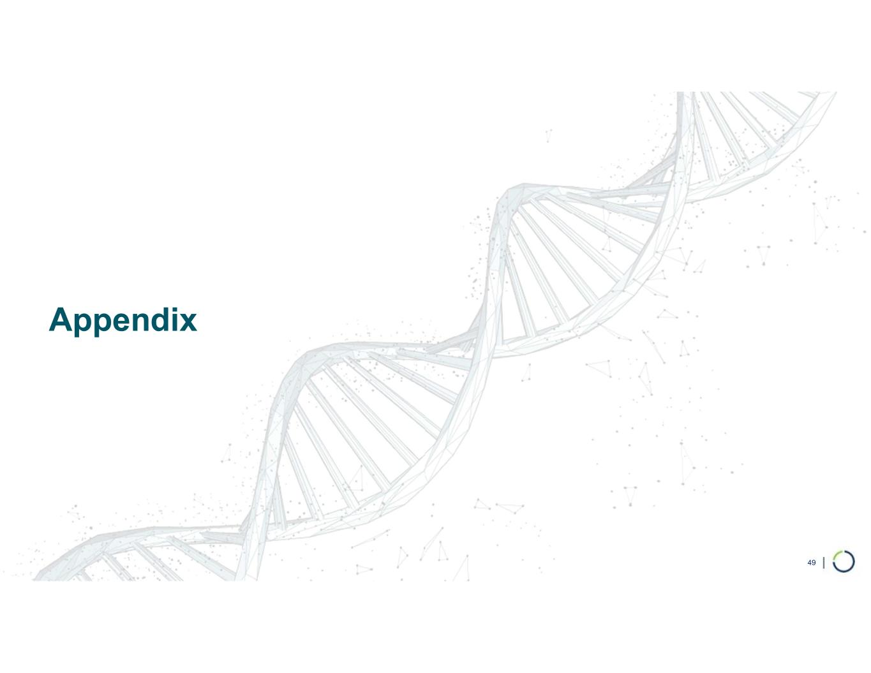
Appendix 49

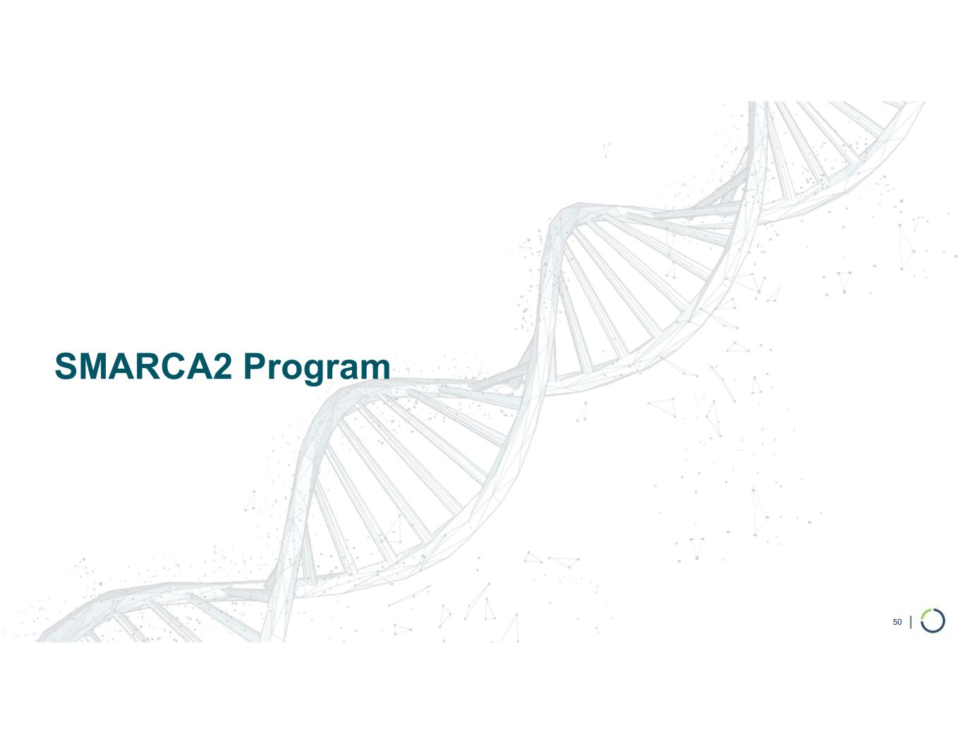
SMARCA2 Program 50

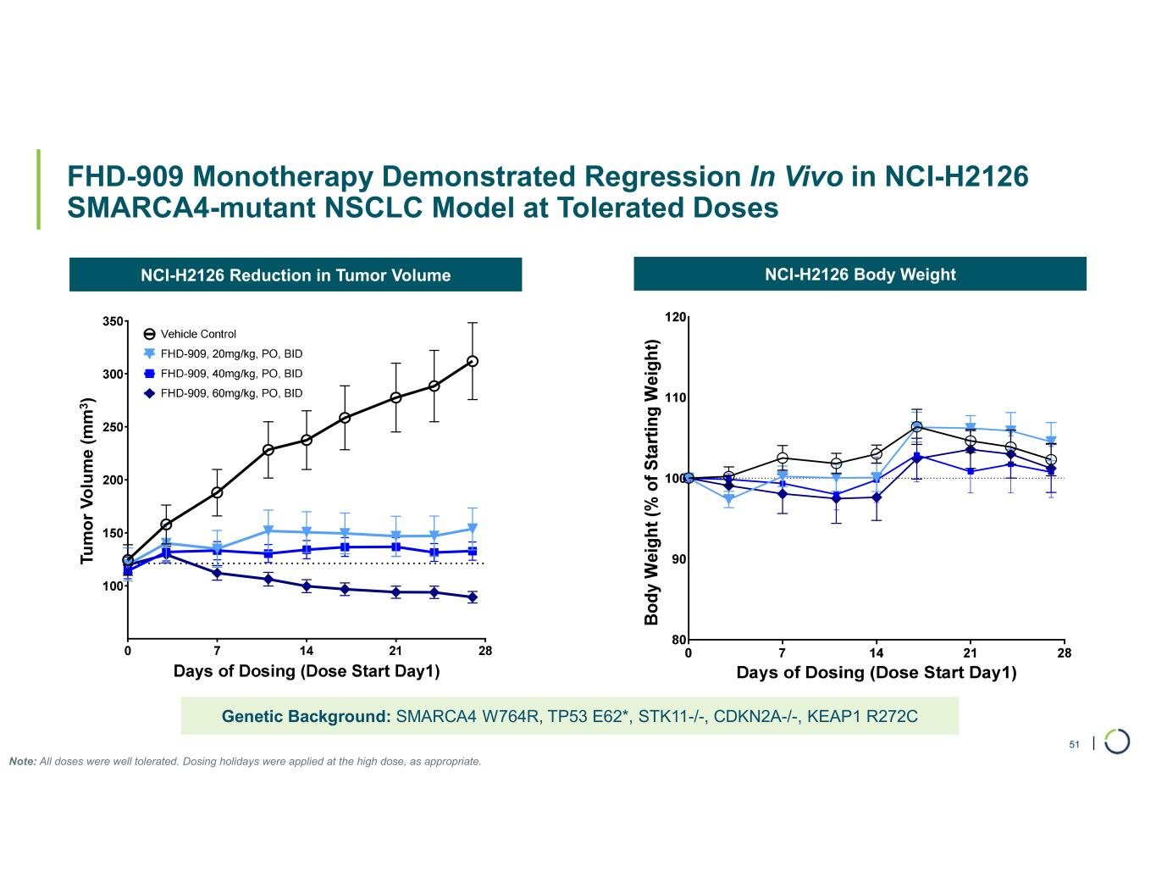
| FHD-909 Monotherapy Demonstrated Regression In Vivo in NCI-H2126 SMARCA4-mutant NSCLC Model at Tolerated Doses 51 NCI-H2126 Reduction in Tumor Volume NCI-H2126 Body Weight Genetic Background: SMARCA4 W764R, TP53 E62*, STK11-/-, CDKN2A-/-, KEAP1 R272C Note: All doses were well tolerated. Dosing holidays were applied at the high dose, as appropriate. T u m o r v o lu m e (m m 3 ) Tu m o r V o lu m e (m m 3 )

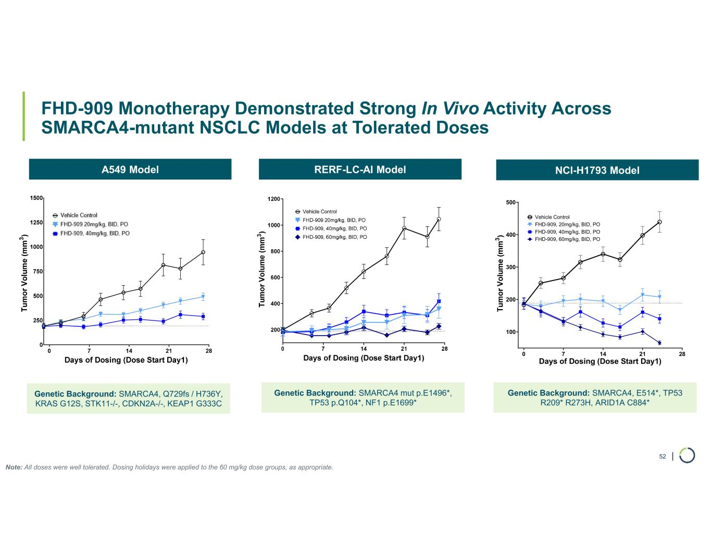
| FHD-909 Monotherapy Demonstrated Strong In Vivo Activity Across SMARCA4-mutant NSCLC Models at Tolerated Doses 52 0 7 14 21 28 100 200 300 400 500 Days of Dosing (Dose Start Day1) Vehicle Control FHD-909, 20mg/kg, BID, PO FHD-909, 40mg/kg, BID, PO FHD-909, 60mg/kg, BID, PO A549 Model RERF-LC-AI Model NCI-H1793 Model Genetic Background: SMARCA4, Q729fs / H736Y, KRAS G12S, STK11-/-, CDKN2A-/-, KEAP1 G333C Genetic Background: SMARCA4 mut p.E1496*, TP53 p.Q104*, NF1 p.E1699* Genetic Background: SMARCA4, E514*, TP53 R209* R273H, ARID1A C884* Note: All doses were well tolerated. Dosing holidays were applied to the 60 mg/kg dose groups, as appropriate.

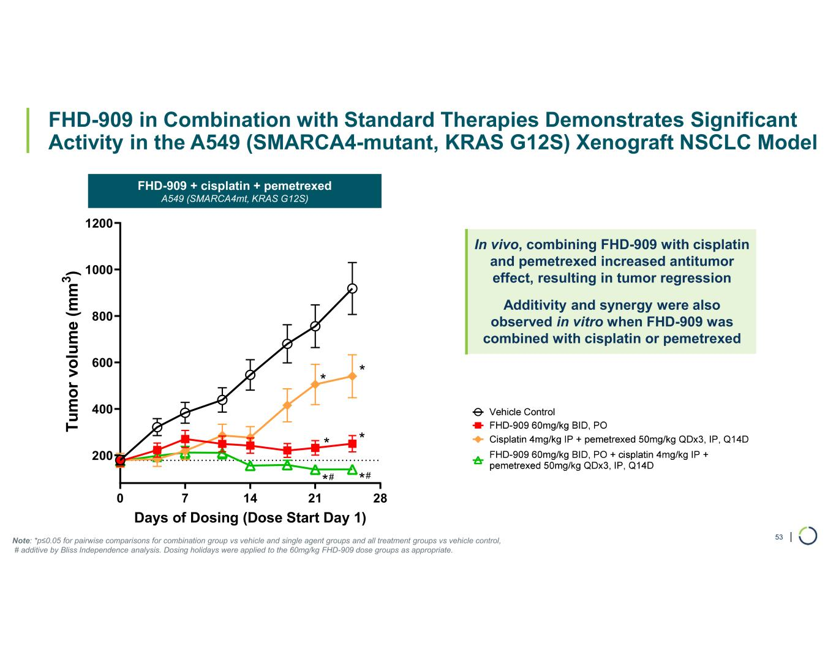
| FHD-909 in Combination with Standard Therapies Demonstrates Significant Activity in the A549 (SMARCA4-mutant, KRAS G12S) Xenograft NSCLC Model 53 0 7 14 21 28 200 400 600 800 1000 1200 Days of Dosing (Dose Start Day 1) T u m o r vo lu m e (m m 3 ) * * * * ** ## Note: *p≤0.05 for pairwise comparisons for combination group vs vehicle and single agent groups and all treatment groups vs vehicle control, # additive by Bliss Independence analysis. Dosing holidays were applied to the 60mg/kg FHD-909 dose groups as appropriate. FHD-909 + cisplatin + pemetrexed A549 (SMARCA4mt, KRAS G12S) In vivo, combining FHD-909 with cisplatin and pemetrexed increased antitumor effect, resulting in tumor regression Additivity and synergy were also observed in vitro when FHD-909 was combined with cisplatin or pemetrexed

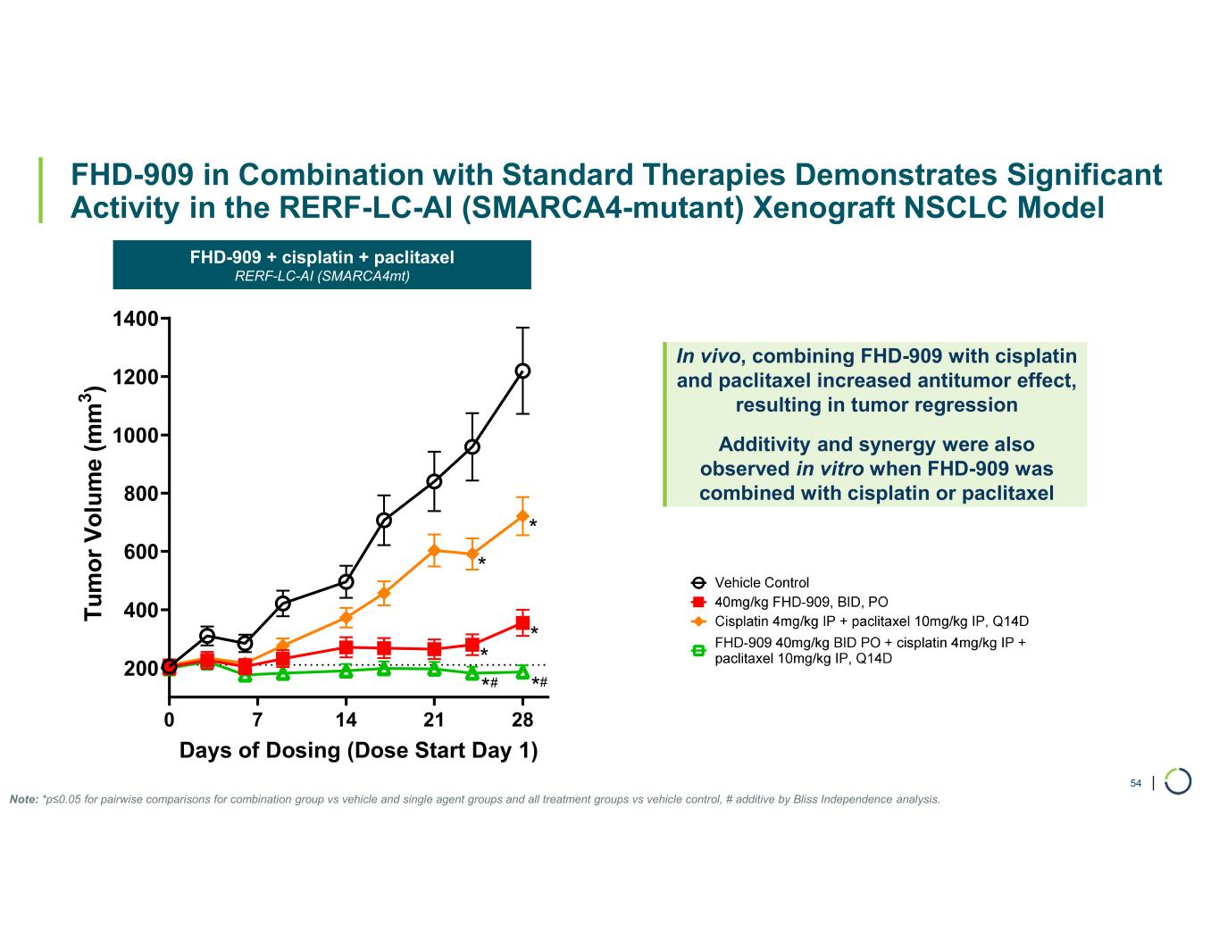
| FHD-909 in Combination with Standard Therapies Demonstrates Significant Activity in the RERF-LC-AI (SMARCA4-mutant) Xenograft NSCLC Model 54 0 7 14 21 28 200 400 600 800 1000 1200 1400 Days of Dosing (Dose Start Day 1) T u m o r V o lu m e (m m 3 ) * * * * **# # Note: *p≤0.05 for pairwise comparisons for combination group vs vehicle and single agent groups and all treatment groups vs vehicle control, # additive by Bliss Independence analysis. In vivo, combining FHD-909 with cisplatin and paclitaxel increased antitumor effect, resulting in tumor regression Additivity and synergy were also observed in vitro when FHD-909 was combined with cisplatin or paclitaxel FHD-909 + cisplatin + paclitaxel RERF-LC-AI (SMARCA4mt)

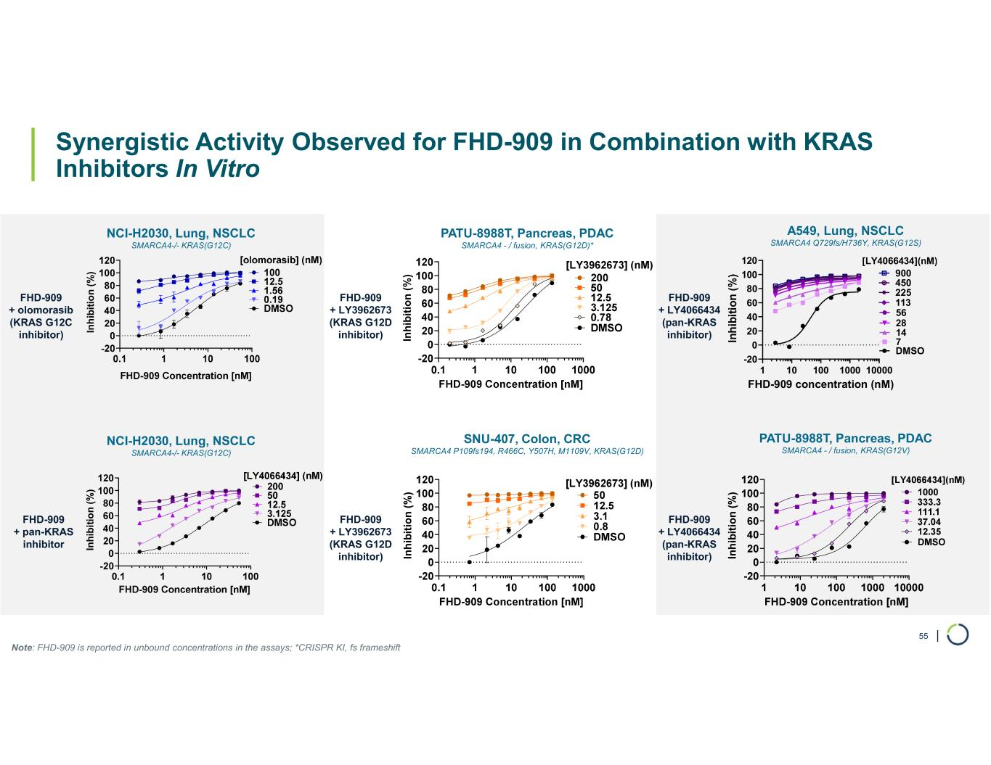
| Synergistic Activity Observed for FHD-909 in Combination with KRAS Inhibitors In Vitro 55 In h ib it io n ( % ) In h ib it io n ( % ) FHD-909 + olomorasib (KRAS G12C inhibitor) FHD-909 + pan-KRAS inhibitor In h ib it io n ( % ) In h ib it io n ( % ) 1 10 100 1000 10000 -20 0 20 40 60 80 100 120 FHD-909 concentration (nM) DMSO 7 14 28 56 113 225 450 900 [LY4066434](nM) In h ib it io n ( % ) NCI-H2030, Lung, NSCLC SMARCA4-/- KRAS(G12C) PATU-8988T, Pancreas, PDAC SMARCA4 - / fusion, KRAS(G12D)* SNU-407, Colon, CRC SMARCA4 P109fs194, R466C, Y507H, M1109V, KRAS(G12D) A549, Lung, NSCLC SMARCA4 Q729fs/H736Y, KRAS(G12S) PATU-8988T, Pancreas, PDAC SMARCA4 - / fusion, KRAS(G12V) Note: FHD-909 is reported in unbound concentrations in the assays; *CRISPR KI, fs frameshift FHD-909 + LY3962673 (KRAS G12D inhibitor) FHD-909 + LY4066434 (pan-KRAS inhibitor) FHD-909 + LY3962673 (KRAS G12D inhibitor) FHD-909 + LY4066434 (pan-KRAS inhibitor) NCI-H2030, Lung, NSCLC SMARCA4-/- KRAS(G12C)

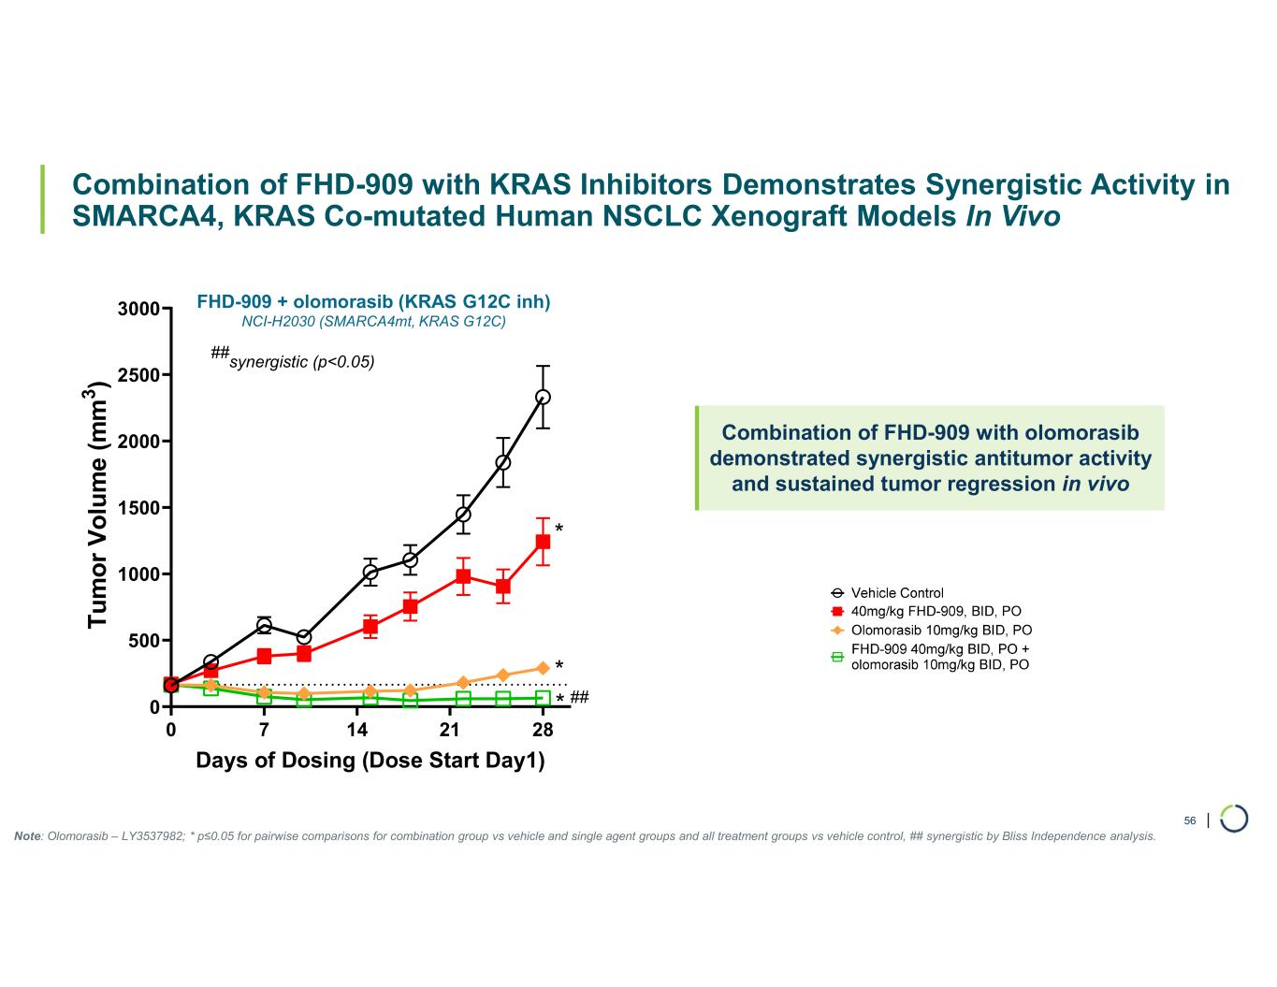
| Combination of FHD-909 with KRAS Inhibitors Demonstrates Synergistic Activity in SMARCA4, KRAS Co-mutated Human NSCLC Xenograft Models In Vivo FHD-909 + olomorasib (KRAS G12C inh) NCI-H2030 (SMARCA4mt, KRAS G12C) 56 0 7 14 21 28 0 500 1000 1500 2000 2500 3000 Days of Dosing (Dose Start Day1) T u m o r V o lu m e (m m 3 ) ## synergistic (p<0.05) * * * ## Combination of FHD-909 with olomorasib demonstrated synergistic antitumor activity and sustained tumor regression in vivo Note: Olomorasib – LY3537982; * p≤0.05 for pairwise comparisons for combination group vs vehicle and single agent groups and all treatment groups vs vehicle control, ## synergistic by Bliss Independence analysis.

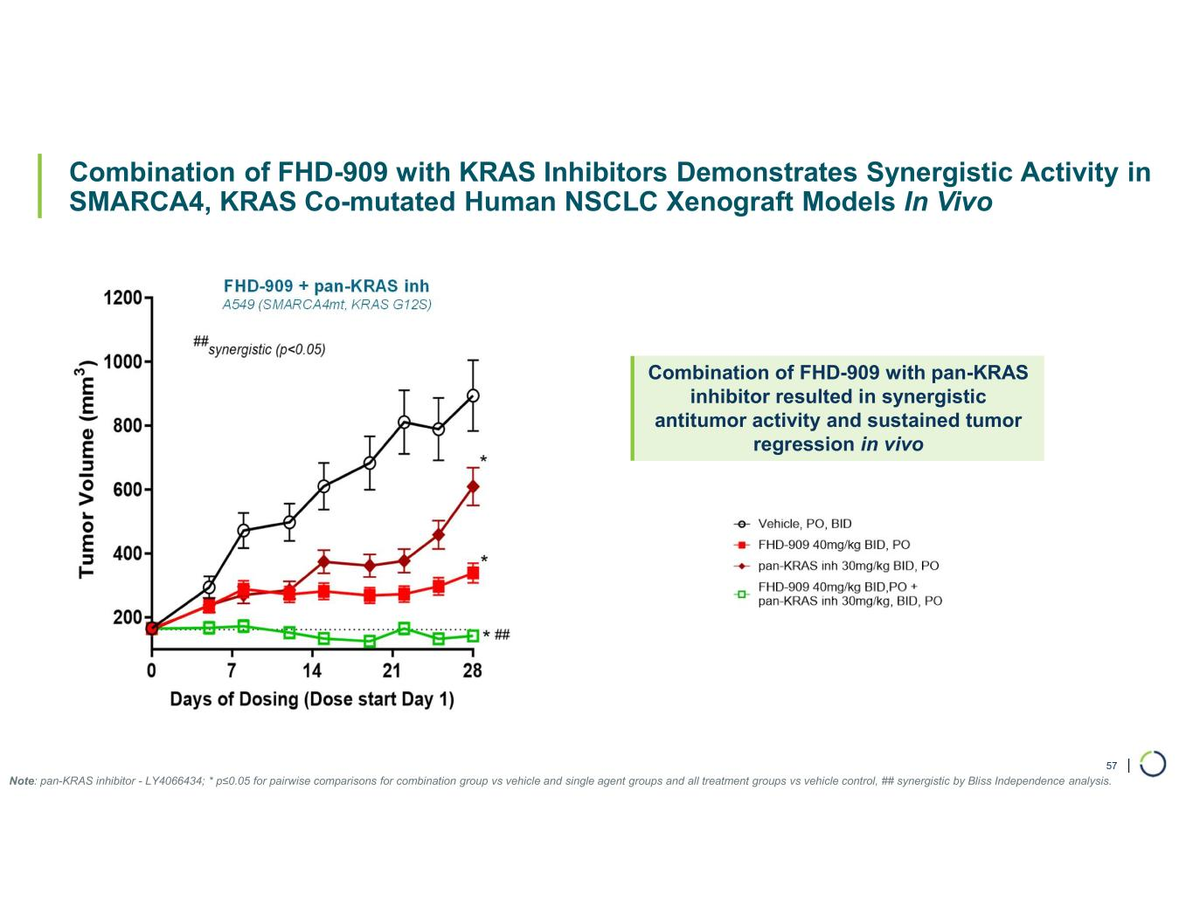
| Combination of FHD-909 with KRAS Inhibitors Demonstrates Synergistic Activity in SMARCA4, KRAS Co-mutated Human NSCLC Xenograft Models In Vivo FHD-909 + pan-KRAS inh A549 (SMARCA4mt, KRAS G12S) 57 Combination of FHD-909 with pan-KRAS inhibitor resulted in synergistic antitumor activity and sustained tumor regression in vivo Note: pan-KRAS inhibitor - LY4066434; * p≤0.05 for pairwise comparisons for combination group vs vehicle and single agent groups and all treatment groups vs vehicle control, ## synergistic by Bliss Independence analysis.

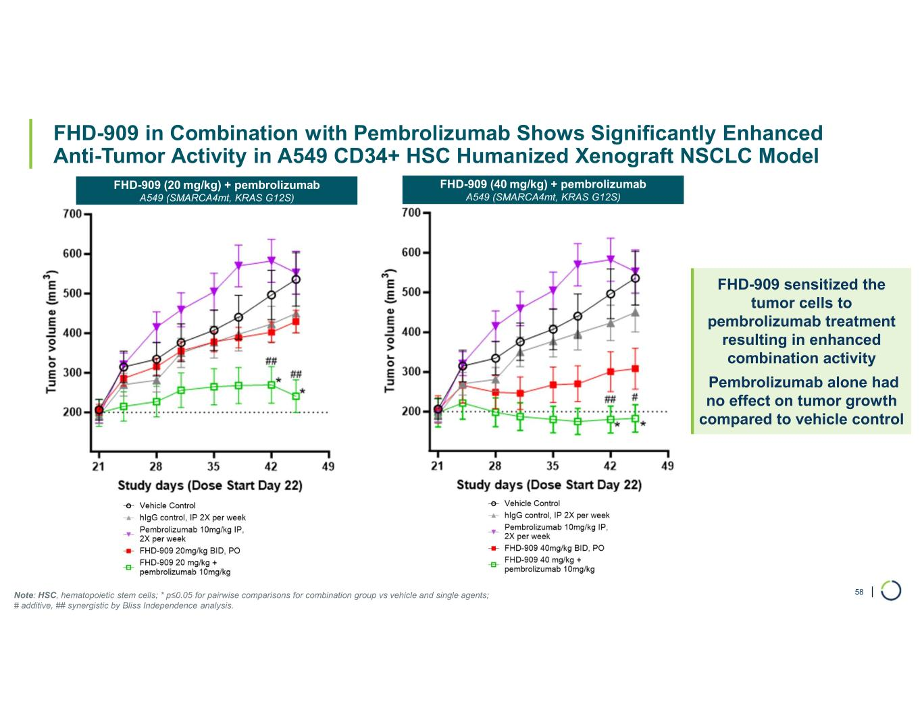
| FHD-909 in Combination with Pembrolizumab Shows Significantly Enhanced Anti-Tumor Activity in A549 CD34+ HSC Humanized Xenograft NSCLC Model 58 FHD-909 sensitized the tumor cells to pembrolizumab treatment resulting in enhanced combination activity Pembrolizumab alone had no effect on tumor growth compared to vehicle control Note: HSC, hematopoietic stem cells; * p≤0.05 for pairwise comparisons for combination group vs vehicle and single agents; # additive, ## synergistic by Bliss Independence analysis. FHD-909 (20 mg/kg) + pembrolizumab A549 (SMARCA4mt, KRAS G12S) FHD-909 (40 mg/kg) + pembrolizumab A549 (SMARCA4mt, KRAS G12S)

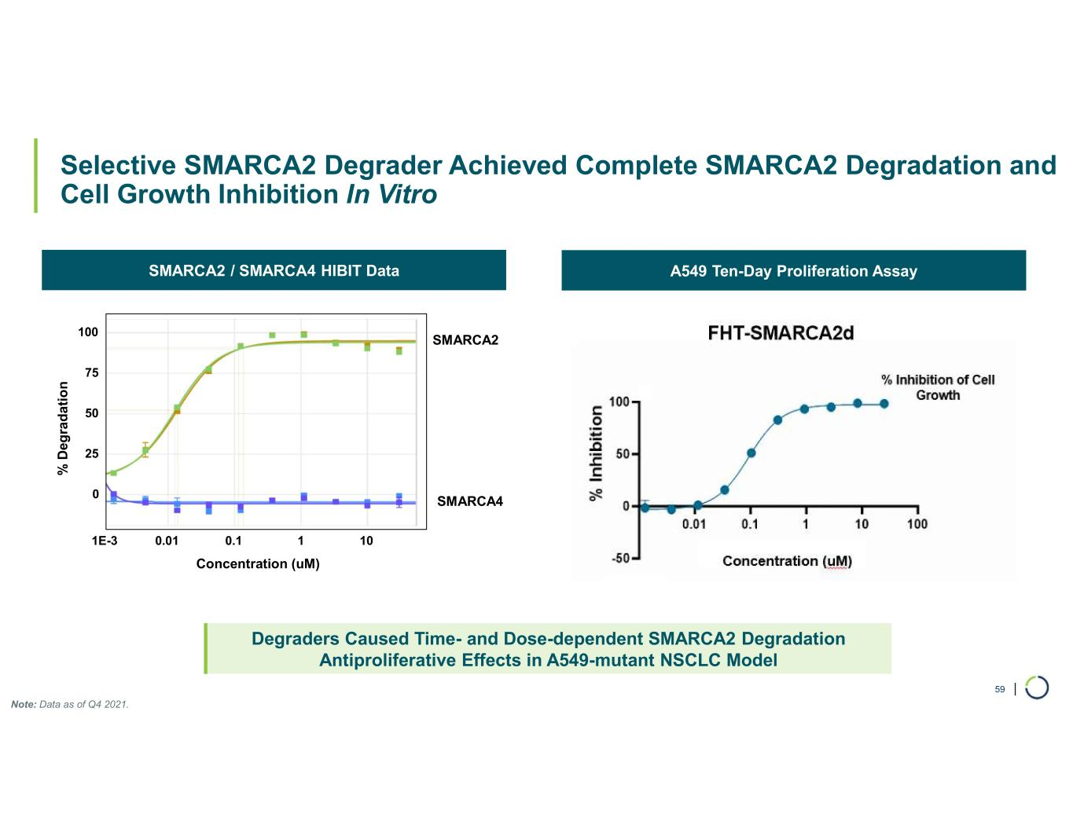
| Selective SMARCA2 Degrader Achieved Complete SMARCA2 Degradation and Cell Growth Inhibition In Vitro 59 Degraders Caused Time- and Dose-dependent SMARCA2 Degradation Antiproliferative Effects in A549-mutant NSCLC Model A549 Ten-Day Proliferation AssaySMARCA2 / SMARCA4 HIBIT Data SMARCA2 SMARCA4 % D eg ra d a ti o n Concentration (uM) 0 25 50 75 100 1E-3 0.01 0.1 1 10 Note: Data as of Q4 2021.

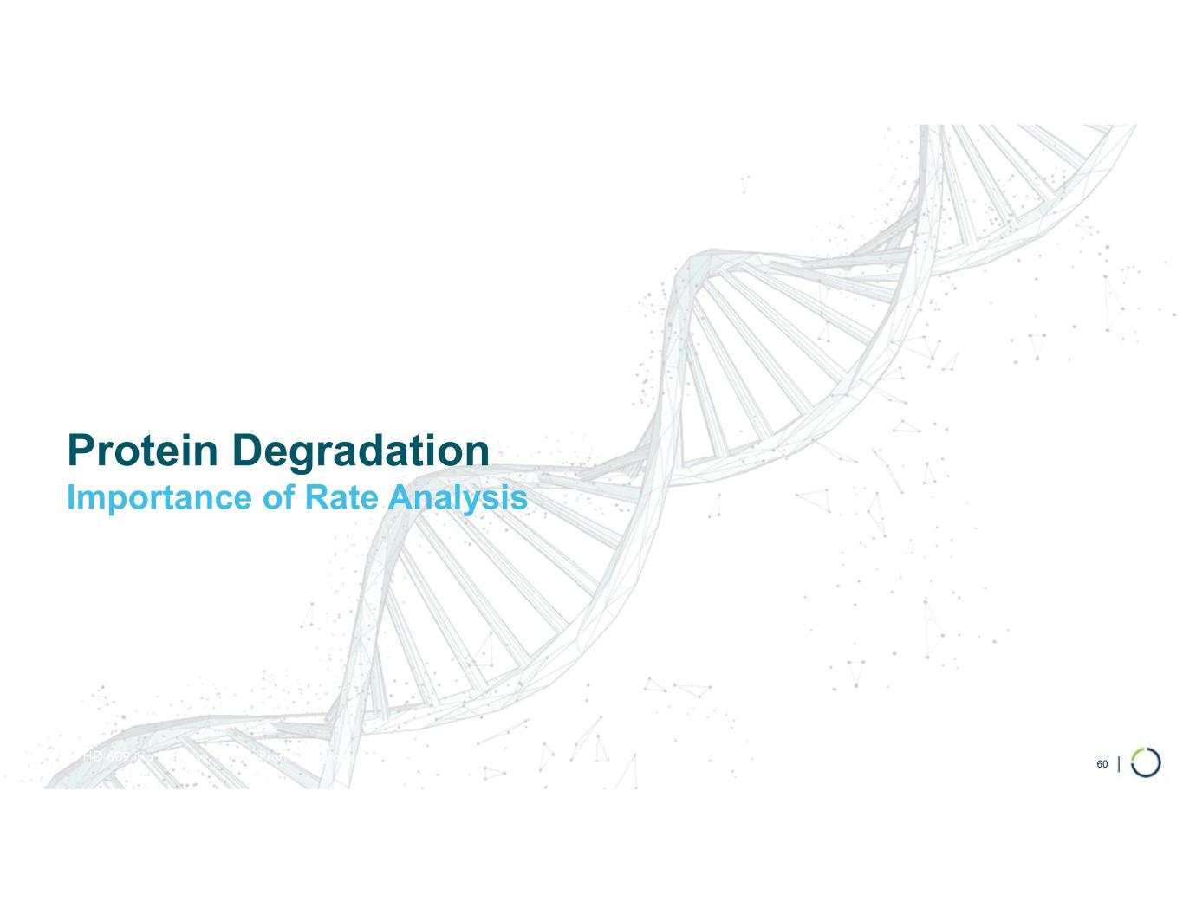
Protein Degradation Importance of Rate Analysis FHD-609 is a Selective, Potent, Protein Degrader of the BRD9 component of the BAF complex 60

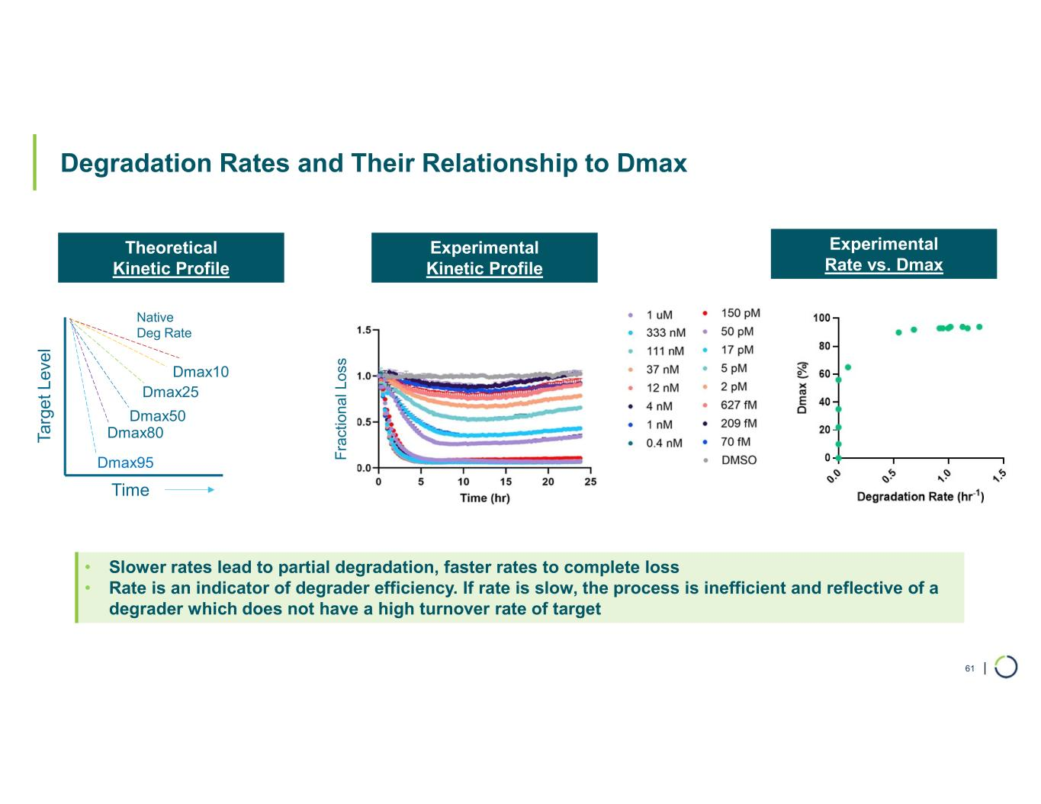
| Degradation Rates and Their Relationship to Dmax 61 • Slower rates lead to partial degradation, faster rates to complete loss • Rate is an indicator of degrader efficiency. If rate is slow, the process is inefficient and reflective of a degrader which does not have a high turnover rate of target Native Deg Rate Ta rg e t L ev e l Time Dmax10 Dmax25 Dmax50 Dmax80 Dmax95 Experimental Rate vs. Dmax Experimental Kinetic Profile Theoretical Kinetic Profile F ra ct io na l L os s

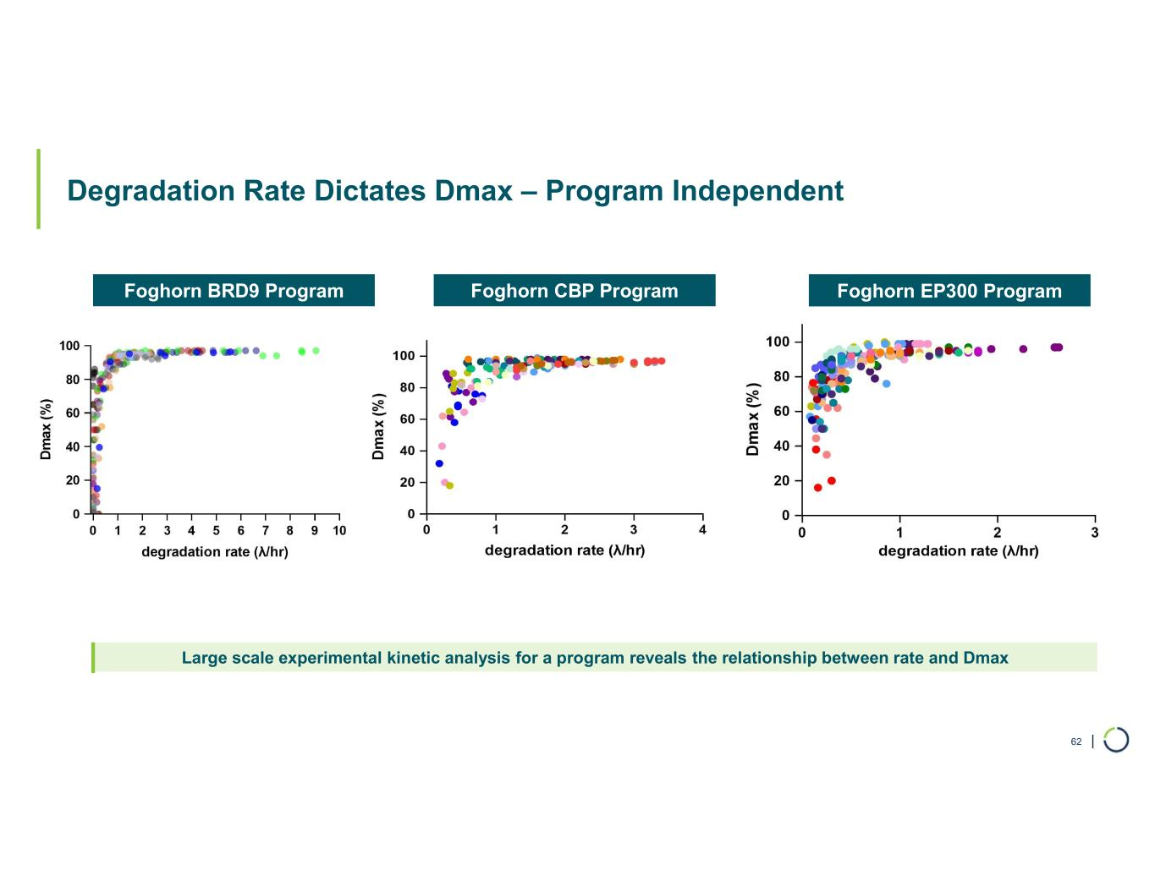
| Degradation Rate Dictates Dmax – Program Independent 62 Foghorn CBP ProgramFoghorn BRD9 Program Foghorn EP300 Program Large scale experimental kinetic analysis for a program reveals the relationship between rate and Dmax

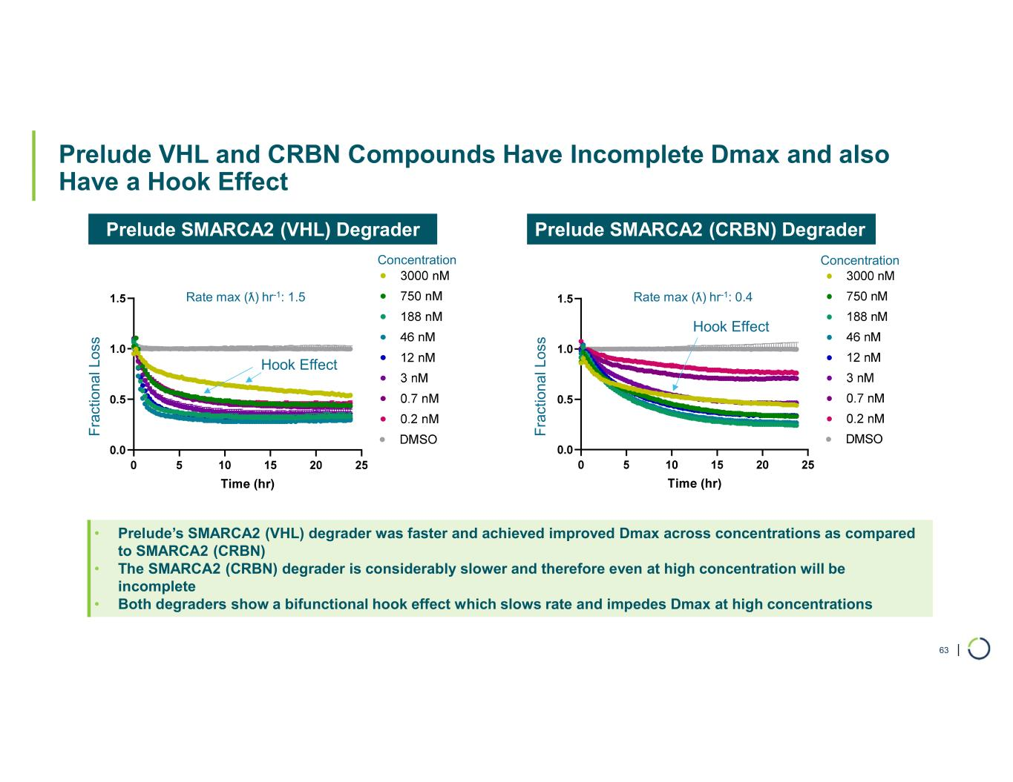
| Prelude VHL and CRBN Compounds Have Incomplete Dmax and also Have a Hook Effect 63 • Prelude’s SMARCA2 (VHL) degrader was faster and achieved improved Dmax across concentrations as compared to SMARCA2 (CRBN) • The SMARCA2 (CRBN) degrader is considerably slower and therefore even at high concentration will be incomplete • Both degraders show a bifunctional hook effect which slows rate and impedes Dmax at high concentrations Prelude SMARCA2 (CRBN) DegraderPrelude SMARCA2 (VHL) Degrader F ra c ti o n a l L u m in e s c e n c e (R L U ) Concentration F ra ct io n a l L u m in es ce n ce (R L U ) Concentration Hook Effect Hook Effect Rate max (ƛ) hr-1: 0.4Rate max (ƛ) hr-1: 1.5 F ra ct io na l L os s F ra ct io na l L os s

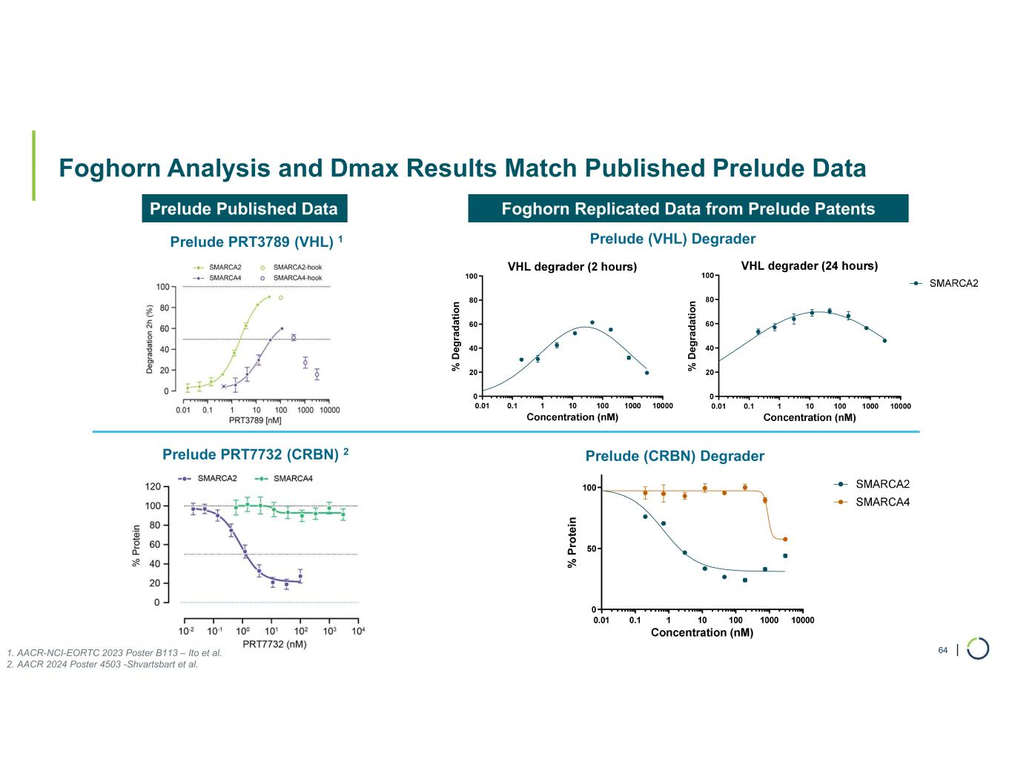
| Foghorn Analysis and Dmax Results Match Published Prelude Data 64 Prelude Published Data Prelude PRT3789 (VHL) 1 Prelude PRT7732 (CRBN) 2 % P ro te in Prelude (CRBN) Degrader Prelude (VHL) Degrader Foghorn Replicated Data from Prelude Patents 1. AACR-NCI-EORTC 2023 Poster B113 – Ito et al. 2. AACR 2024 Poster 4503 -Shvartsbart et al. % D eg ra d at io n % D e g ra d a ti o n

